Residential Sales
January – December 2021

DO NOT REMOVE FROM ASSESSORS OFFICE

Table of Contents
Home Style: Page:
Conventional …………………………………… 3
Contemporary………………………………….. 11
Garrison……………………………………………. 14
Raised Cape & Cape Cod……………………. 24
Colonial & New Colonial…………………….. 32
Raised Ranch………………………………………. 80
Ranch………………………………………………….. 95
Split-Level……………………………………………. 114
Tri-Level………………………………………………. 119
Tudor…………………………………………………… 125
Garden Style Condominium………………… 128
Townhouse Condominium…………………… 134
Hollis Hills, Brooksmont & Hollis Woods.139

Conventional

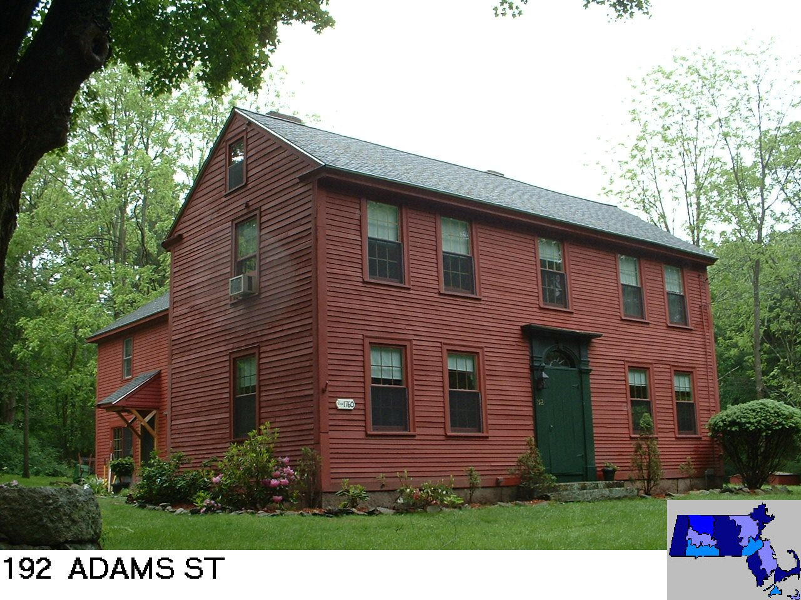
Sale Price = $607,500 Sale Date = 01/04/2021

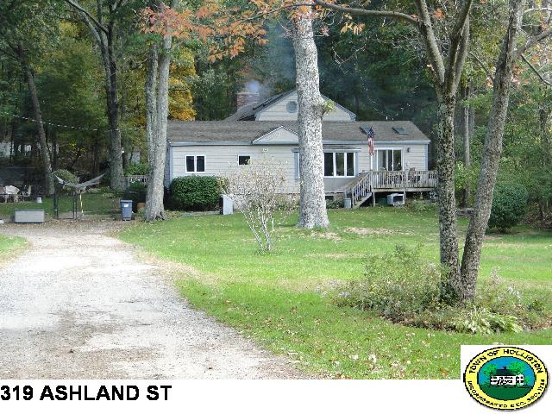
Sale Price = $549,900 Sale Date = 02/19/2021
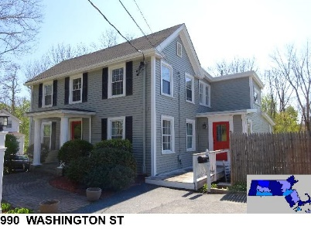
Sale Price = $700,000 Sale Date = 3/25/2021

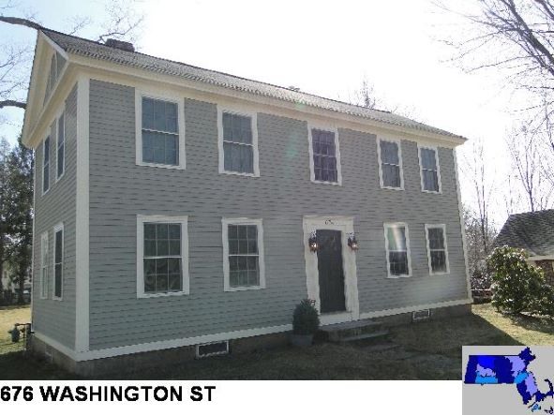
Sale Price = $660,000 Sale Date = 8/17/2021

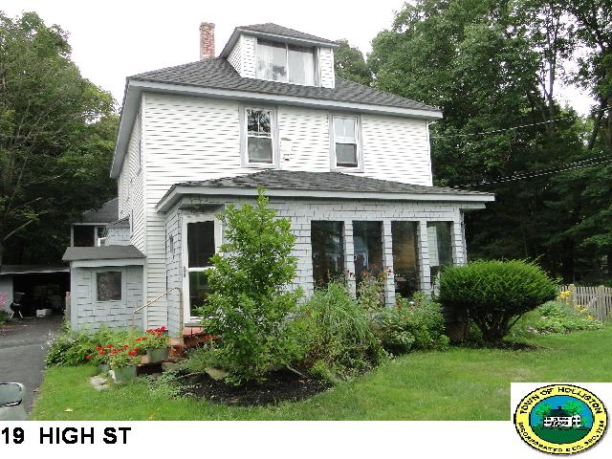
Sale Price = $565,000 Sale Date = 8/31/2021

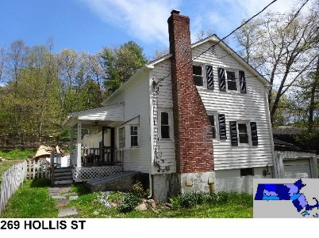
Sale Price = $415,000 Sale Date = 9/22/2021
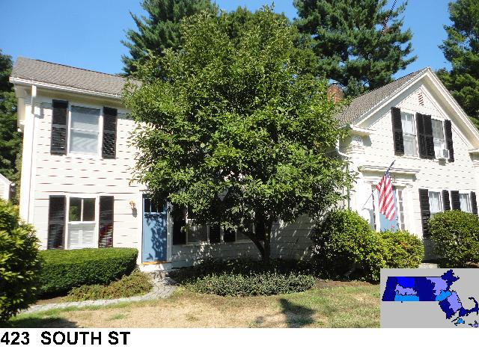
Sale Price = $599,900 Sale Date = 9/22/21

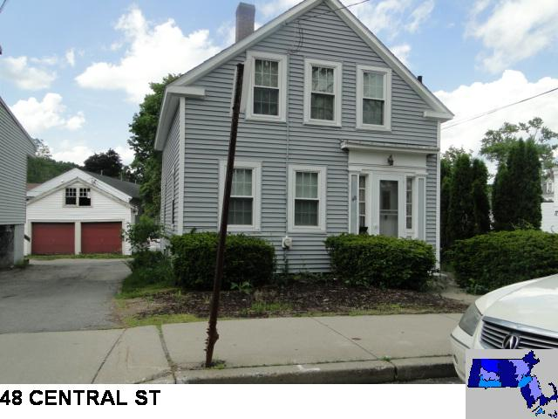
Sale Price = $297,500 Sale Date = 10/22/21
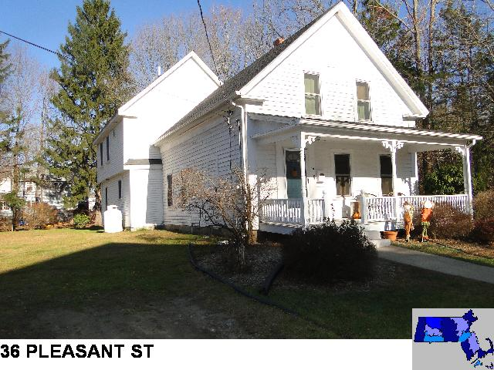
Sale Price = $487,500 Sale Date = 11/5/2021

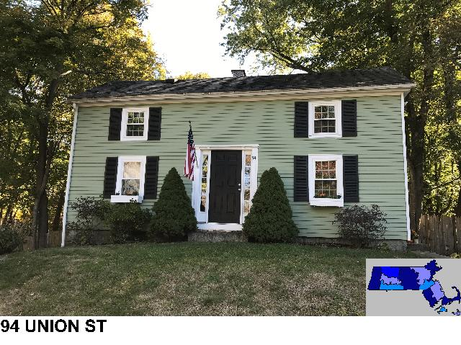
Sale Price = $500,000 Sale Date = 11/18/2021
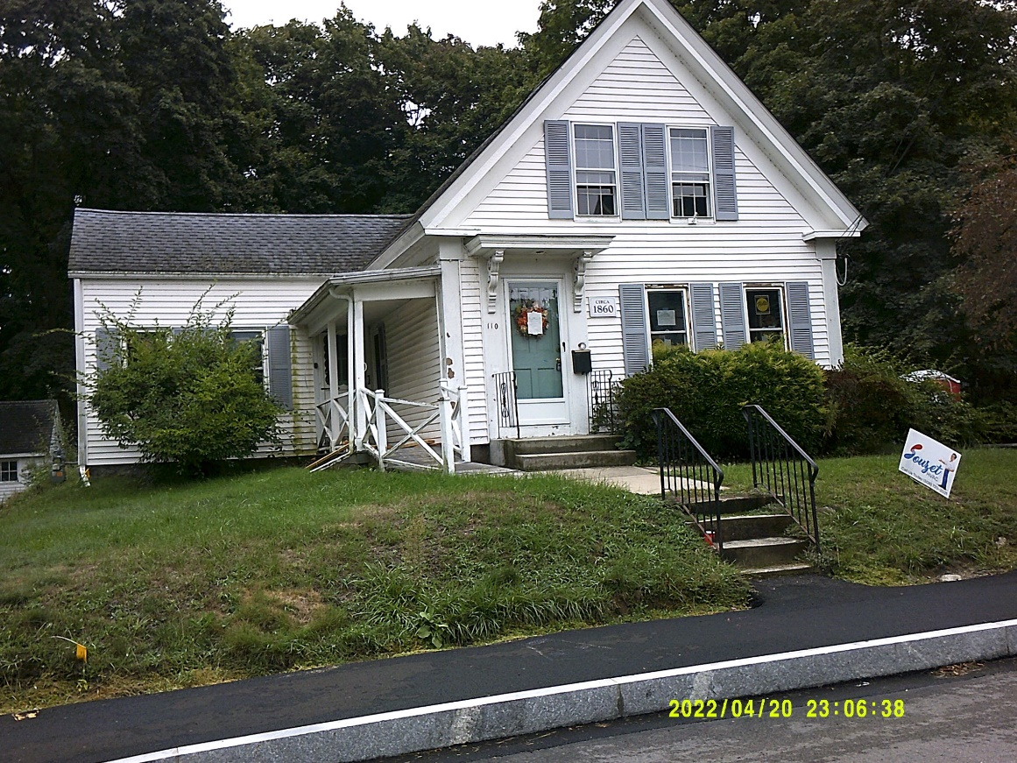
110 Union St
Sale Price = $270,000 Sale Date = 11/18/2021
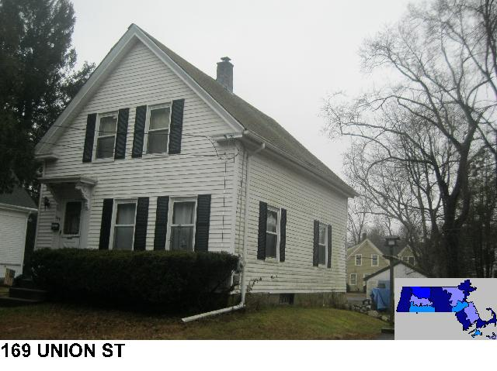
Sale Price = $334,000 Sale Date 11/23/2021

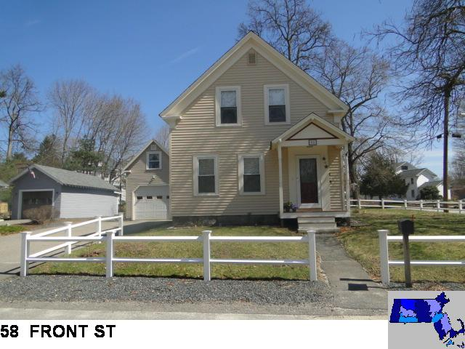
Sale Price = $442,500 Sale Date = 12/9/2021

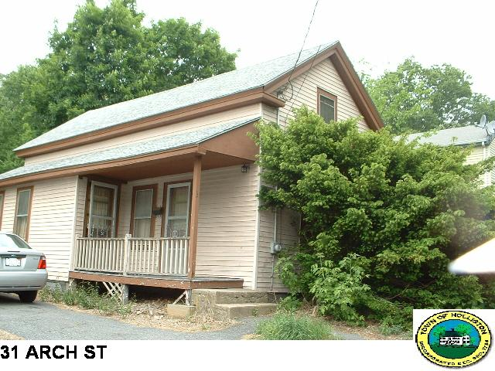
Sale Price = $200,000 Sale Date = 12/17/2021

Contemporary

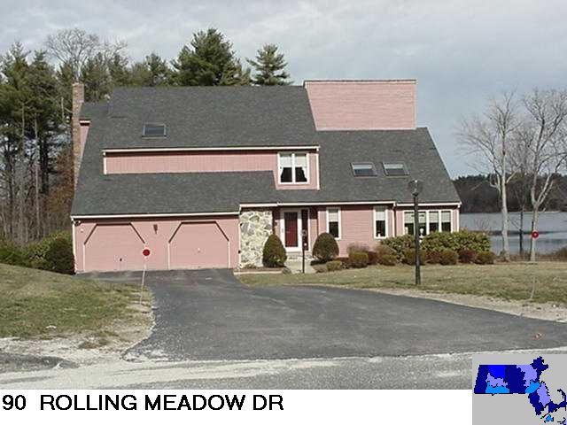
Sale Price = $735,000 Sale Date = 1/4/2021

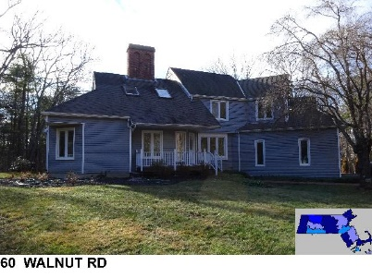
Sale Price = $725,000 Sale Date – 3/26/2021
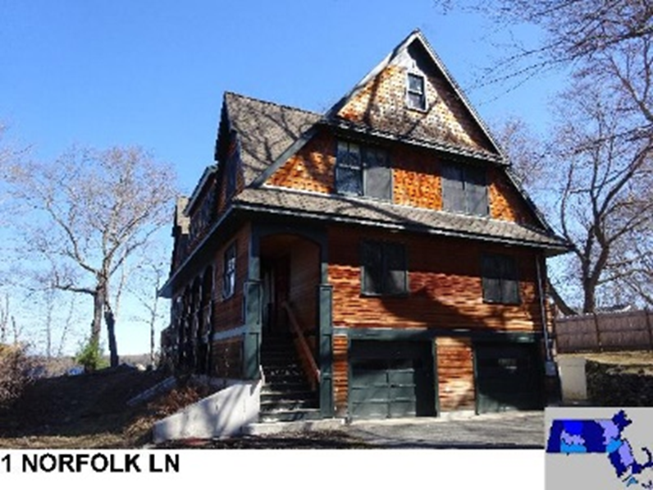
Sale Price = $1,400,000 Sale Date = 5/12/2021

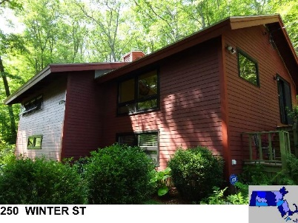
Sale Price = $675,000 Sale Date = 7/30/2021

Garrison

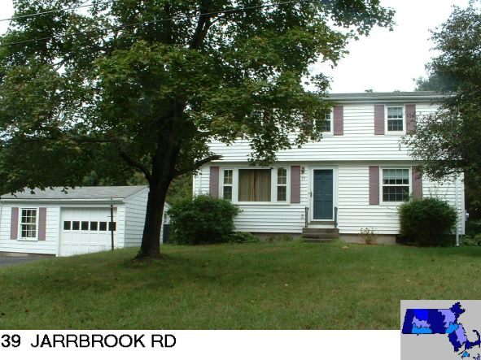
Sale Price = $460,000 Sale Date = 2/4/2021

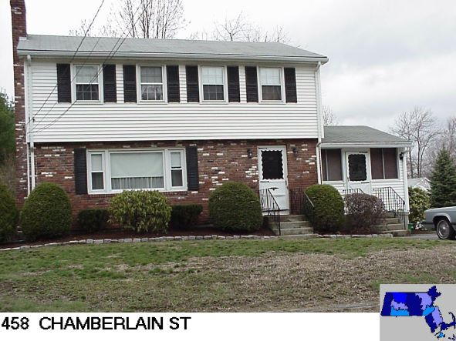
Sale Price = $484,900 Sale Date = 2/23/2021

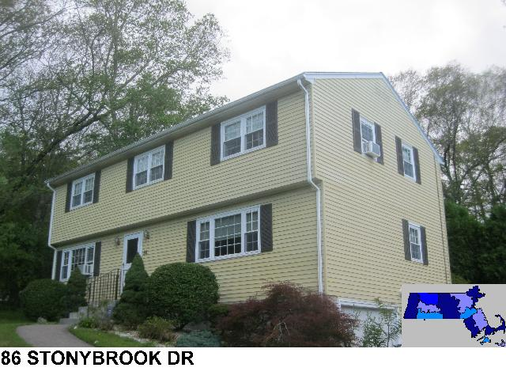
Sale Price = $524,903 Sale Date = 4/21/2021

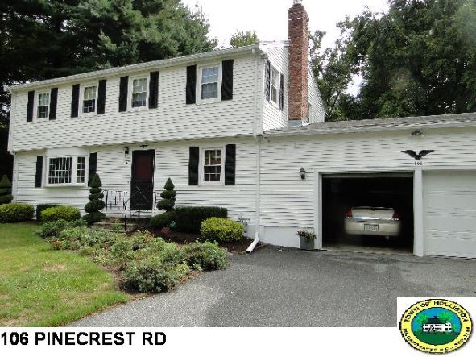
Sale Price = $660,000 Sale Date = 4/23/2021

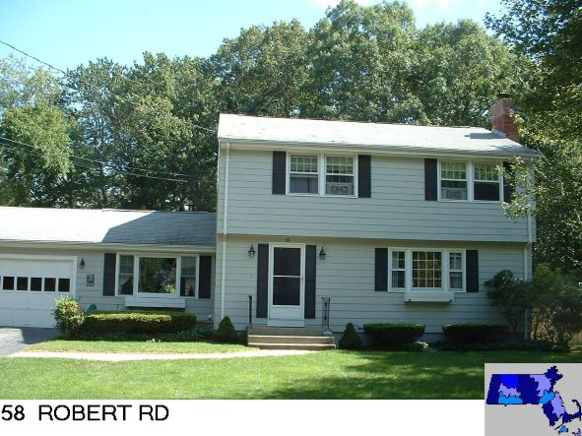
Sale Price = $595,000 Sale Date = 5/27/2021

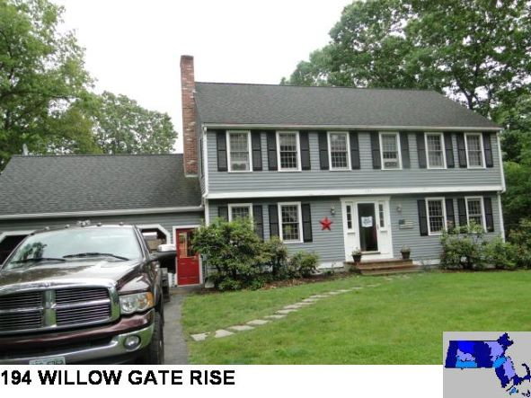
Sale Price = $853,000 Sale Date = 6/14/2021
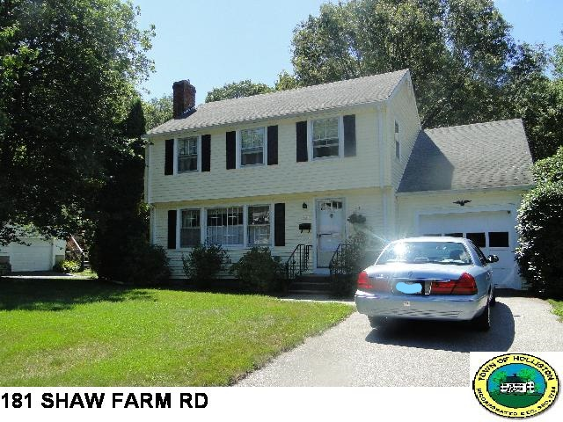
Sale Price = $540,000 Sale Date = 6/18/2021

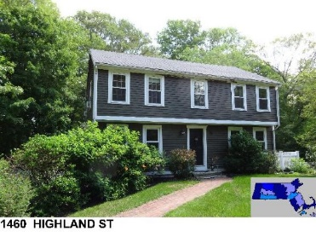
Sale Price = $630,000 Sale Date = 6/23/2021
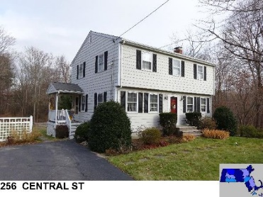
Sale Price = $575,000 Sale Date = 7/15/2021

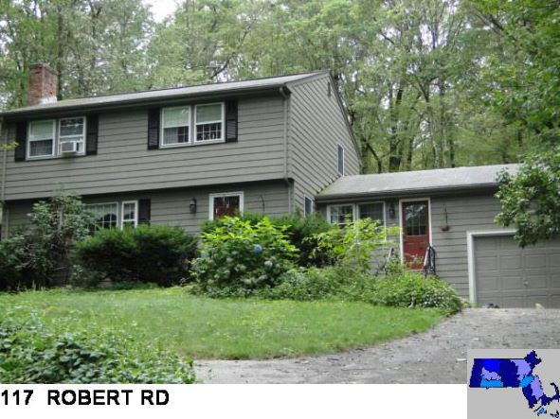
Sale Price = $660,000 Sale Date = 7/22/2021

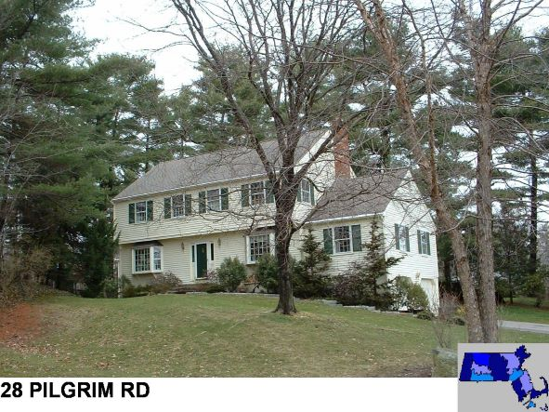
Sale Price = $645,000 Sale Date = 7/29/2021

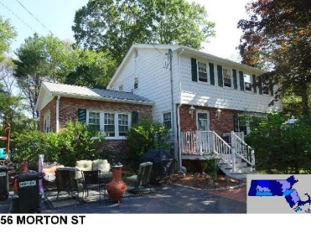
Sale Price = $610,000 Sale Date 7/30/2021

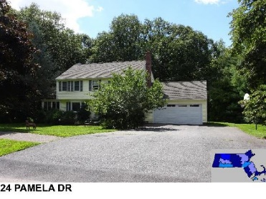
Sale Price = $718,500 Sale Date 8/16/2021

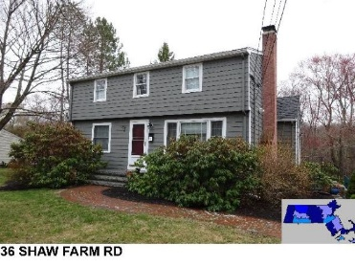
Sale Price = $485,000 Sale Date = 8/20/2021
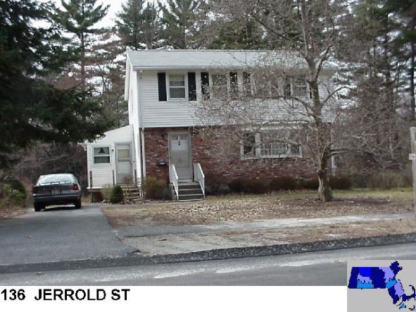
Sale Price = $601,000 Sale Date = 9/29/2021

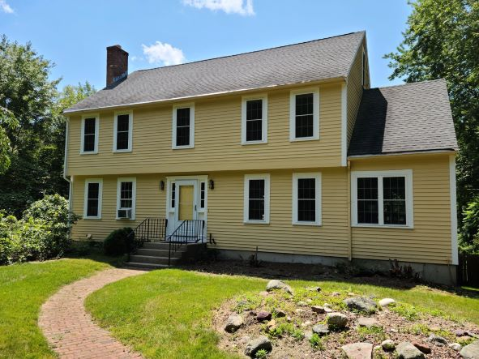

745 Highland Street

Sale Price = $685,000 Sale Date = 10/15/2021

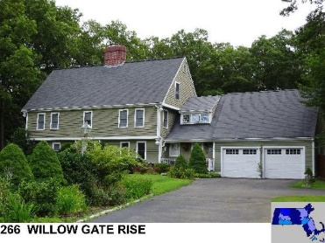
Sale Price = $925,000 Sale Date = 10/18/2021

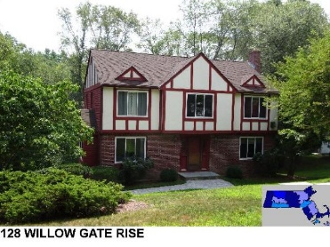
Sale Price = $625,000 Sale Date = 12/03/2021

Raised Cape
&
Cape Cod

Raised Cape
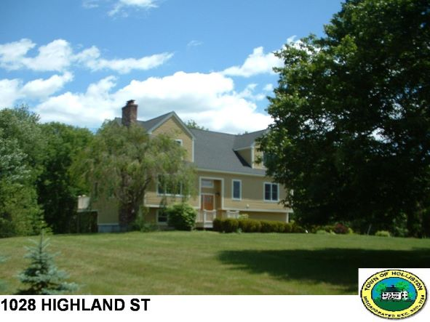
Sale Price = $760,000 Sale Date = 4/06/2021

Cape Cod
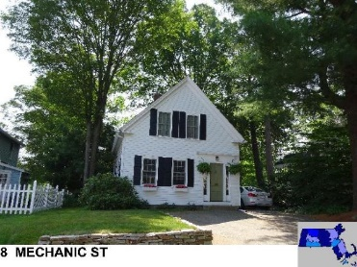
Sale Price = $440,000 Sale Date = 5/11/2021
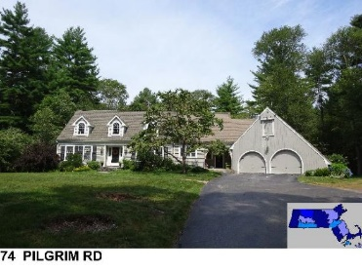
Sale Price = $910,000 Sale Date = 5/26/2021

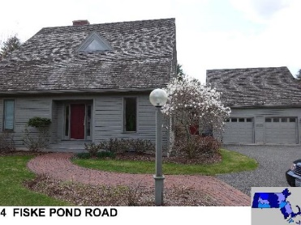
Sale Price = $960,000 Sale Date = 5/27/2021

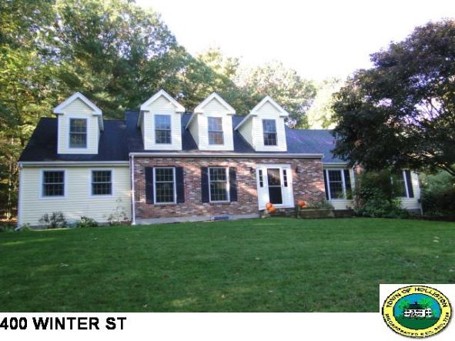
Sale Price = $899,000 Sale Date = 6/10/2021

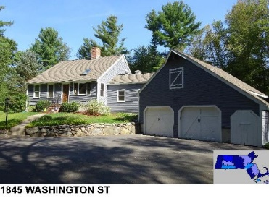
Sale Price = $635,000 Sale Date = 6/24/2021
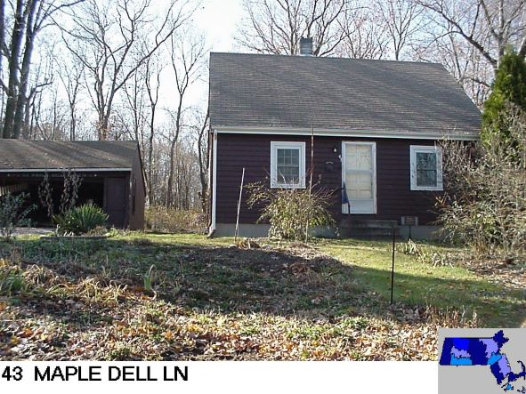
Sale Price = $420,000 Sale Date = 6/28/2021

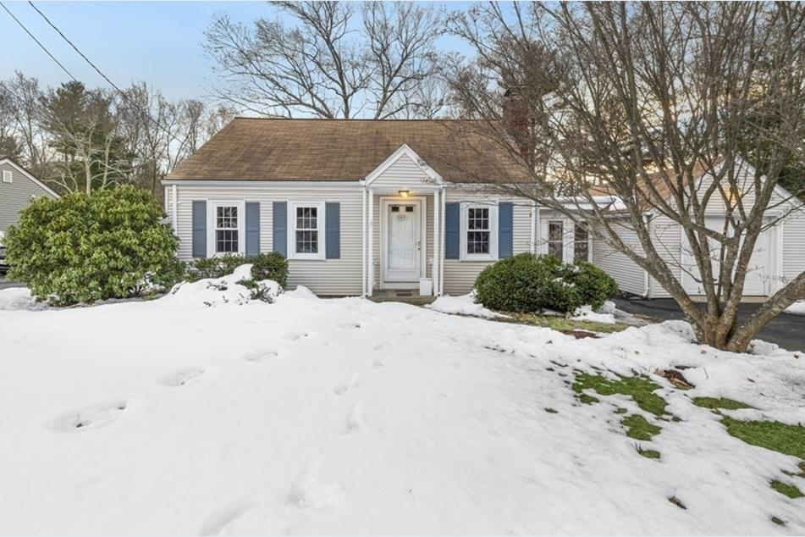
202 Ashland St
Sale Price = $425,000 Sale Date = 6/29/2021

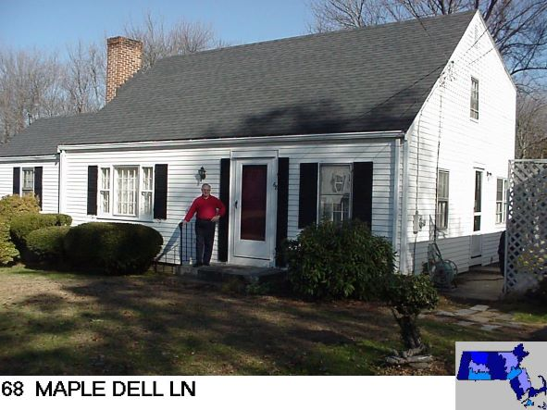
Sale Price = $455,000 Sale Date = 7/29/2021

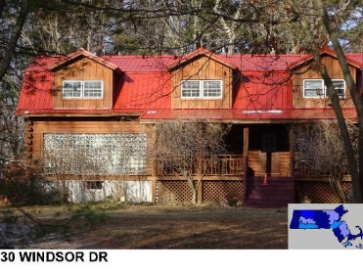
Sale Price = $675,000 Sale Date = 9/27/2021

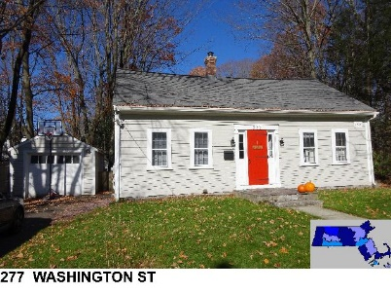
Sale Price = $437,000 Sale Date = 9/30/2021

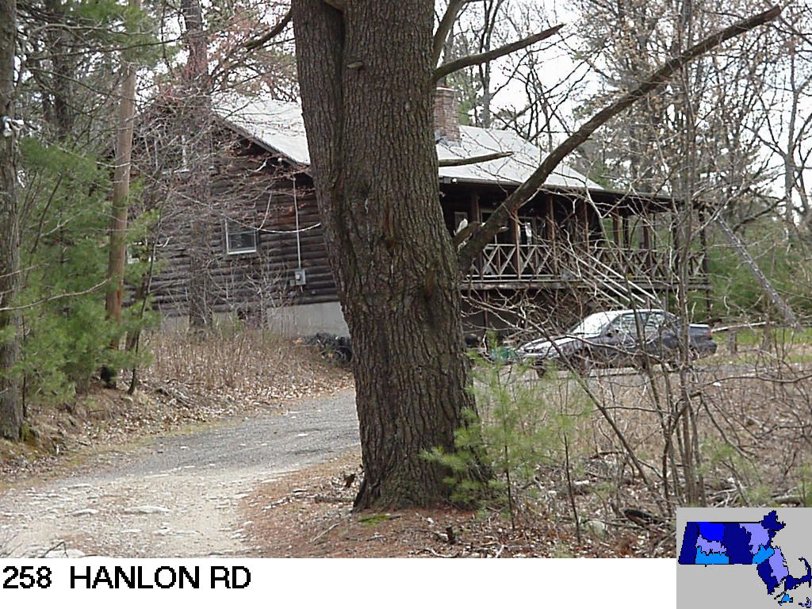
Sale Price =$552,900 Sale Date = 12/8/2021
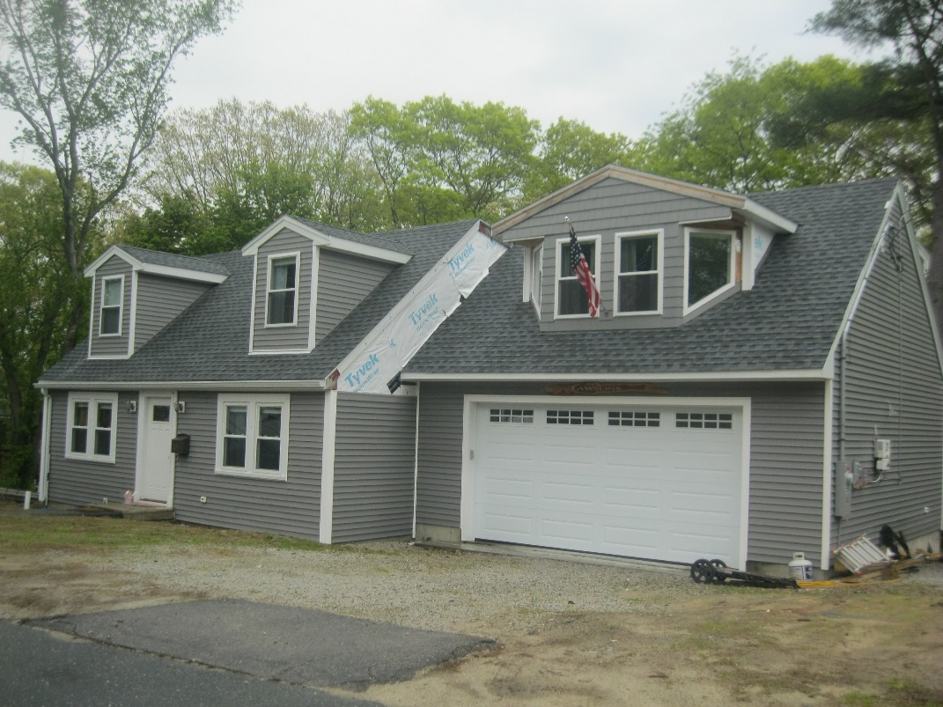
6 Skyview Terr.
Sale Price = $675,000 Sale Date = 12/15/2021

Colonial &
New Colonial

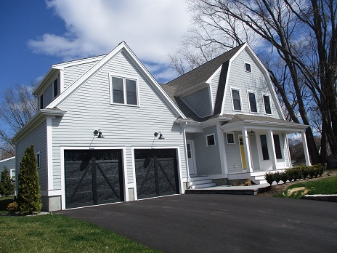
24 Spring St.
Sale Price = $799,900 Sale Date = 1/5/2021

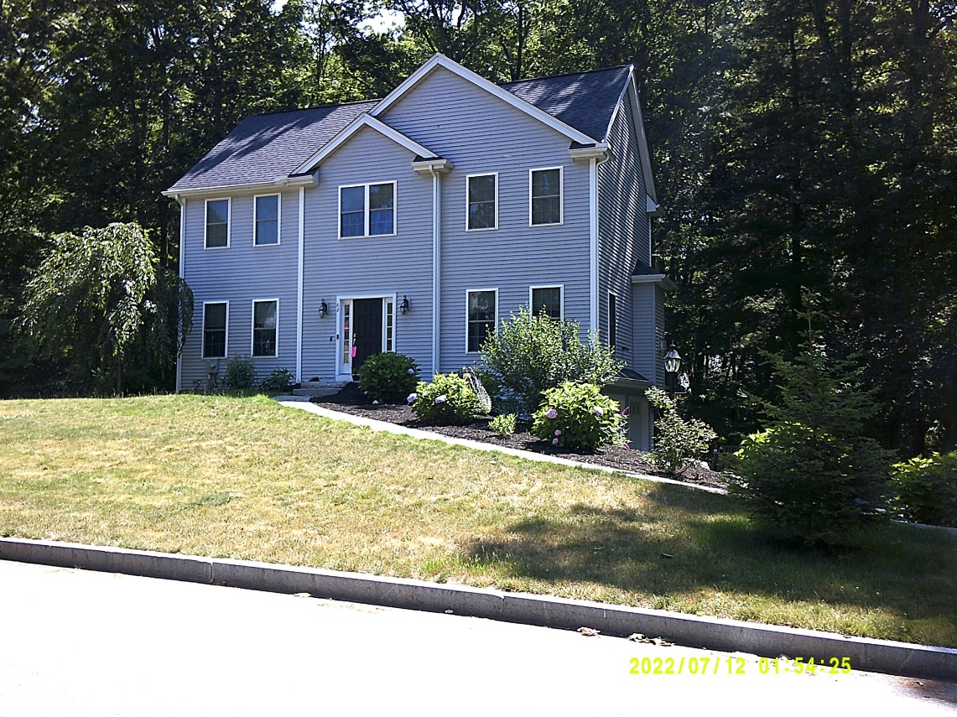
62 Indian Ridge South
Sale Price = 660,000 Sale Date = 1/8/2021
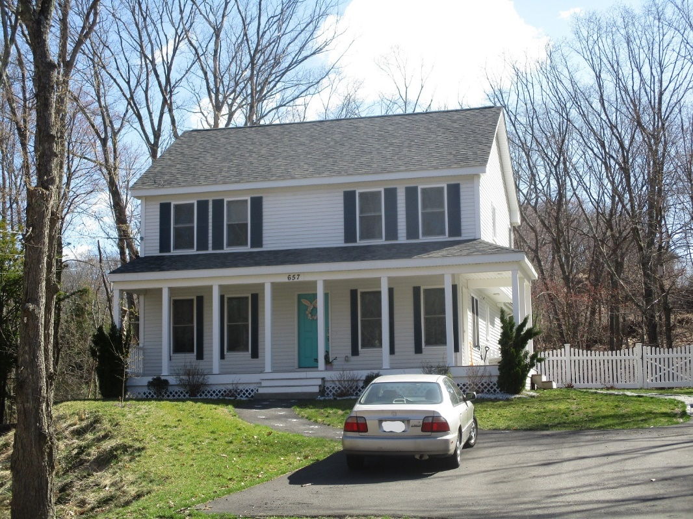
657 Concord St.
Sale Price = $540,000 Sale Date = 1/19/2021

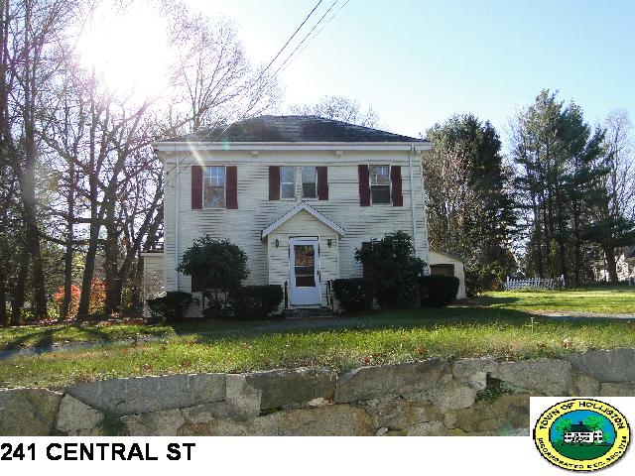
Sale Price = $470,400 Sale Date = 1/20/2021

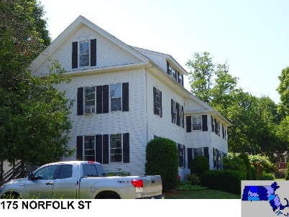
Sale Price = $580,000 Sale Date = 1/29/2021

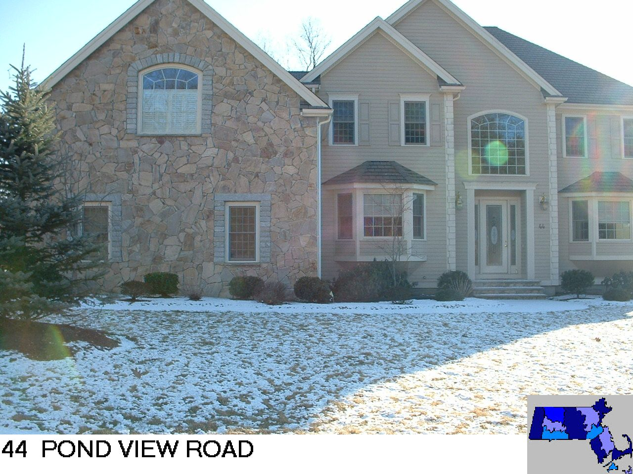
Sale Price = $915,000 Sale Date = 1/29/2021
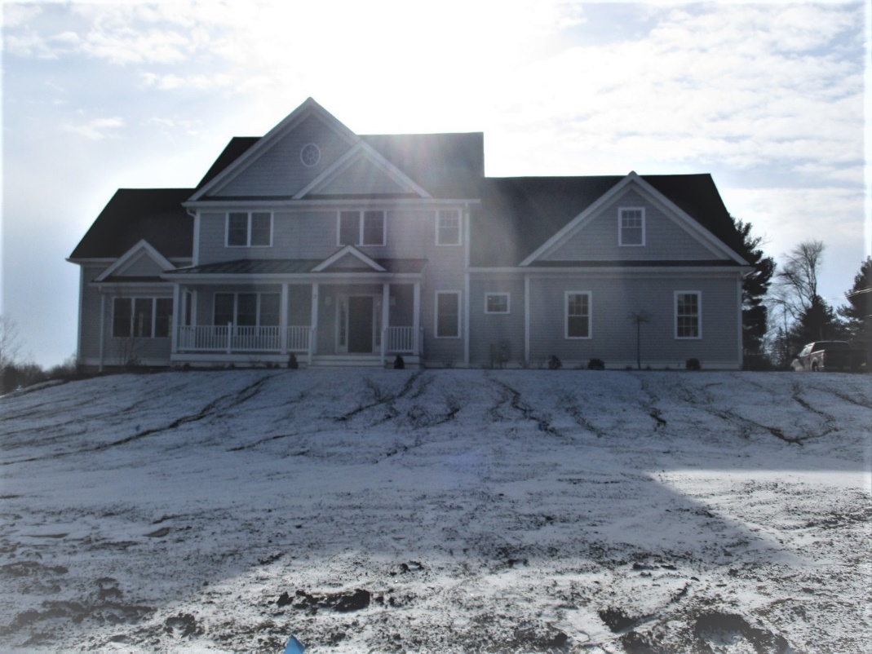
3 Summitpointe Dr.
Sale Price = $1,143,094 Sale Date = 1/29/2021

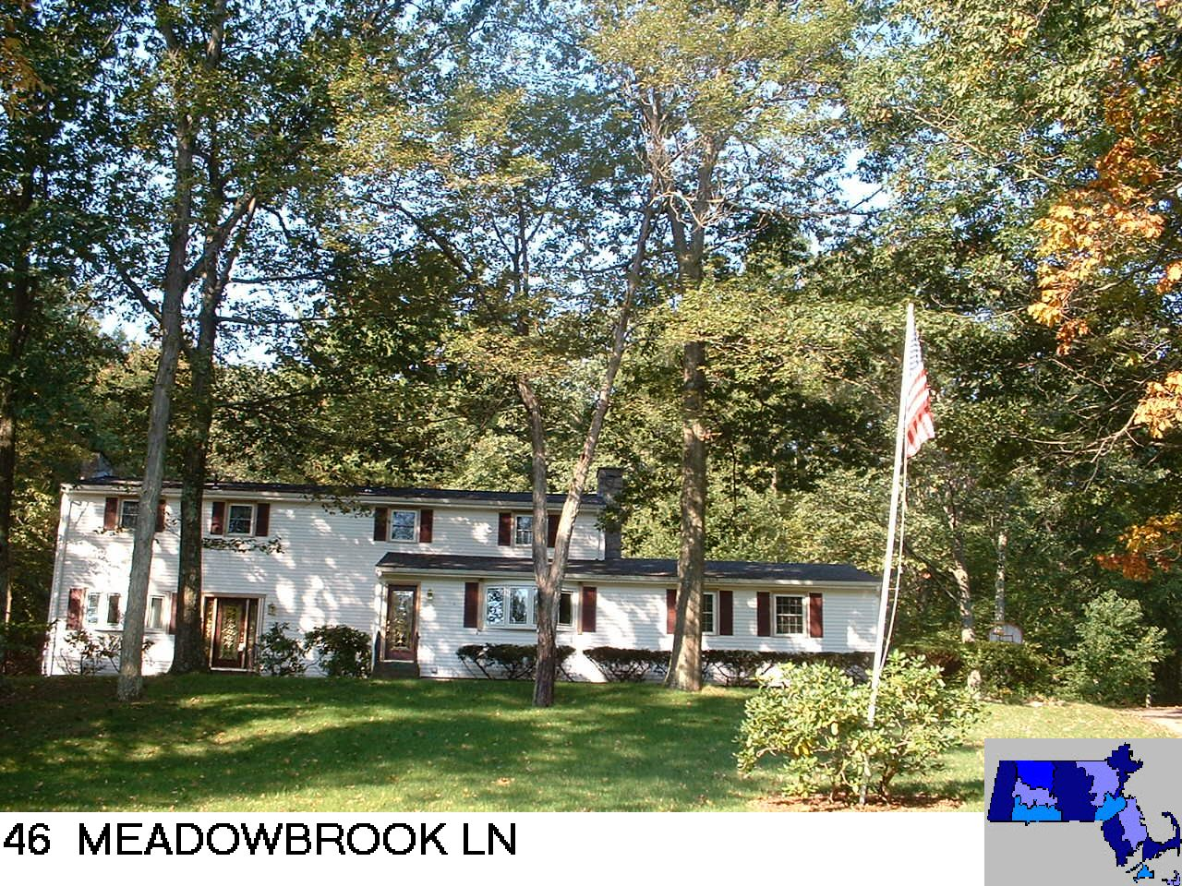
Sale Price = $625,000 Sale Date = 2/11/2021

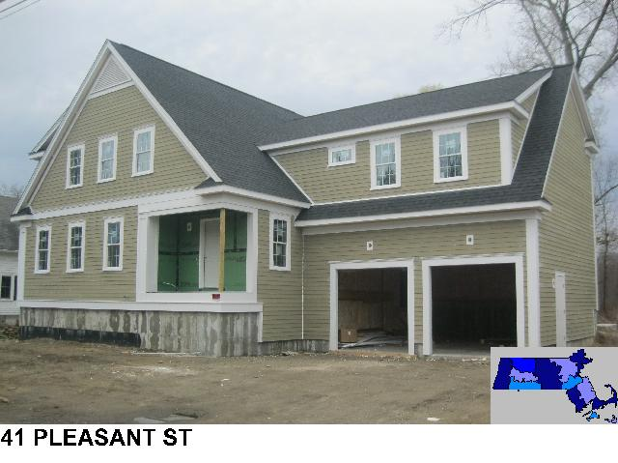
Sale Price = $815,000 Sale Date = 2/19/2021

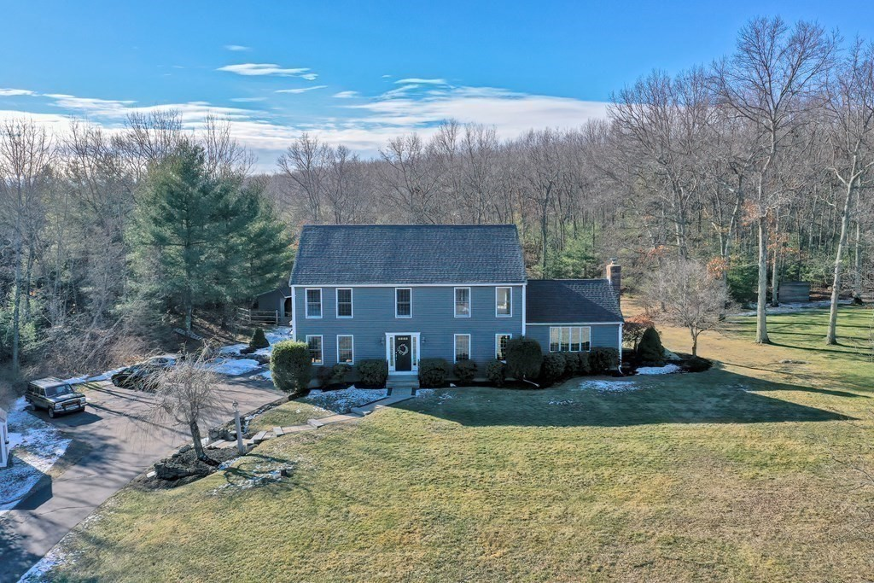
740 Prentice St.
Sale Price = $775,000 Sale Date = 2/22/2021

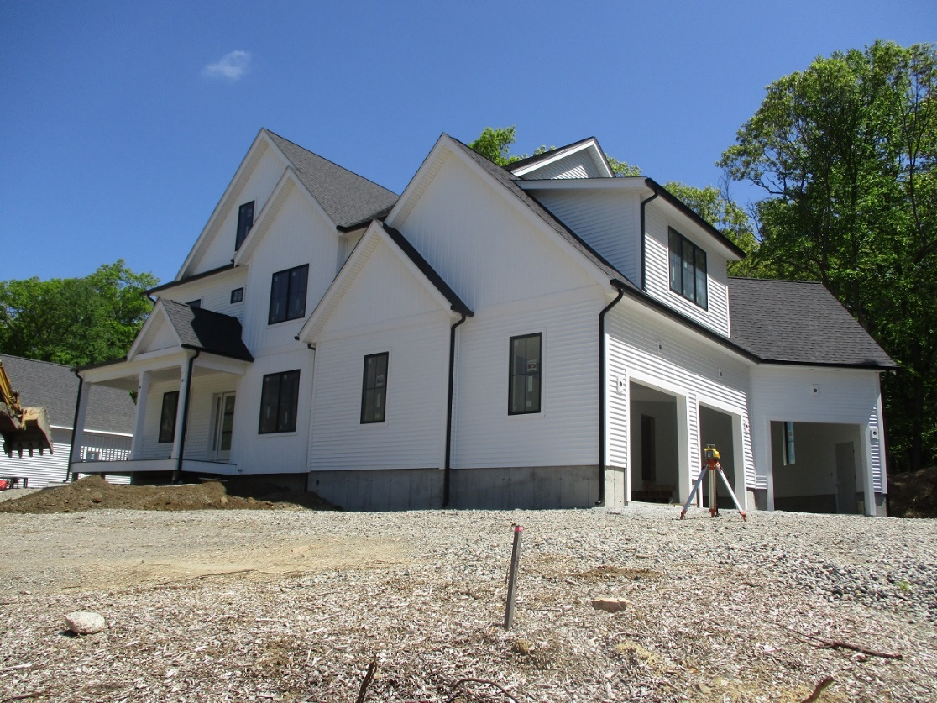
7 Liberty Ln.
Sale Price = $1,140,000 Sale Date = 2/23/2021

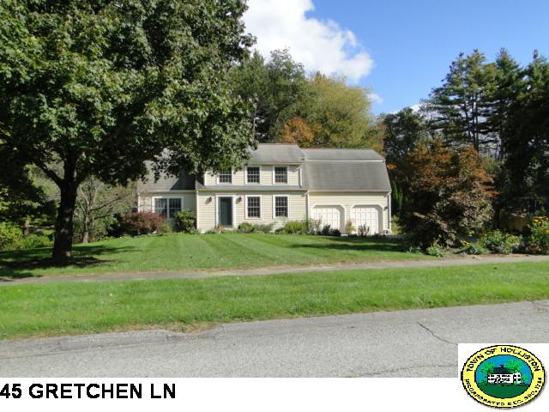
Sale Price = $634,900 Sale Date = 2/25/2021
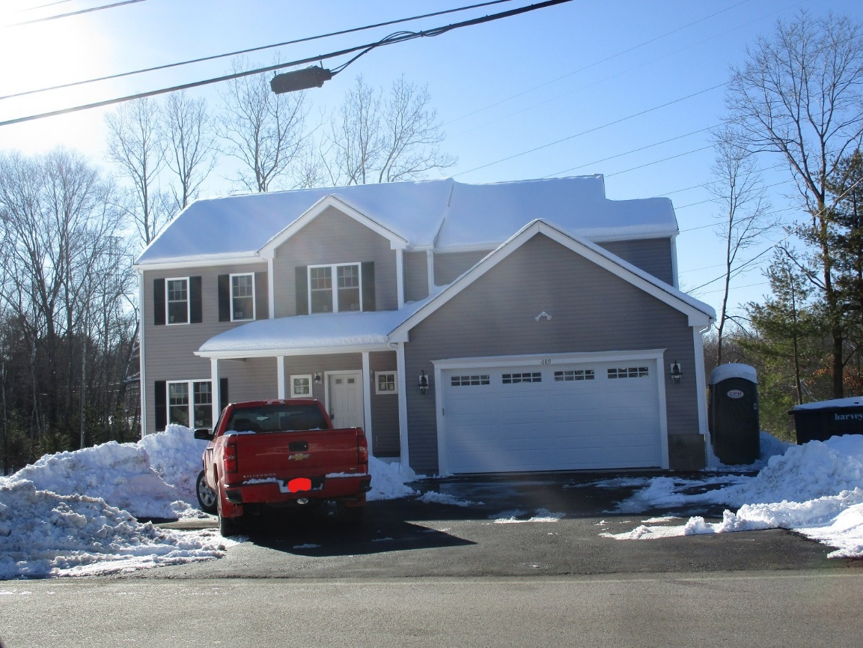
689 Norfolk St.
Sale Price = $675,000 Sale Date = 3/2/2021

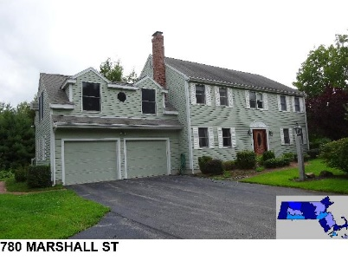
Sale Price = $810,000 Sale Date = 3/10/2021
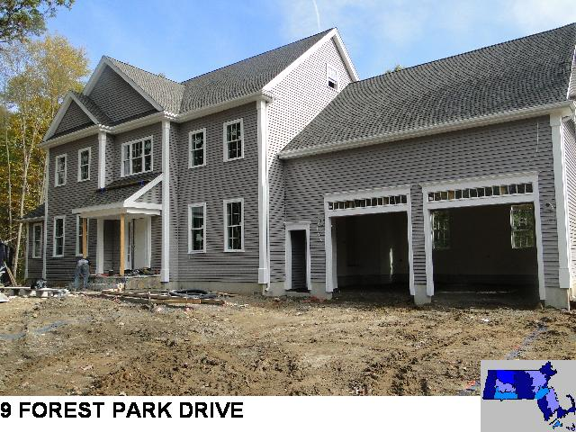
Sale Price = $955,000 Sale Date = 3/25/2021

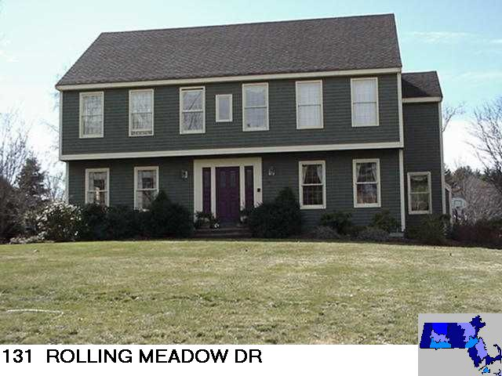
Sale Price - $796,500 Sale Date = 3/26/2021
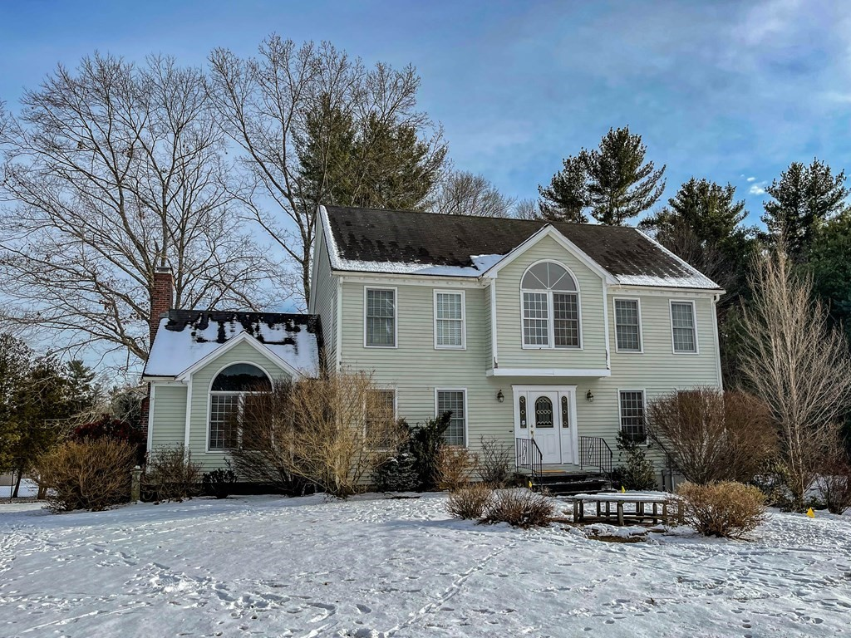
8 Lone Oak Cir.
Sale Price = $580,000 Sale Date 3/30/2021

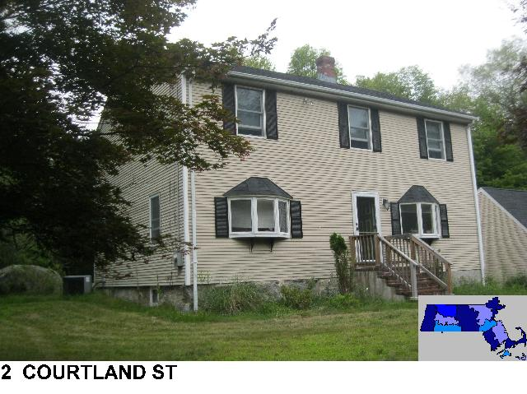
Sale Price = $595,000 Sale Date = 4/15/2021
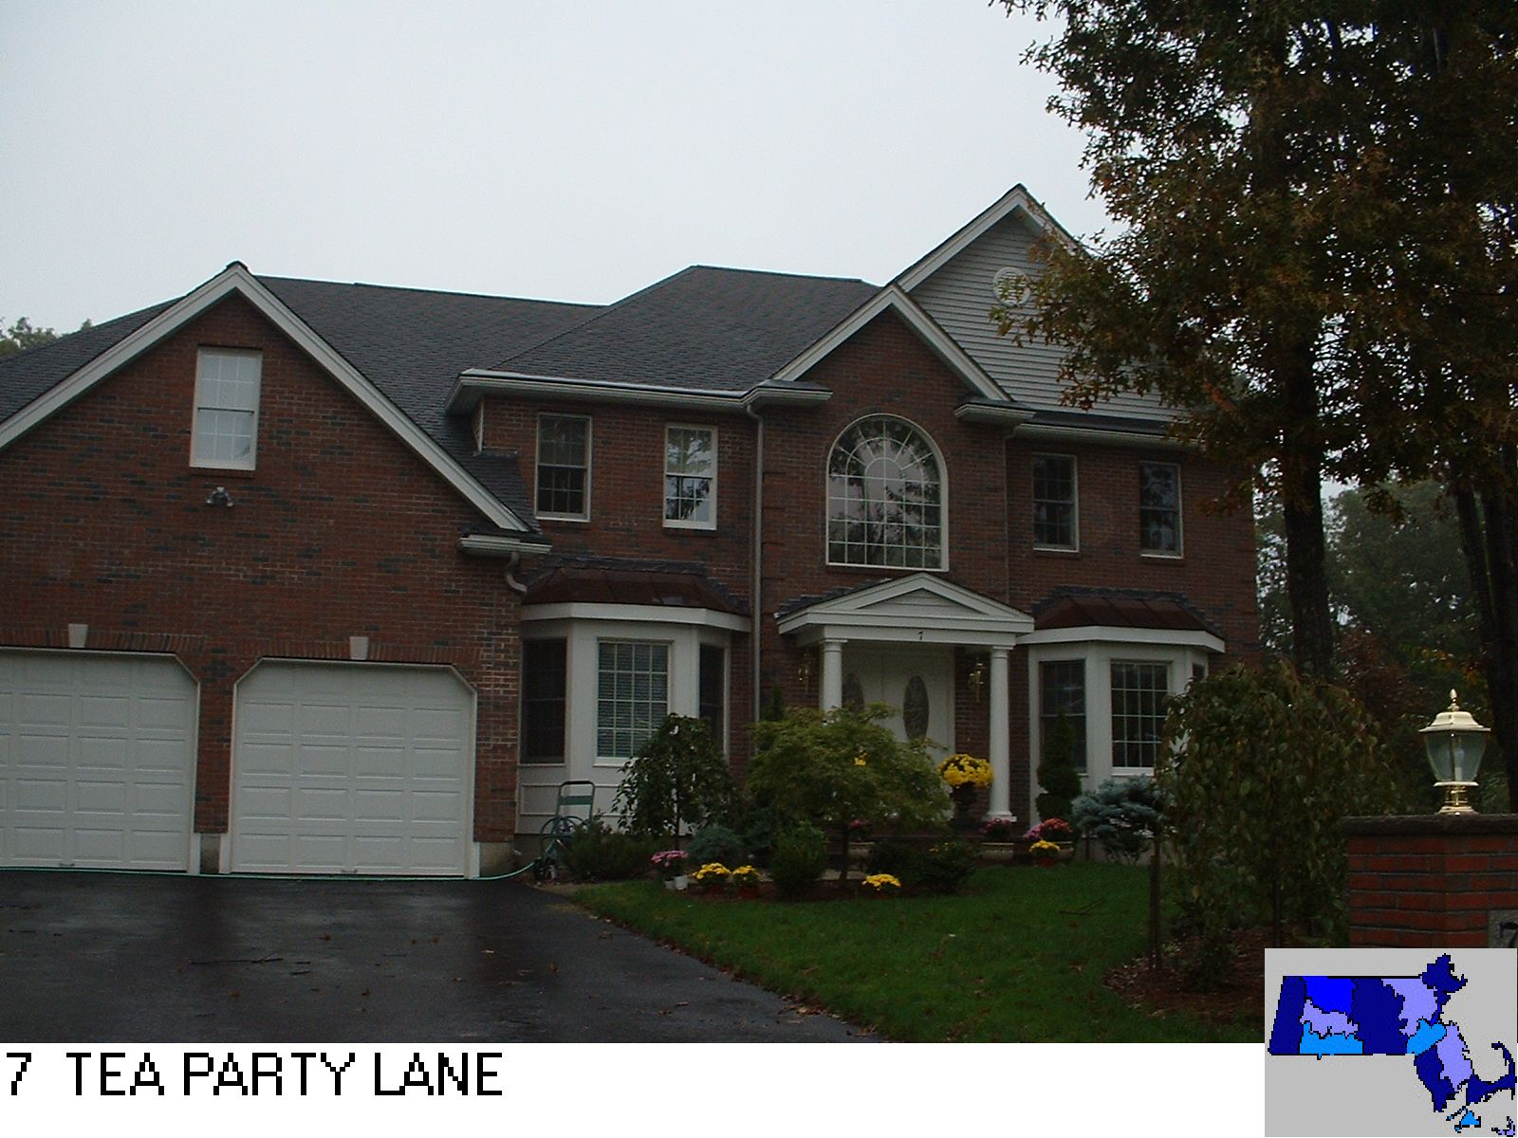
Sale Price = $900,000 Sale Date = 4/16/2021

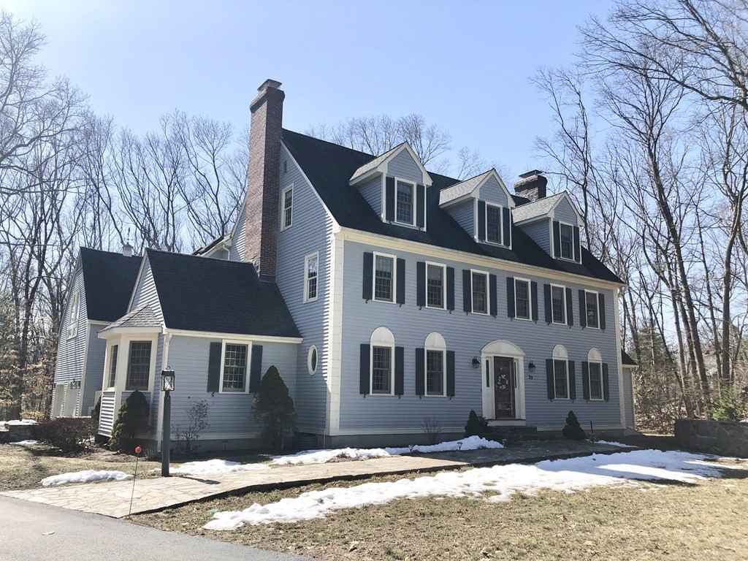
29 Foxwood Cove
Sale Price = $850,000 Sale Date 4/23/2021
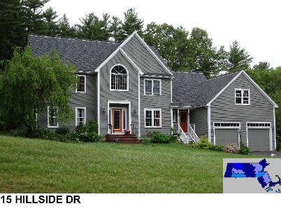
Sale Price = $935,000 Sale Date 4/28/2021

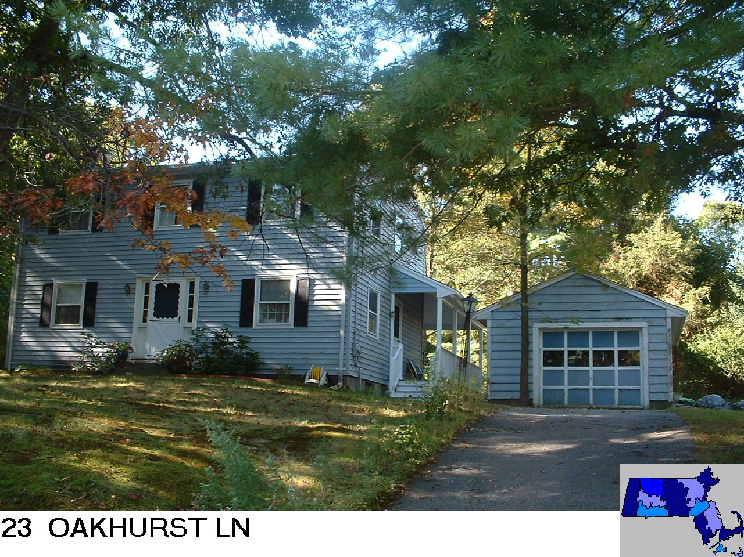
Sale Price = $410,000 Sale Date = 5/3/2021

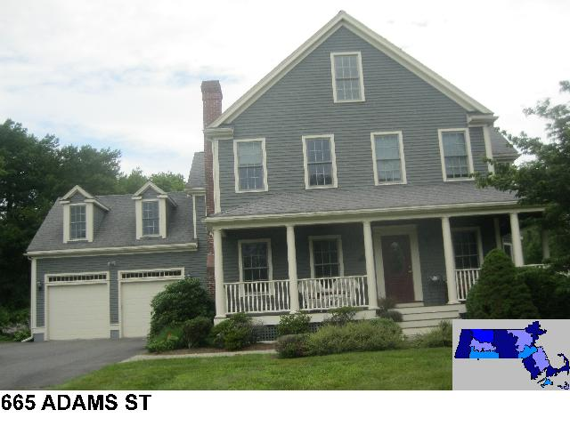
Sale Price = $1,295,000 Sale Date = 5/5/2021

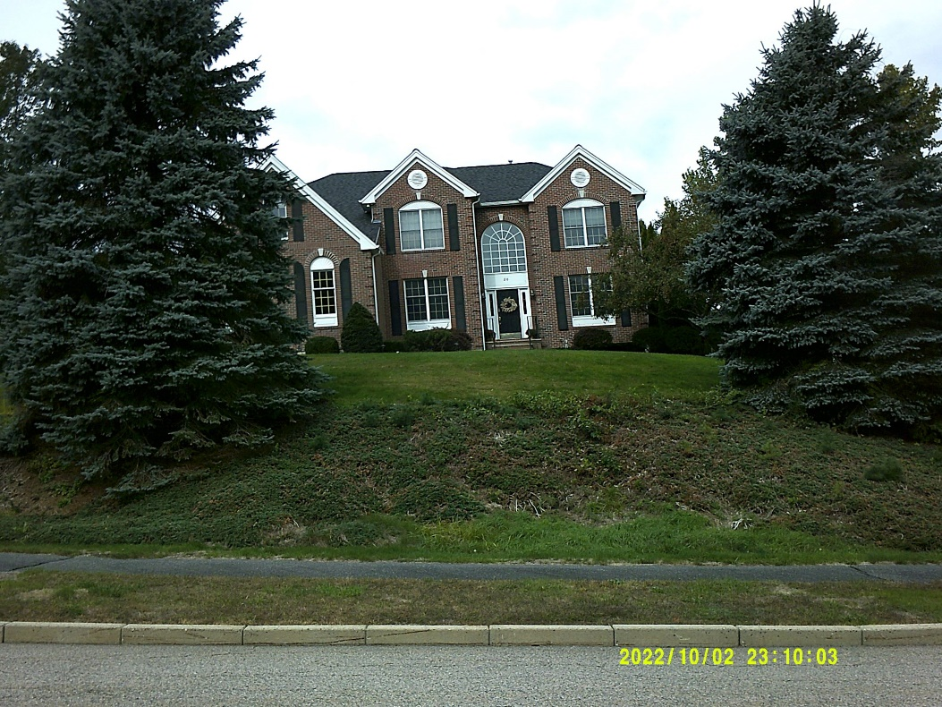
20 Partridge Way
Sale Price = $865,000 Sale Date = 5/7/2021
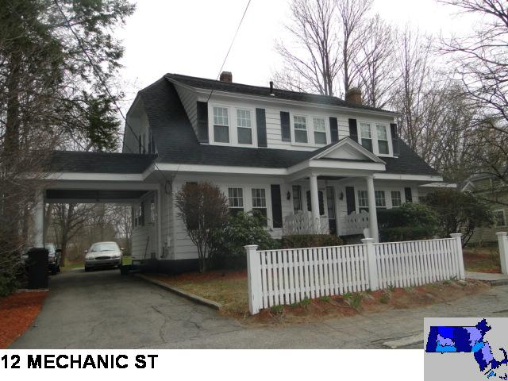
Sale Price = $430,000 Sale Date = 5/12/2021

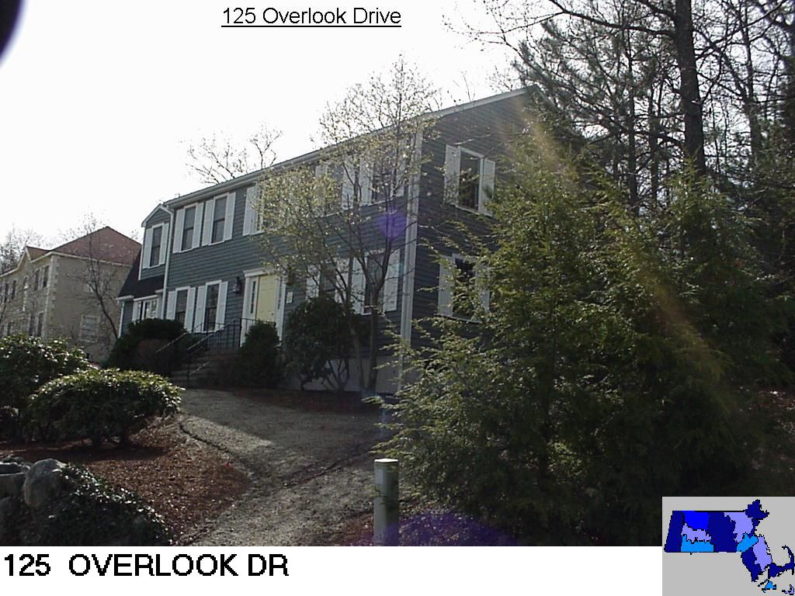
Sale Price = $659,125 Sale Date = 5/14/2021
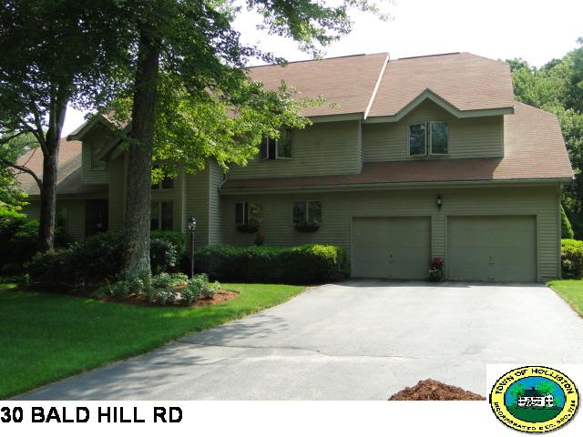
Sale Price = $829,000 Sale Date = 5/14/2021

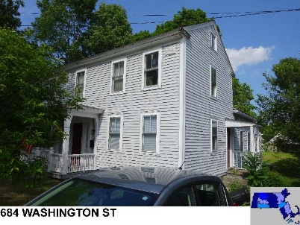
Sale Price = $540,000 sale Date = 5/18/2021

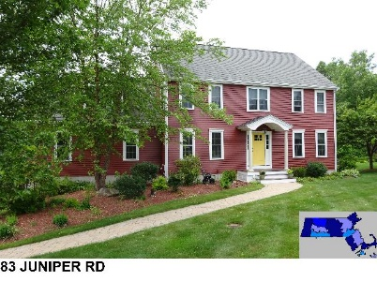
Sale Price = $875,000 Sale Date = 5/21/2021

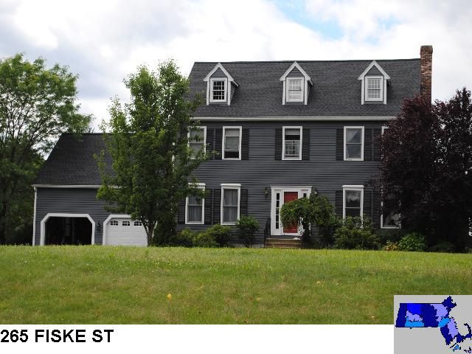
Sale Price = $718,000 Sale Date = 5/26/2021
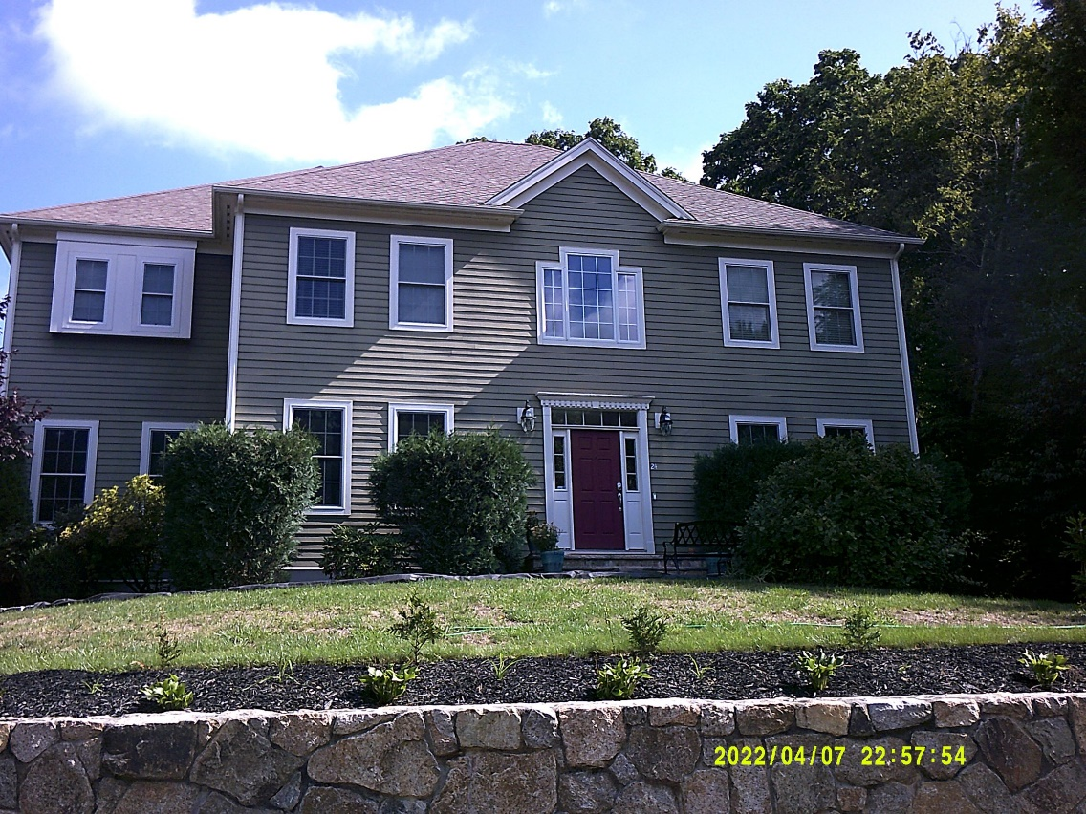
24 Kingsbury Dr.
Sale Price = $975,000 Sale Date = 5/26/2021

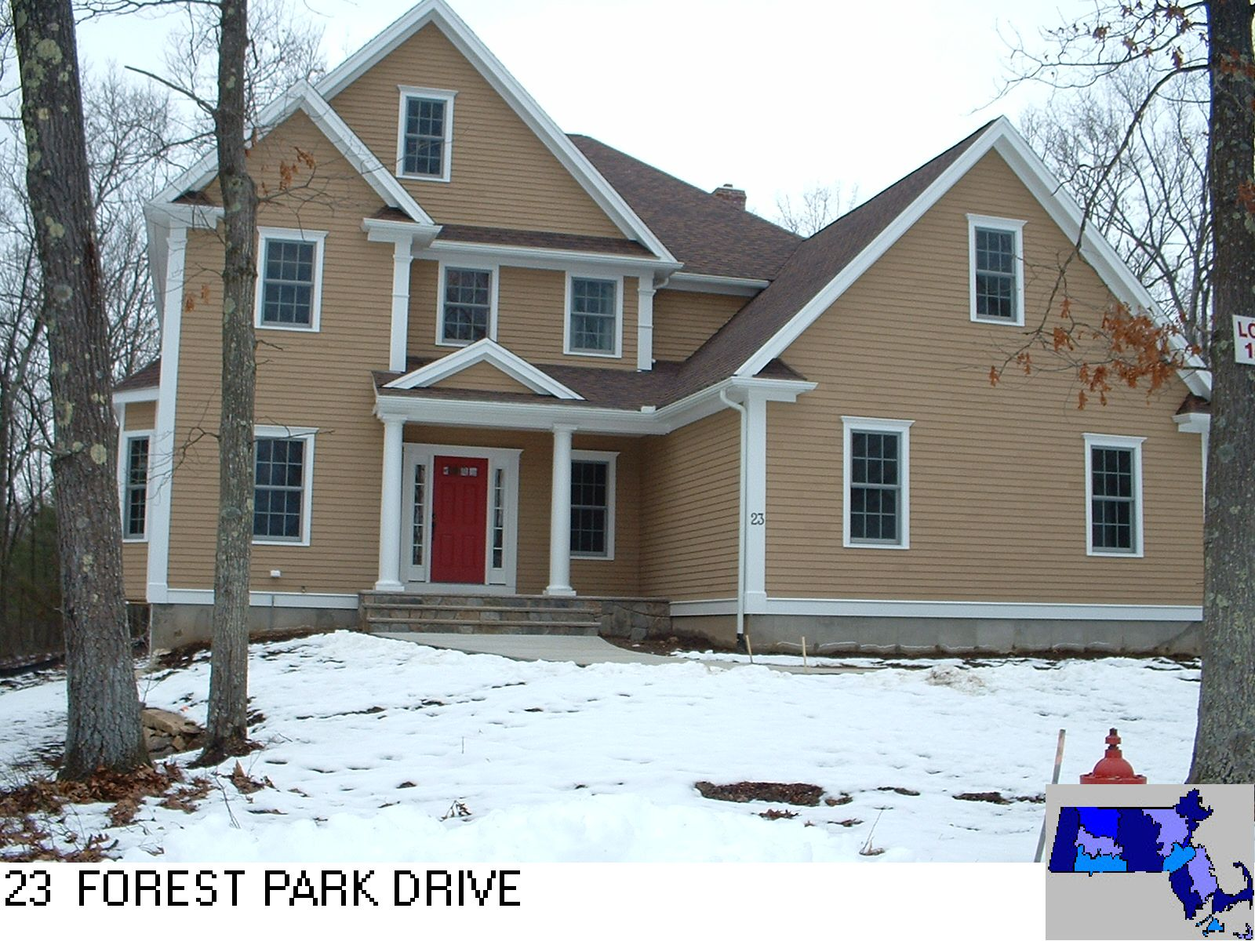
Sale Price = $990,000 Sale Date = 6/1/2021
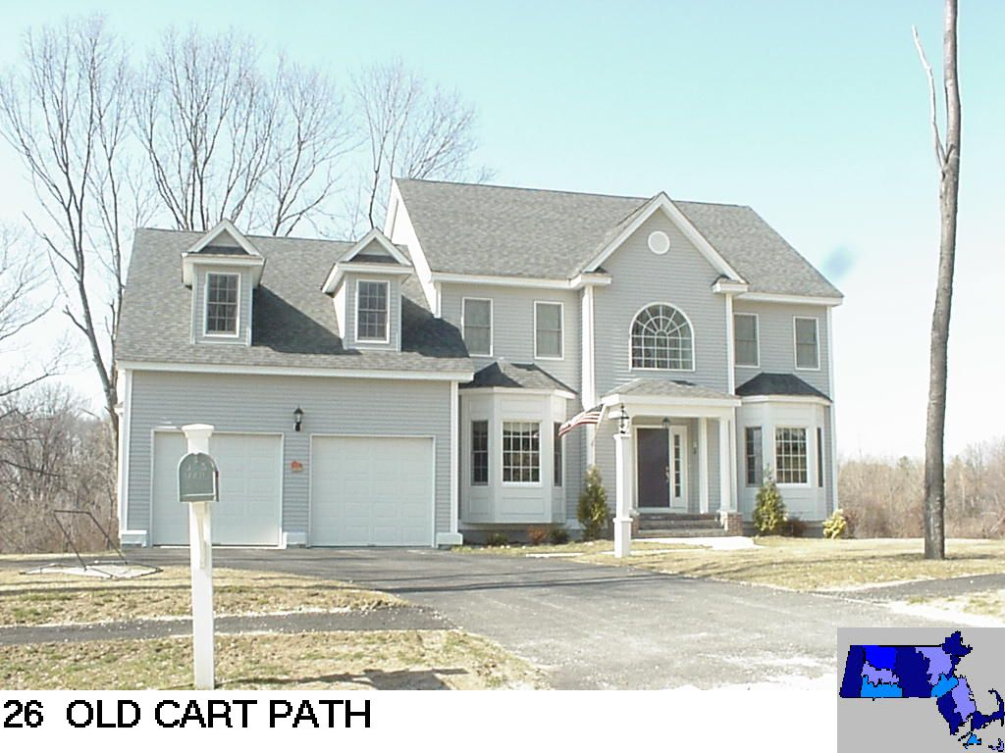
Sale Price = $842,500 Sale Date = 6/16/2021

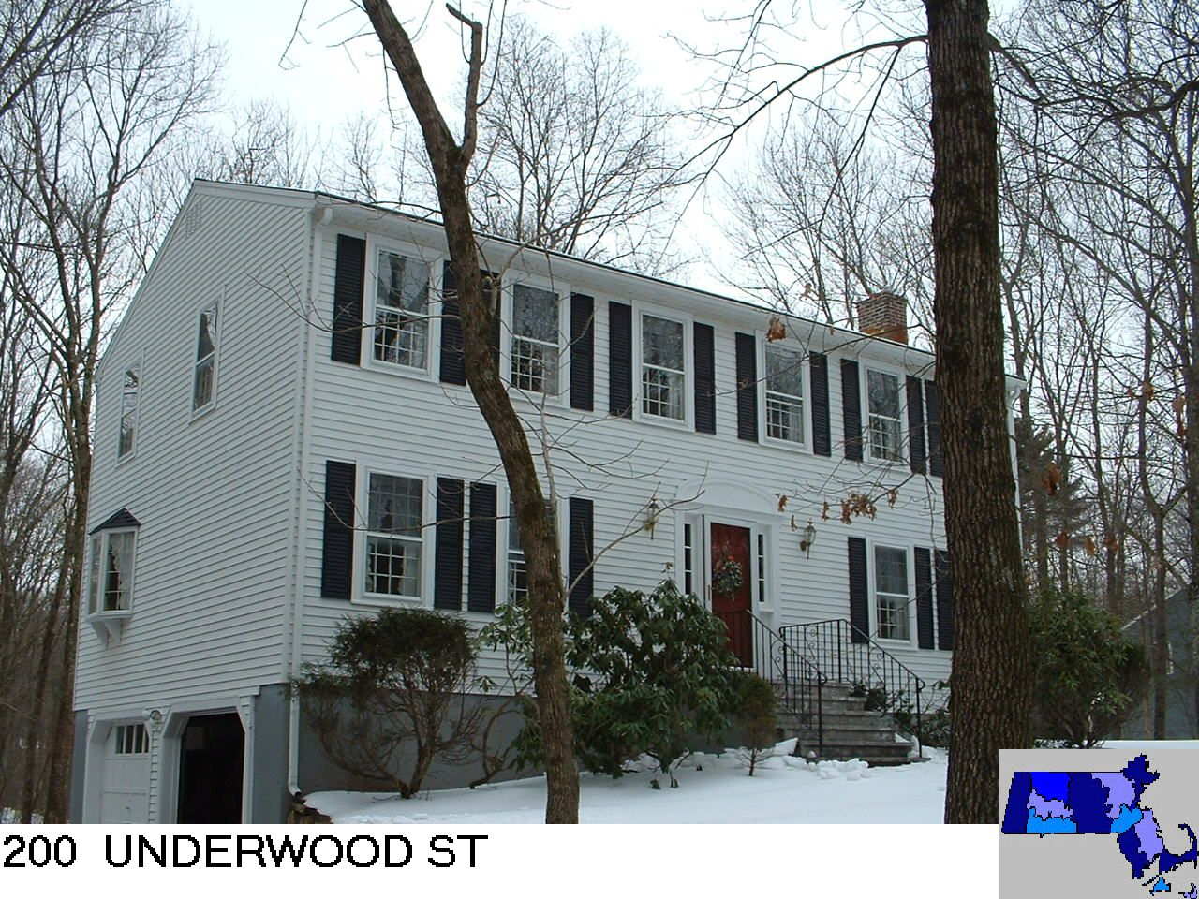
Sale Price = $600,000 Sale Date 6/18/2021
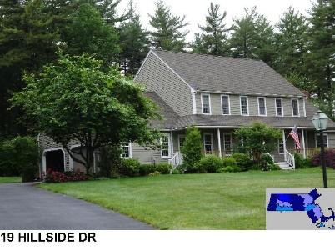
Sale Price = $957,500 Sale Date = 6/18/2021

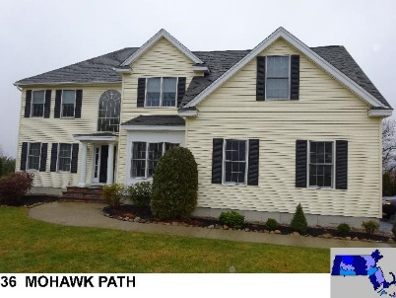
Sale Price = $920,000 Sale Date = 6/21/2021

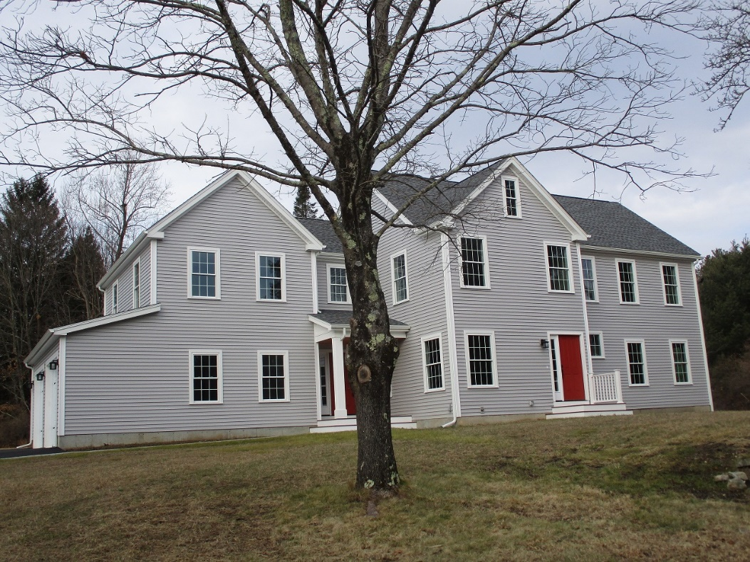
607 Marshall St.
Sale Price = $867,530 Sale Date = 6/23/2021

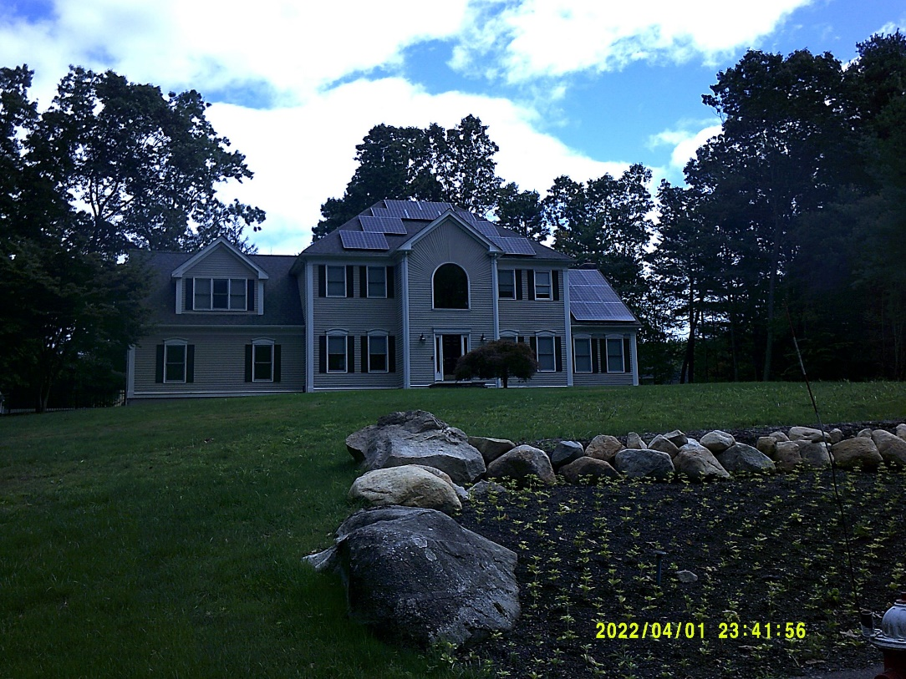
55 Alberta Ln.
Sale Price = $925,000 Sale Date = 6/23/2021
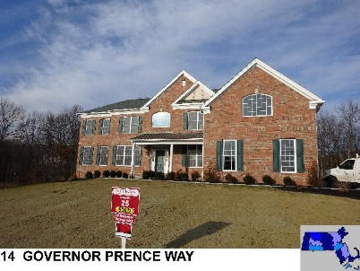
Sale Price = $1,100,000 Sale Date = 6/25/2021

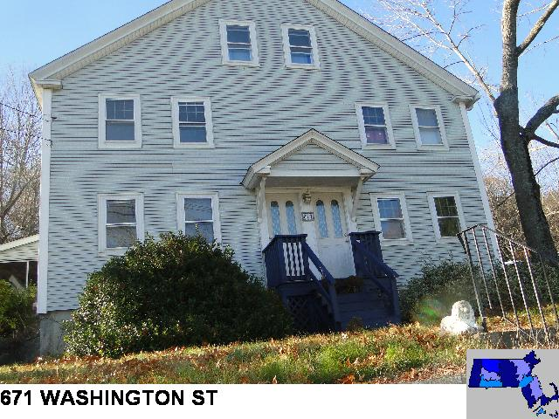
Sale Price = $570,000 Sale Date = 6/28/2021

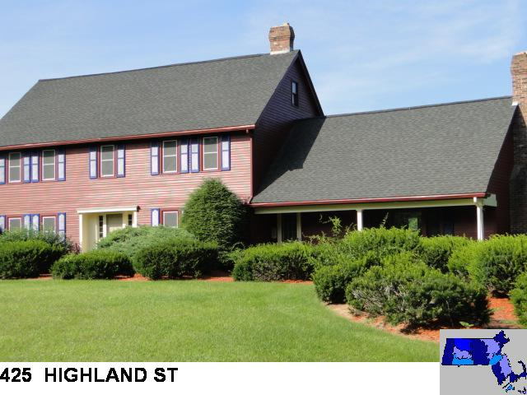
Sale Price = $808,000 Sale Date = 6/29/2021

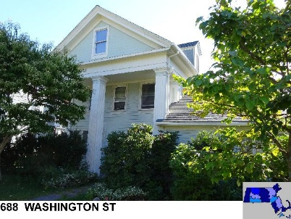
Sale Price = $650,000 Sale Date = 6/29/2021
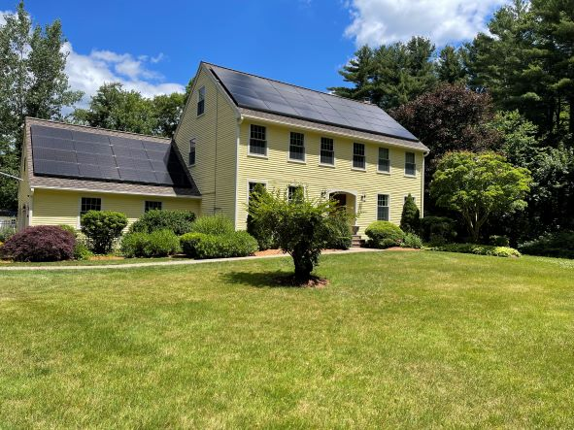
55 Hanlon Rd.
Sale Price = $921,000 Sale Date = 6/30/2021

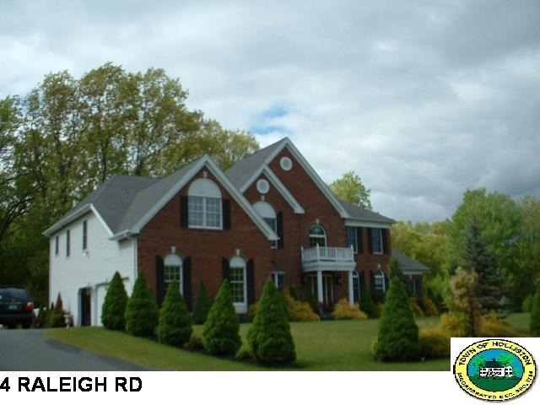
Sale Price = $918,000 Sale Date = 6/30/2021
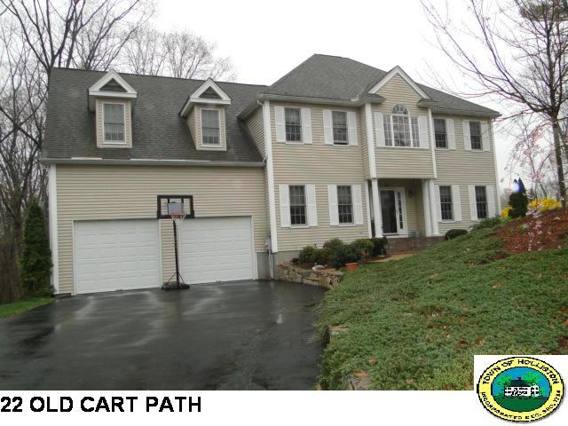
Sale Price = $815,000 Sale Date = 6/30/2021

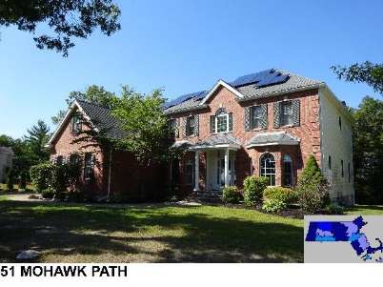
Sale Price = $975,000 Sale Date = 6/30/2021
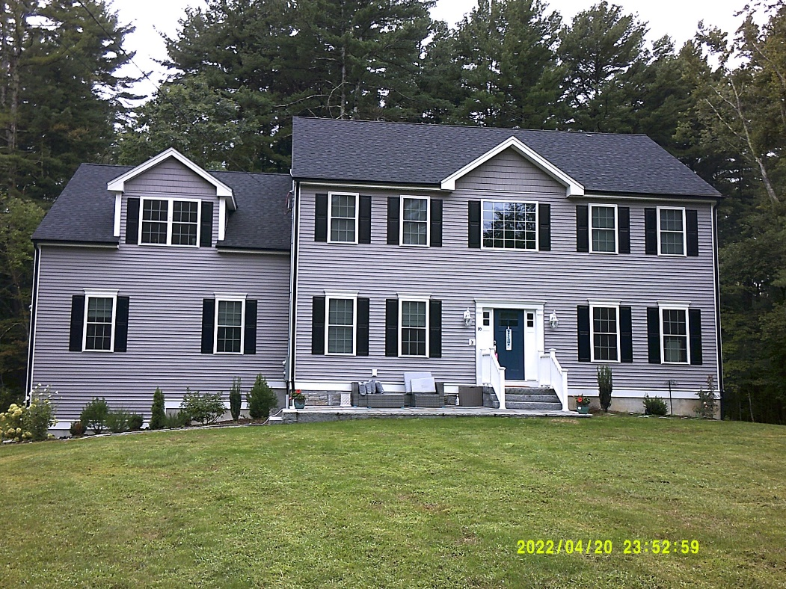
90 Mill St.
Sale Price = $795,000 Sale Date 7/2/2021

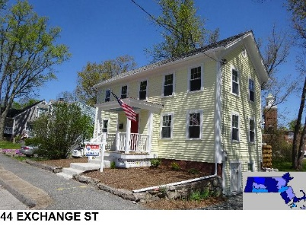
Sale Price = $467,000 Sale Date = 7/6/2021

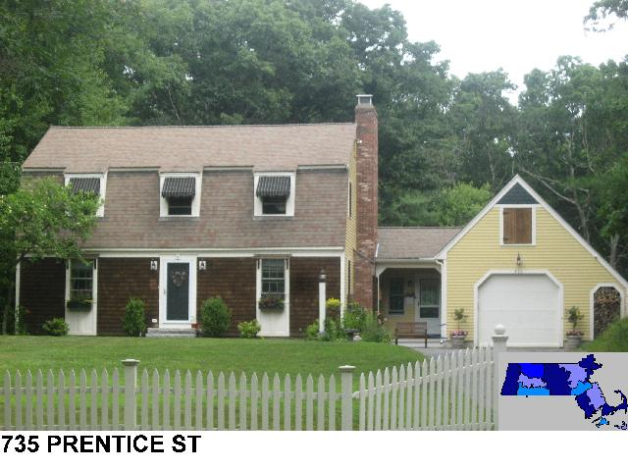
Sale Price = 850,000 Sale Date = 7/9/2021

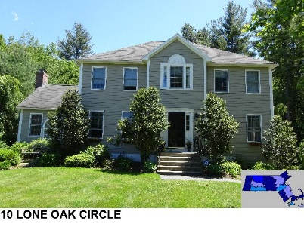
Sale Price = $823,000 Sale Date = 7/9/2021
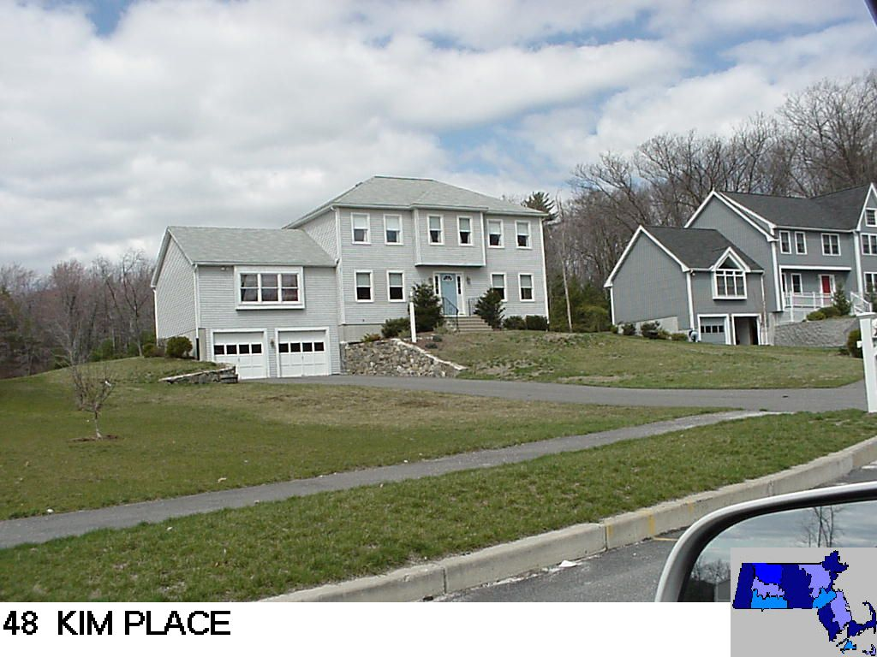
Sale Price = $700,000 Sale Date = 7/12/2021

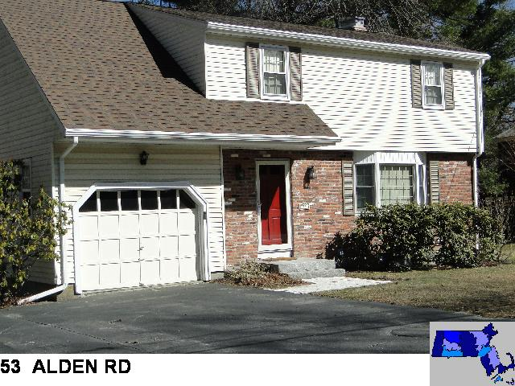
Sale Price = $630,000 Sale Date = 7/19/2021
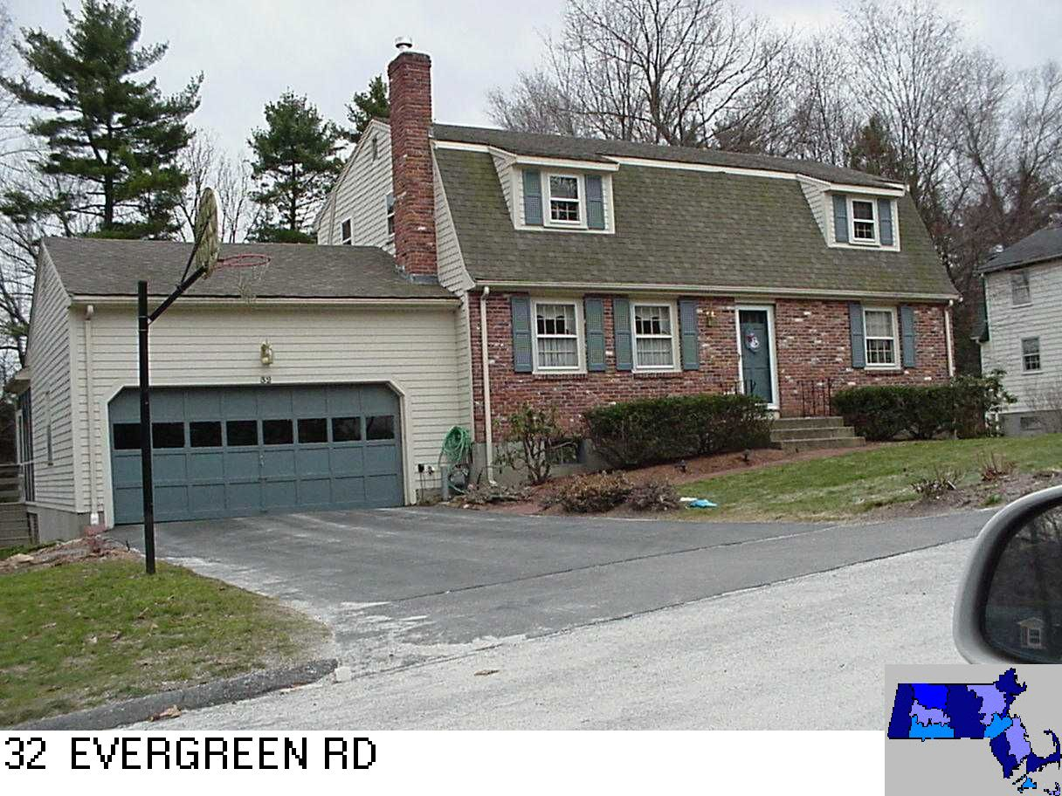
Sale Price = $625,000 Sale Date = 7/22/2021

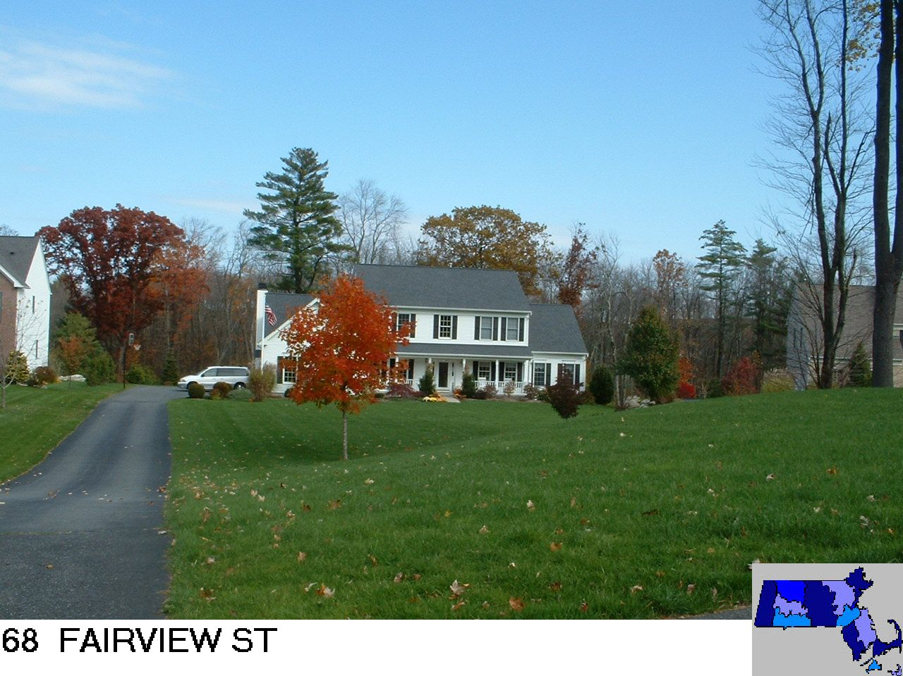
Sale Price = $1,035,000 Sale Date = 7/22/2021

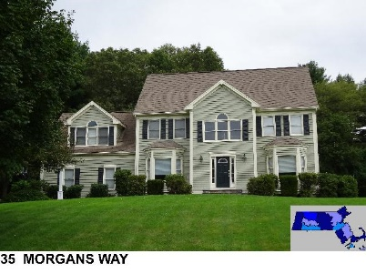
Sale Price = $900,000 Sale Date = 7/29/2021

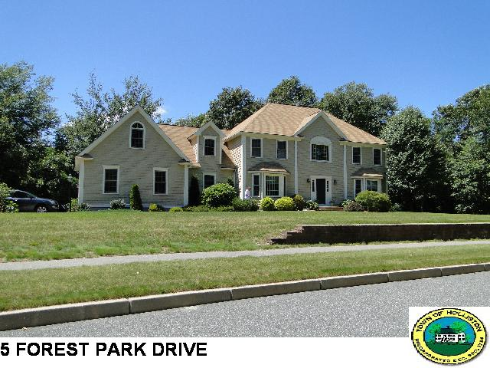
Sale Price = $875,000 Sale Date = 7/30/2021
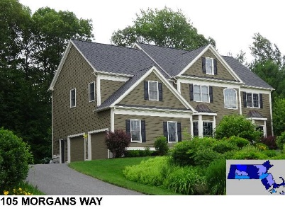
Sale Price = $875,000 Sale Date = 8/2/2021

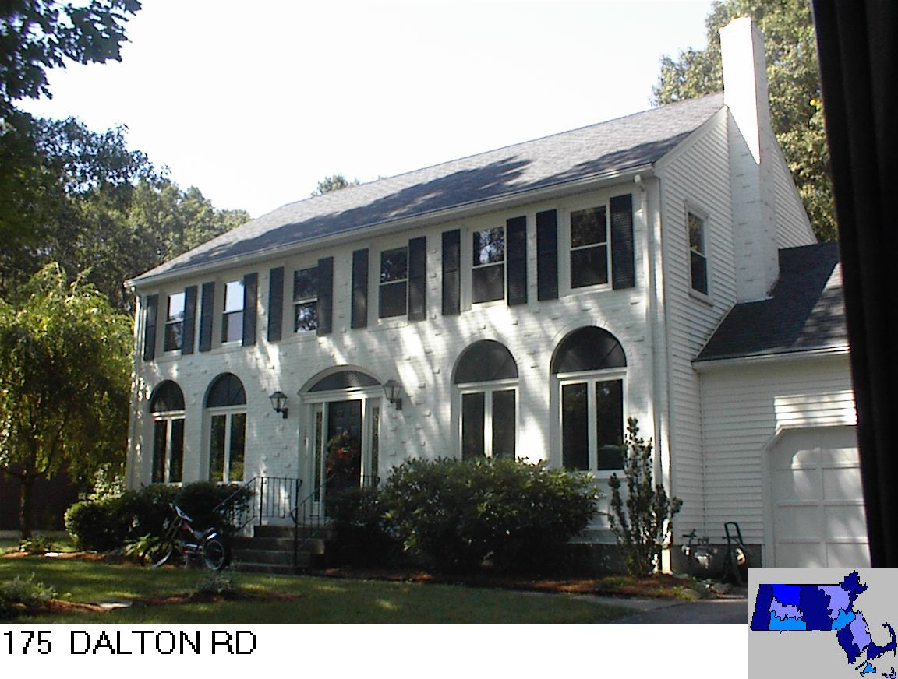
Sale Price = $732,000 Sale Date = 8/2/2021
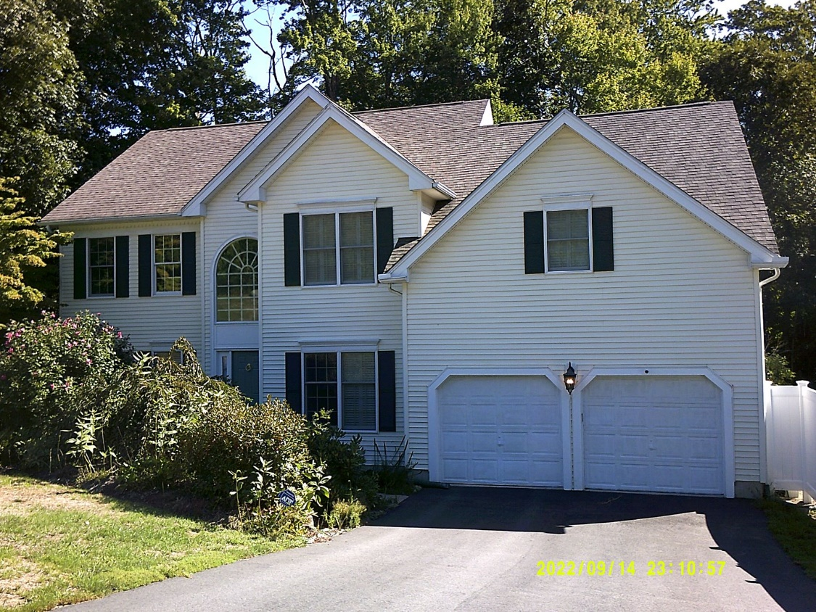
35 Peter St.
Sale Price = $867,000 Sale Date 8/6/2021

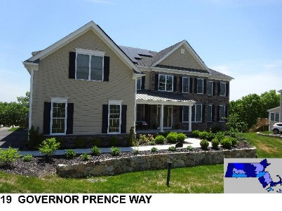
Sale Price = $1,560,000 Sale Date = 8/9/2021
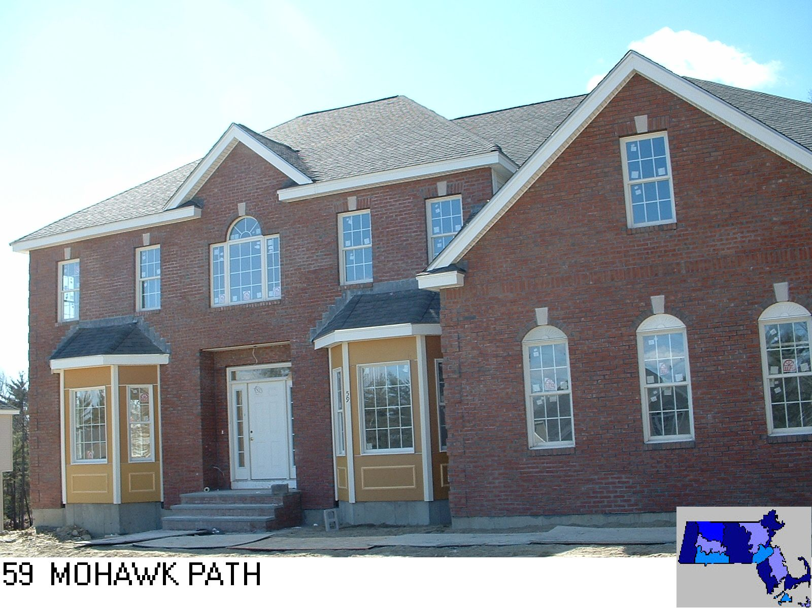
Sale Price = $1,114,908 Sale Date = 8/10/2021

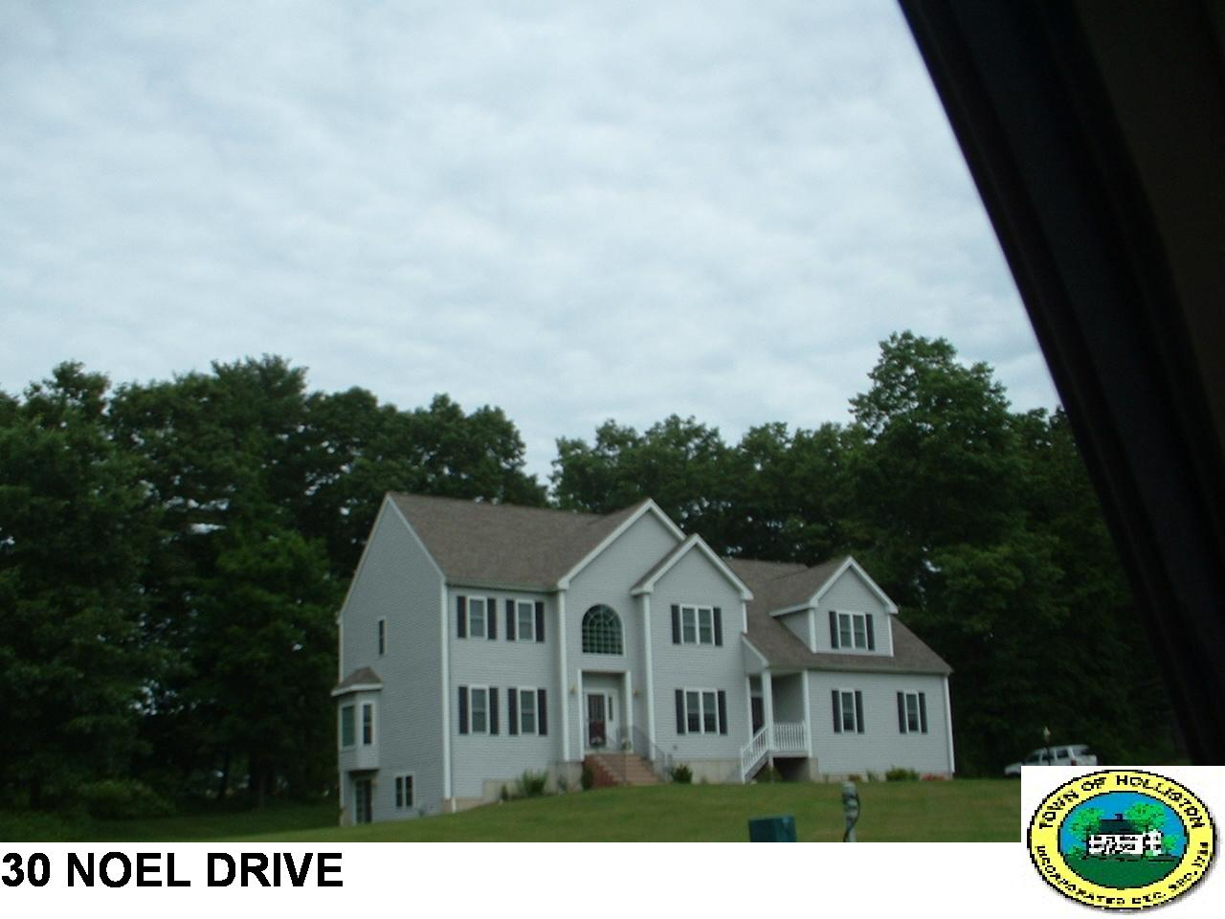
Sale Price = $893,785 Sale Date = 8/18/2021
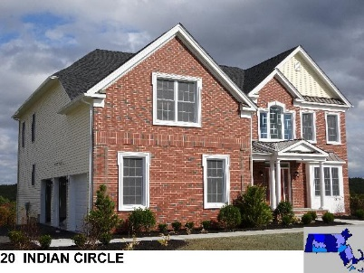
Sale Price = $1,150,000 Sale Date = 8/24/2021

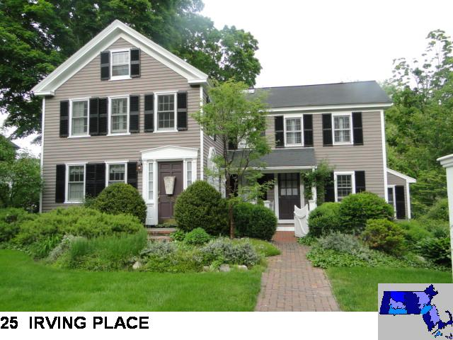
Sale Price = $685,000 Sale Date = 8/24/2021
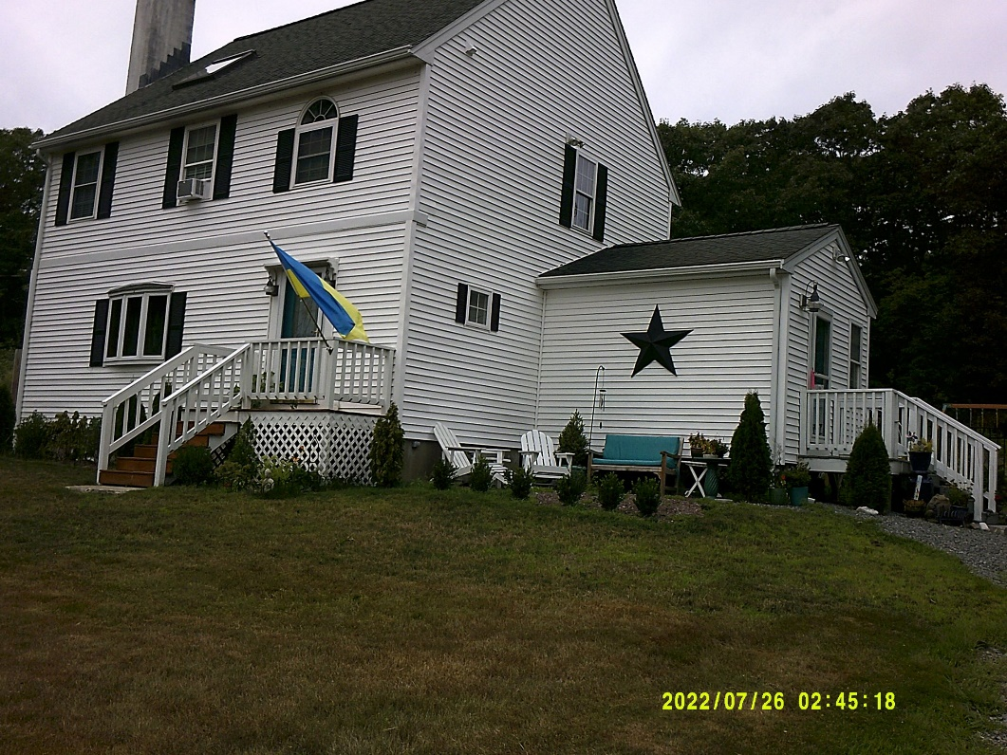
215 South St.
Sale Price = $470,000 Sale Date 8/27/2021

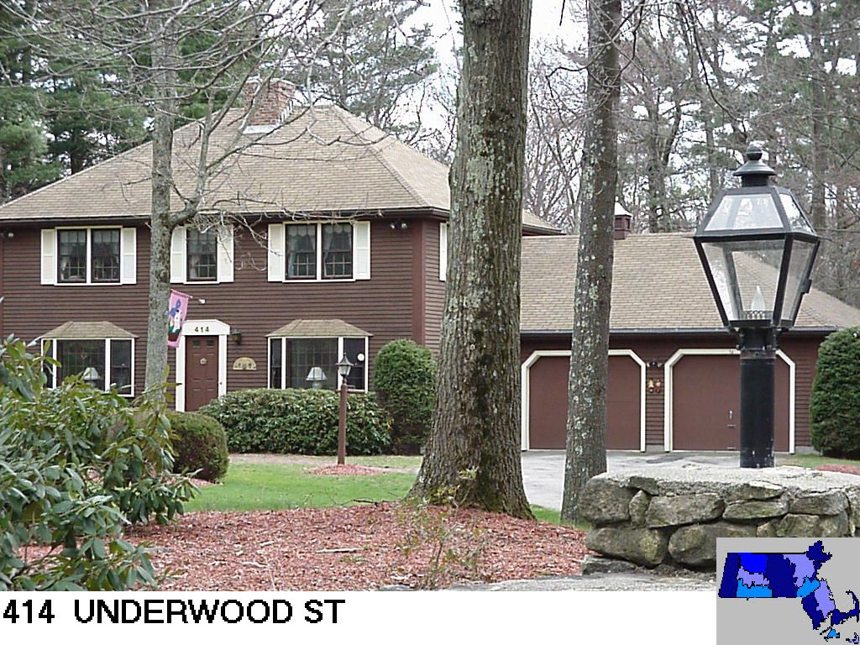
Sale Price = $710,000 Sale Date = 9/3/2021
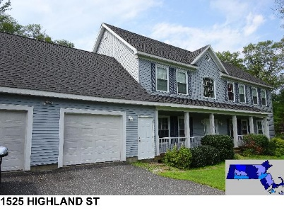
Sale Price = $800,000 Sale Date = 9/10/2021

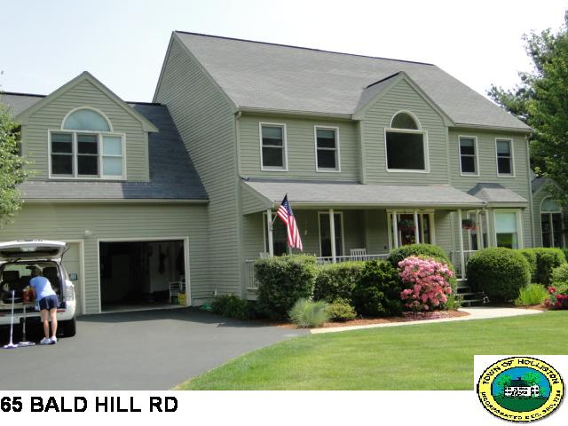
Sale Price = $950,000 Sale Date = 9/27/2021

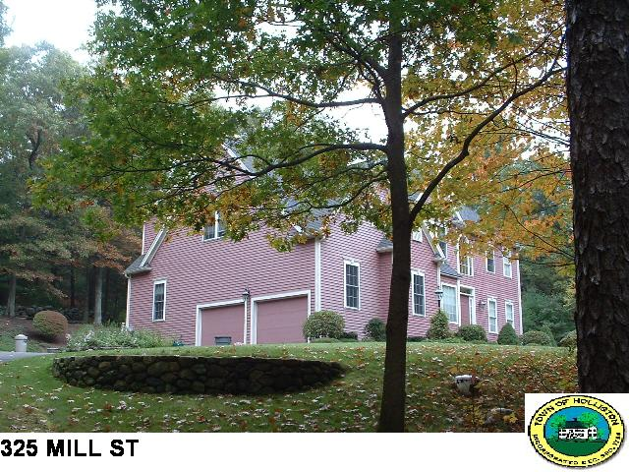
Sale Price = $820,000 Sale Date = 9/27/2021

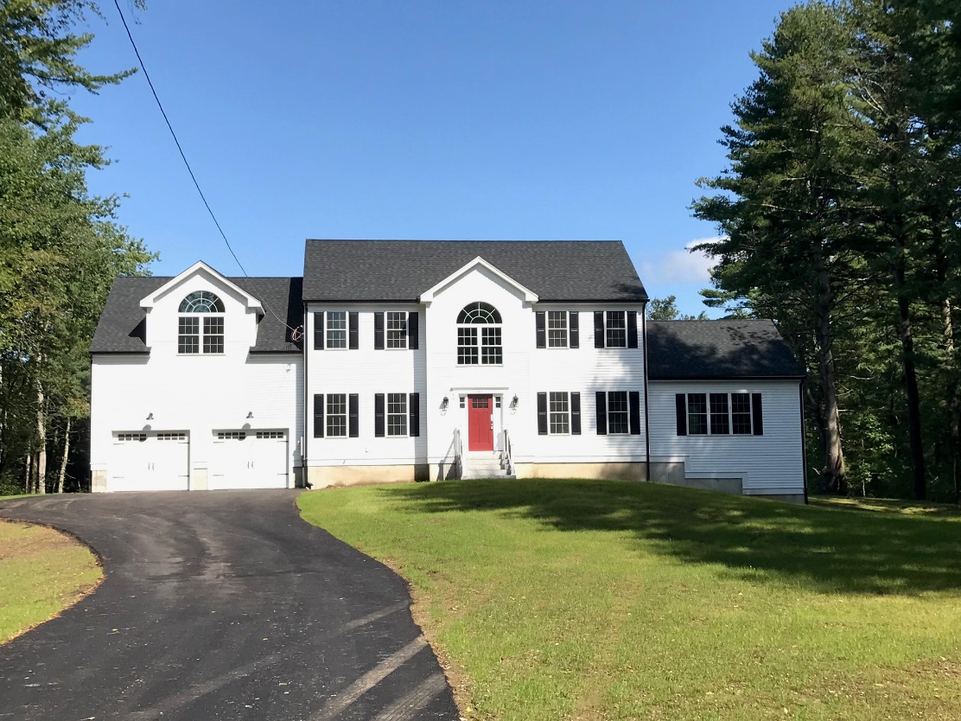
265 Prentice St.
Sale Price = $945,000 Sale Date = 9/30/2021
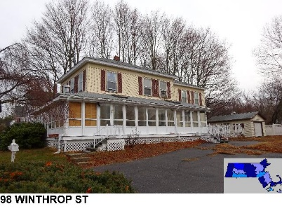
Sale Price = $615,000 Sale Date 10/1/2021

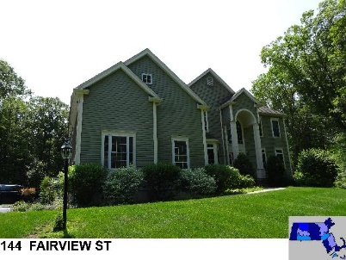
Sale Price = $1,188,000 Sale Date = 10/1/2021
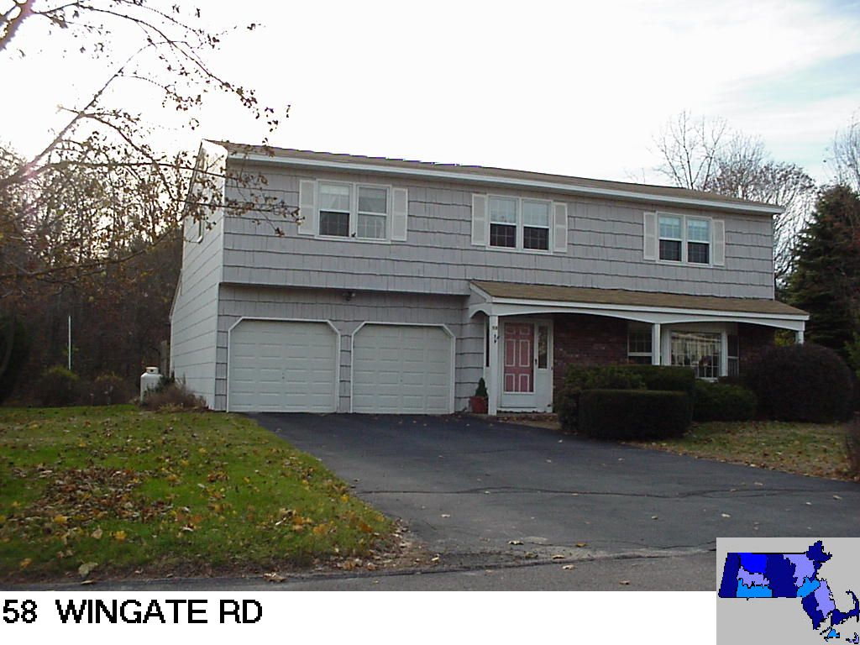
Sale Price = $592,000 Sale Date = 10/13/2021

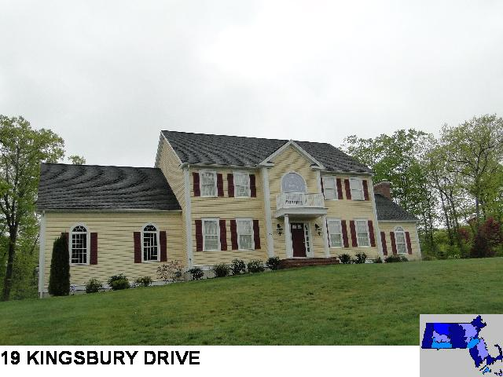
Sale Price = $1,010,000 Sale Date = 10/13/2021
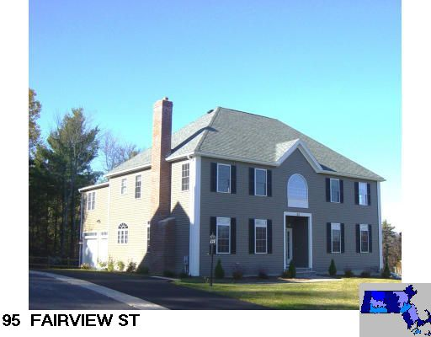
Sale Price = $825,000 Sale Date = 10/14/2021
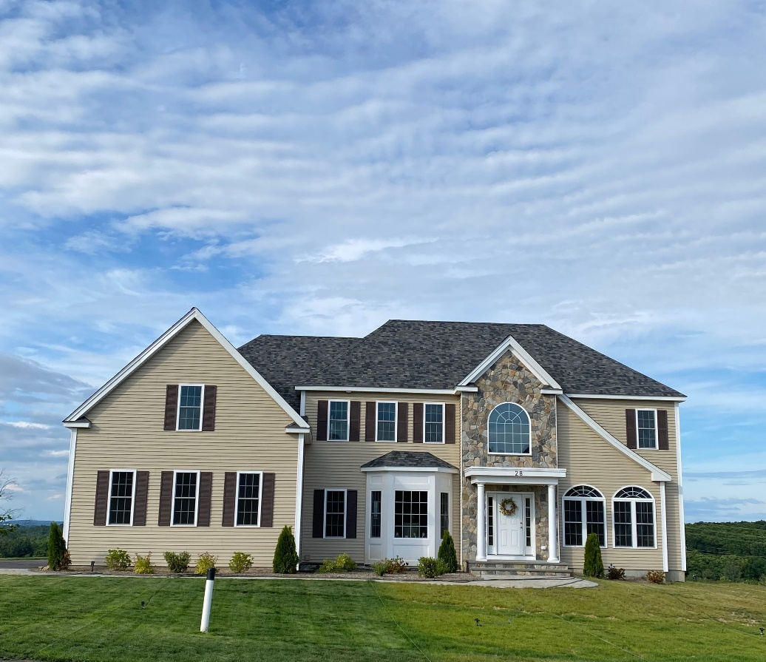
28 Hiawatha Tr.
Sale Price = $1,062,000 Sale Date = 10/14/2021
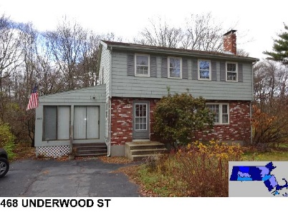
Sale Price = $515,000 Sale Date = 10/14/2021

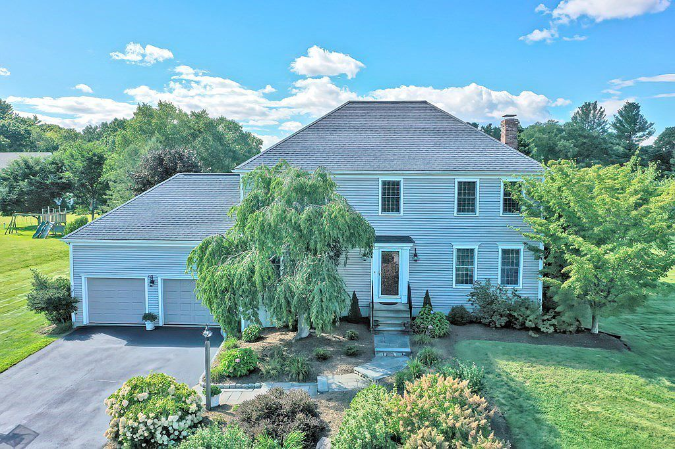
5 Lone Oak Cir.
Sale Price = $860,000 Sale Date = 10/15/2021

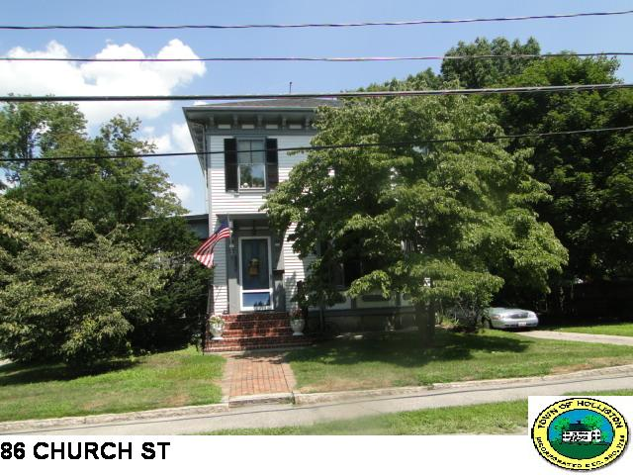
Sale Price = $485,000 Sale Date = 10/22/2021

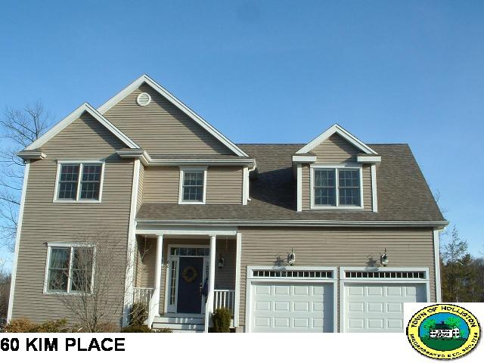
Sale Price = $950,000 Sale Date = 10/22/2021
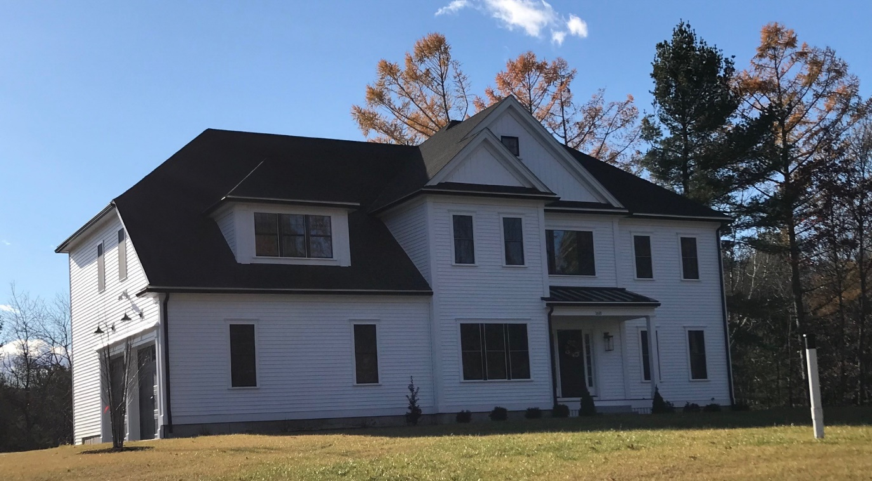
168 Mill St.
Sale Price = $989,000 Sale Date = 10/22/2021

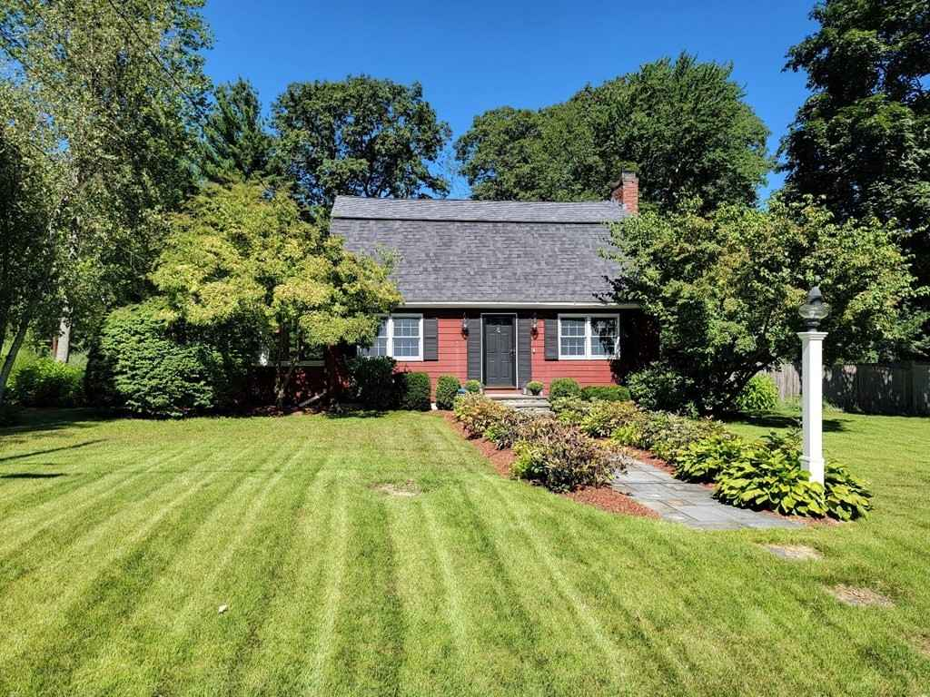
73 Robert Rd.
Sale Price = $599,900 Sale Date = 10/29/2021
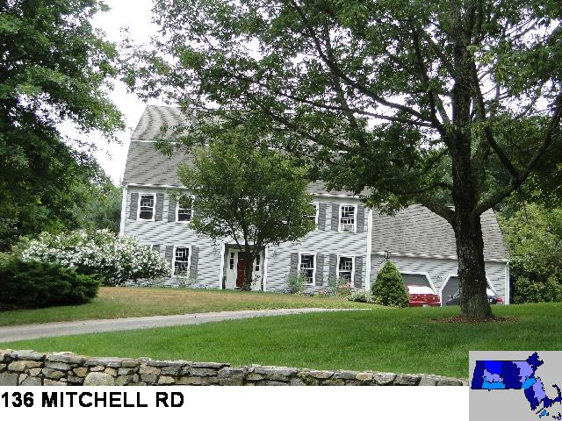
Sale Price = $900,000 Sale Date = 11/1/2021

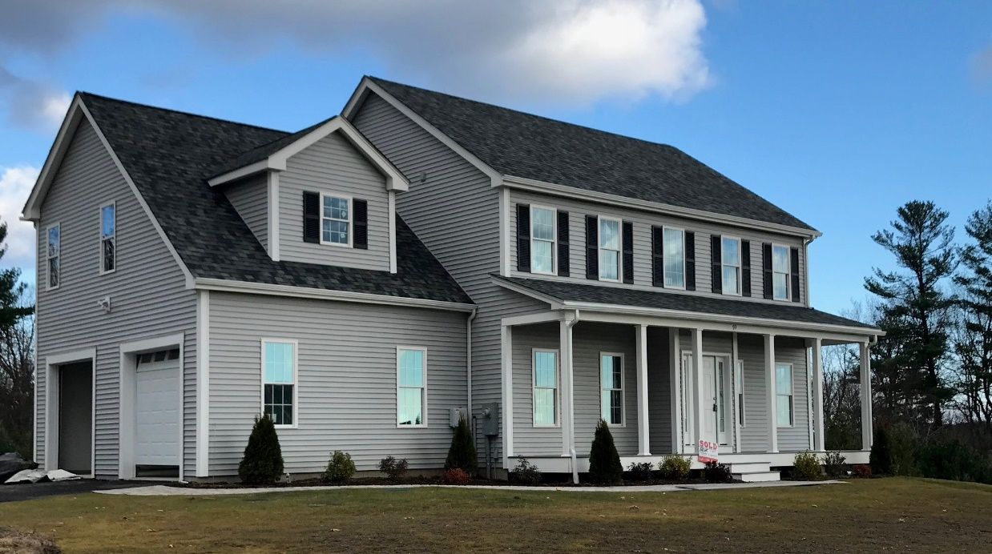
70 Old Cart Pth.
Sale Price = $822,500 Sale Date = 11/23/2021

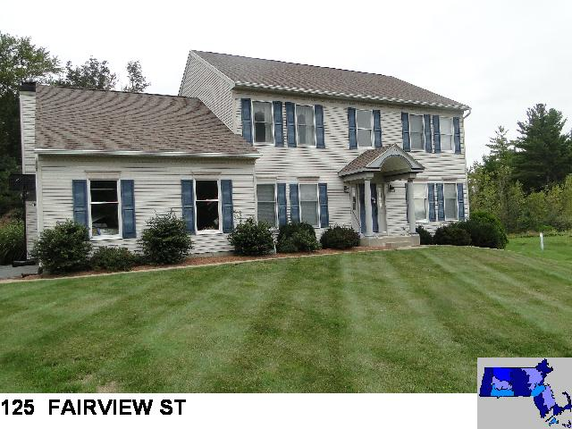
Sale Price = $875,000 Sale Date = 12/14/2021

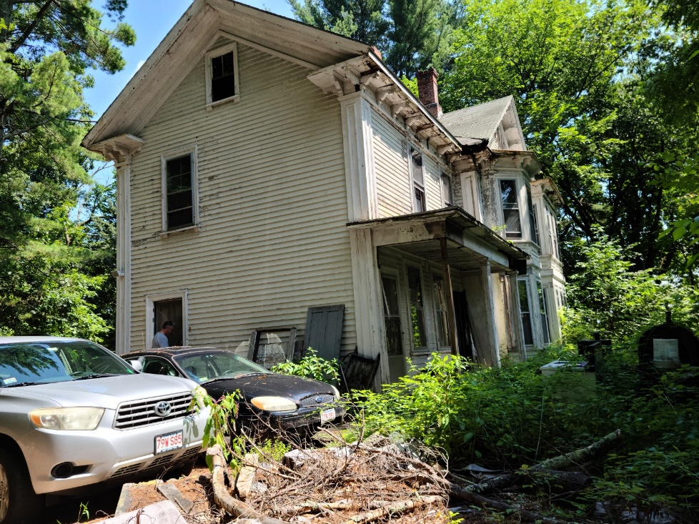
52 Jasper Hill Rd.
Sale Price = $550,000 Sale Date = 12/15/2021
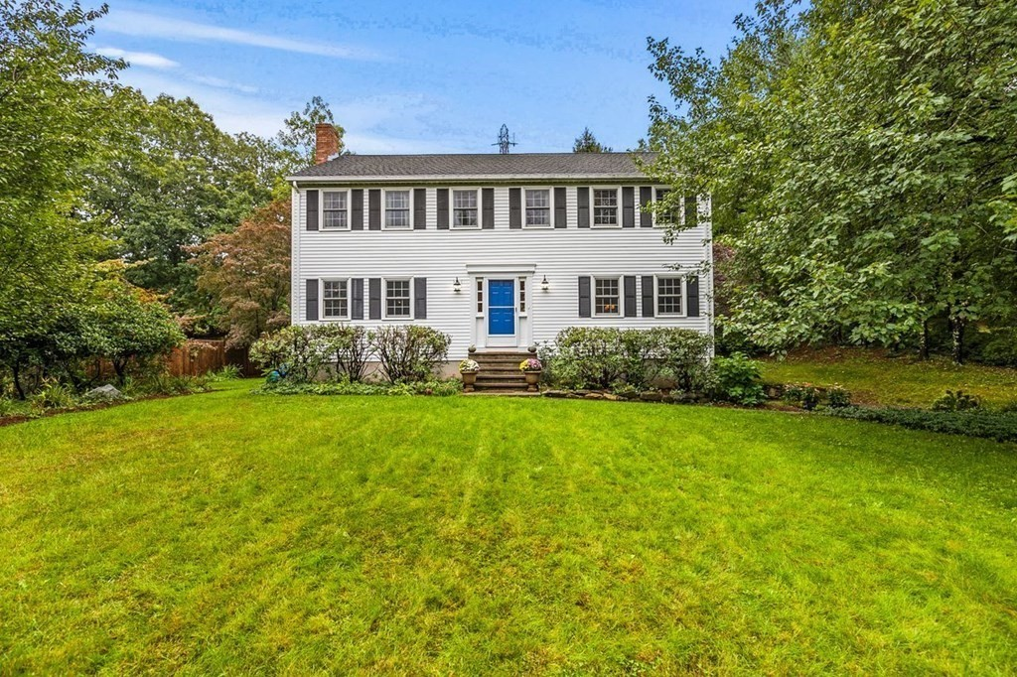
70 Dalton Rd.
Sale Price = $620,000 Sale Date = 12/16/2021

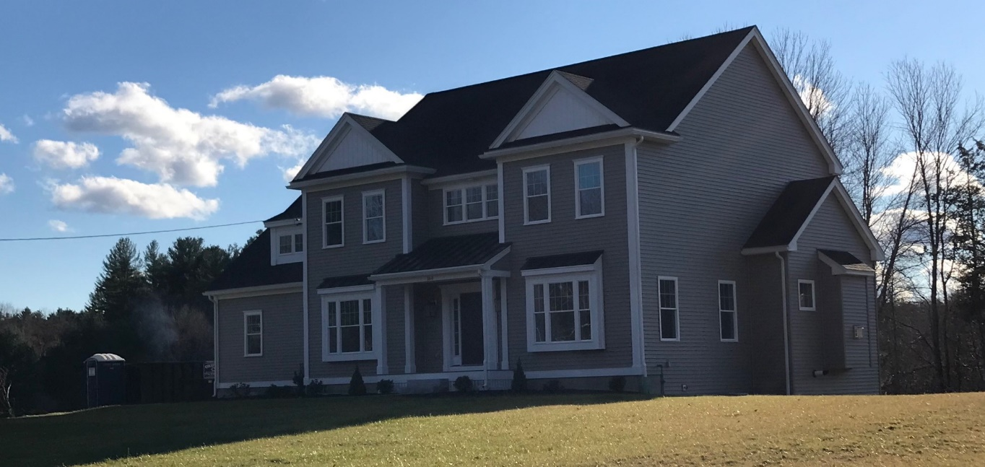
164 Mill St.
Sale Price = $1,025,000 Sale Date = 12/17/2021

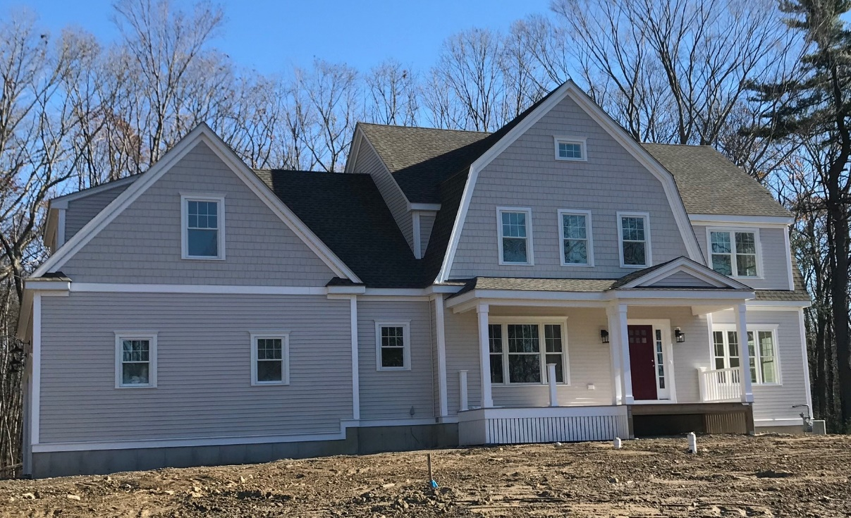
21 Katie Way
Sale Price = $1,236,113 Sale Date = 12/21/2021

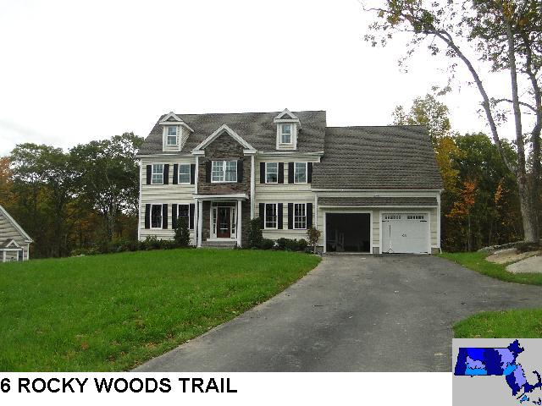
Sale Price = $995,000 Sale Date = 12/23/2021
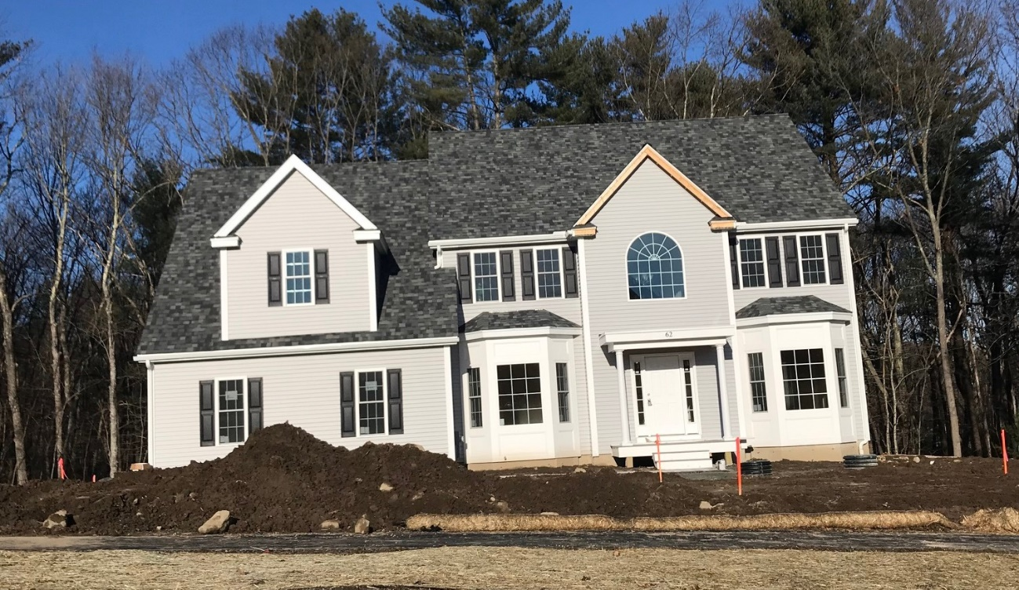
62 Old Cart Path New Colonial style
Sale Price = $855,040 Sale Date = 12/28/2021

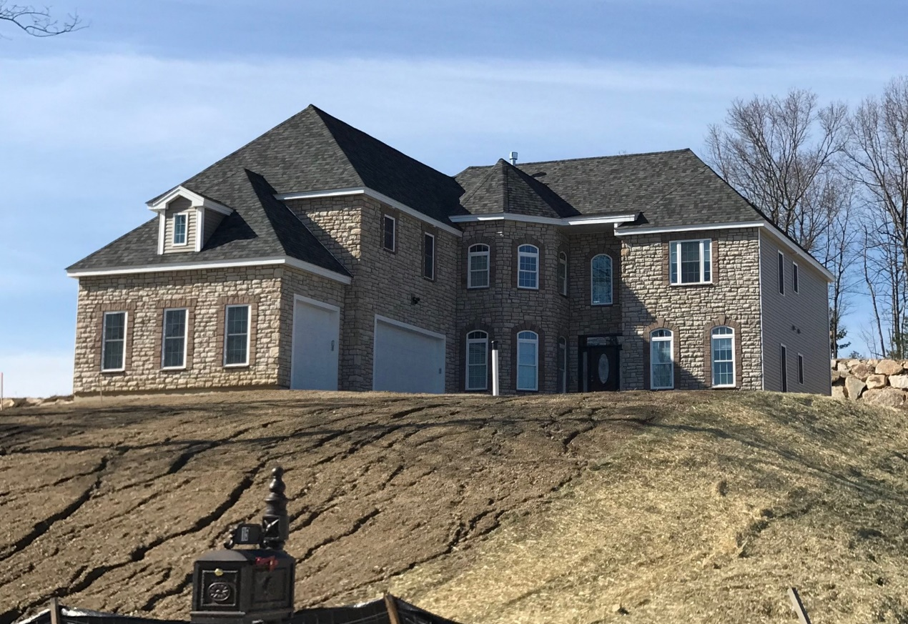
15 Hiawatha Trail
Sale Price = $1,060,400 Sale Date 12/30/2021

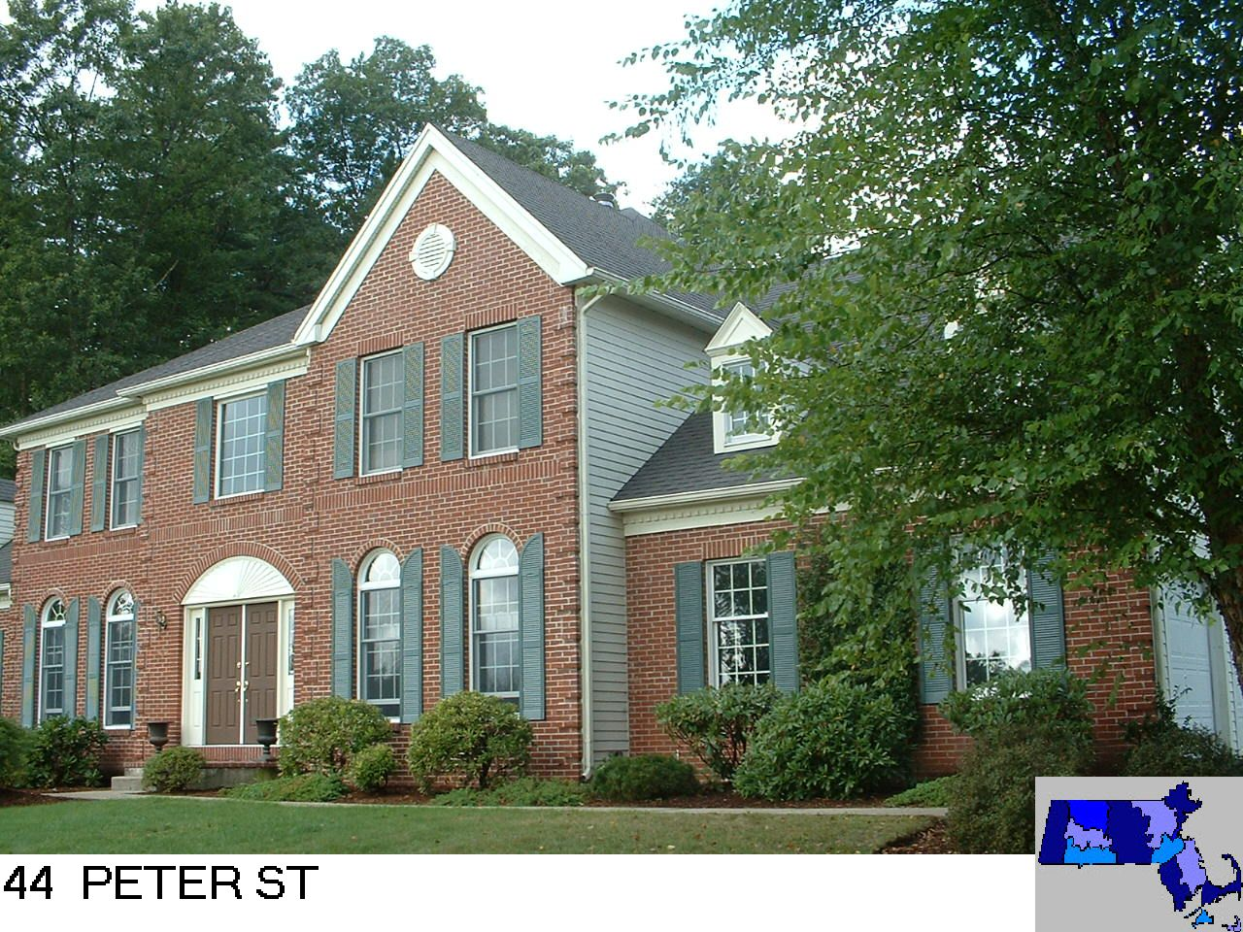
Sale Price = $1,340,000 Sale Date = 12/31/2021

Raised Ranch

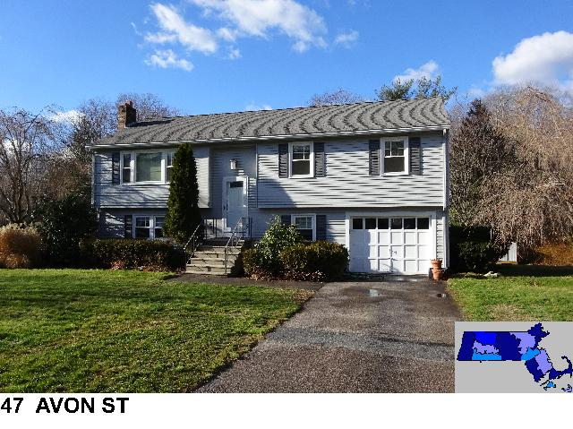
Sale Price = $535,000 Sale Date = 1/8/2021

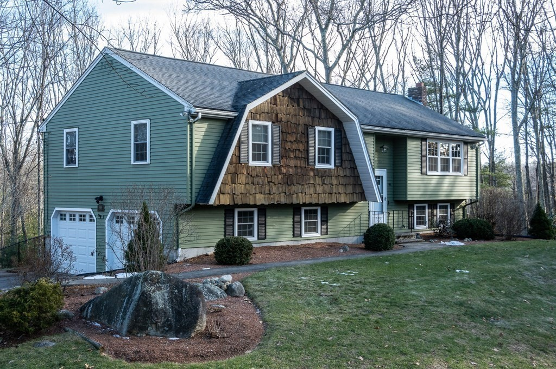
98 South St
Sale Price = $546,000 Sale Date = 2/25/2021

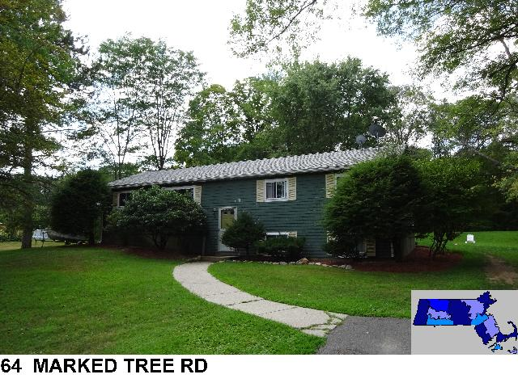
Sale Price = $410,000 Sale Date = 3/8/2021

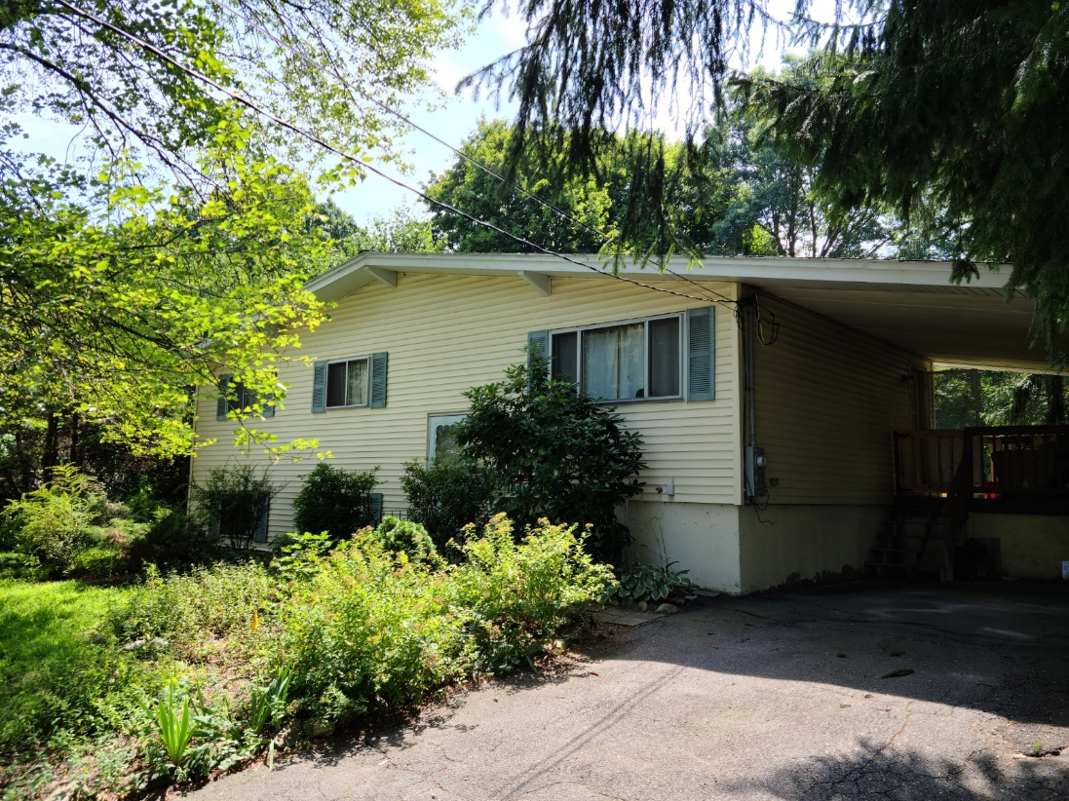
30 Carlton Drive
Sale Price = $395,000 Sale Date = 4/13/2021
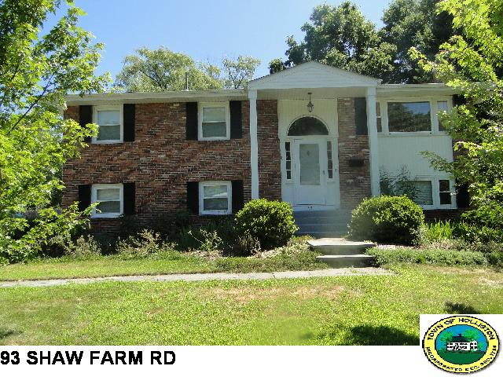
Sale Price = $537,500 Sale Date = 4/26/2021

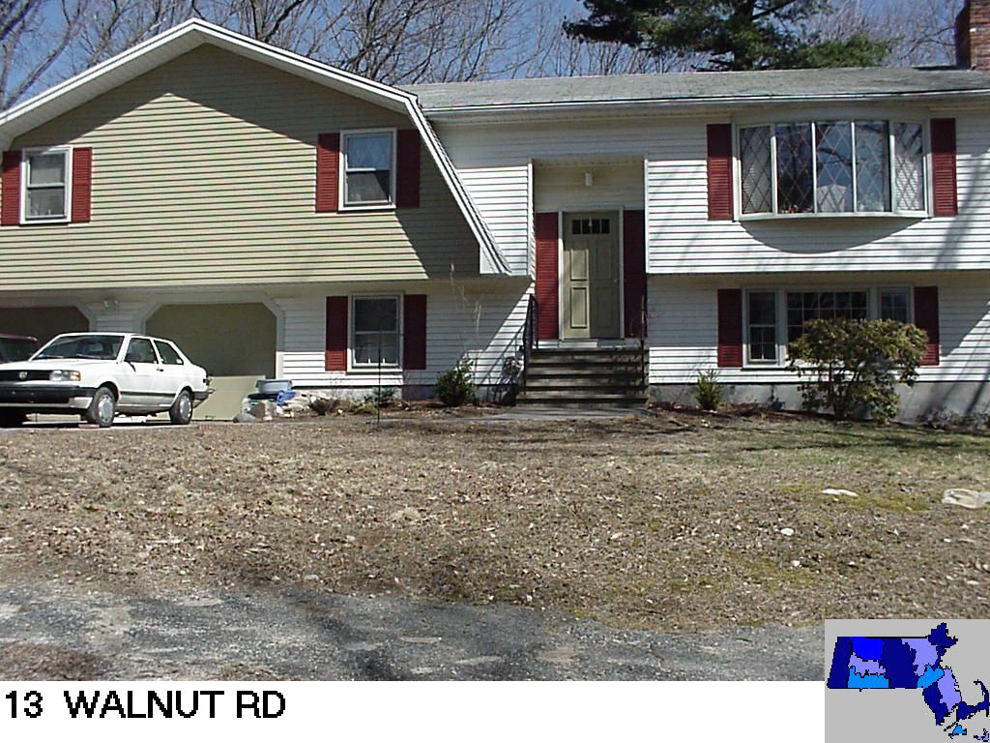
Sale Price = $400,000 Sale Date 5/5/2021

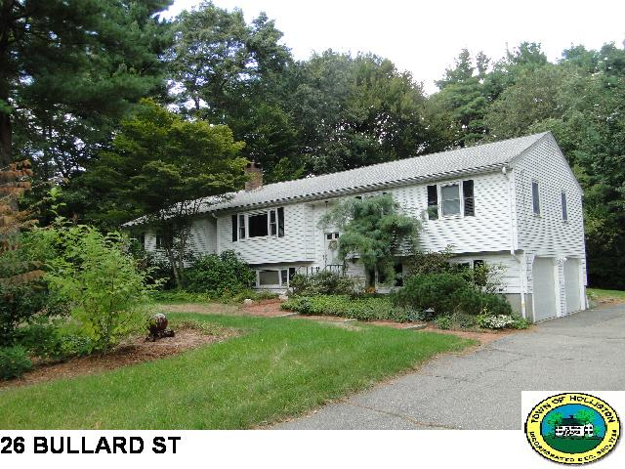
Sale Price = $681,000 Sale Date = 5/5/2021

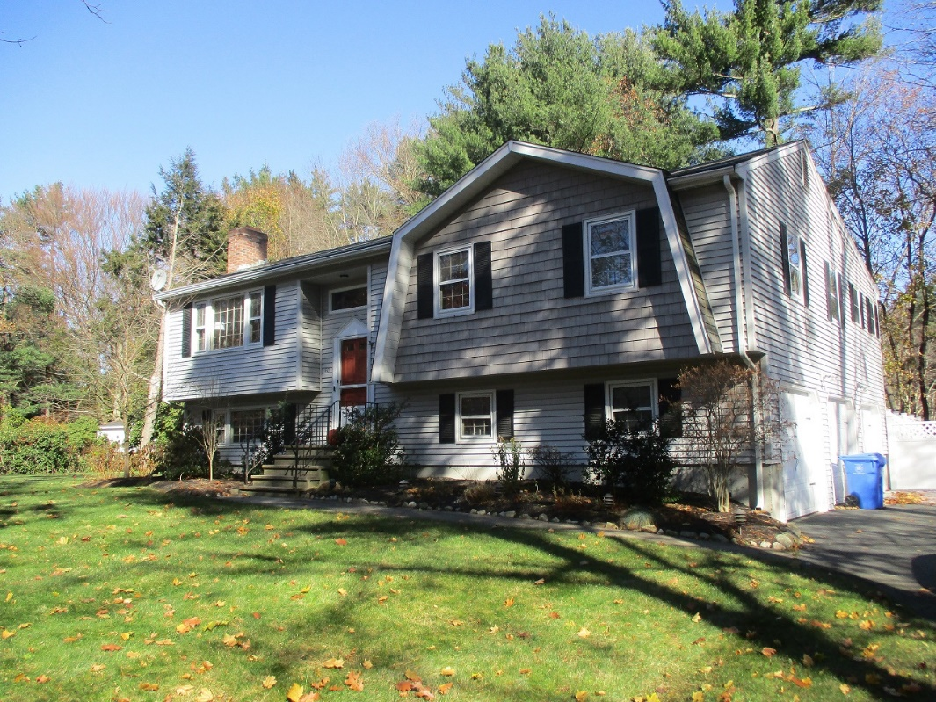
40 Bullard St.
Sale Price = $700,000 Sale Date = 5/21/2021

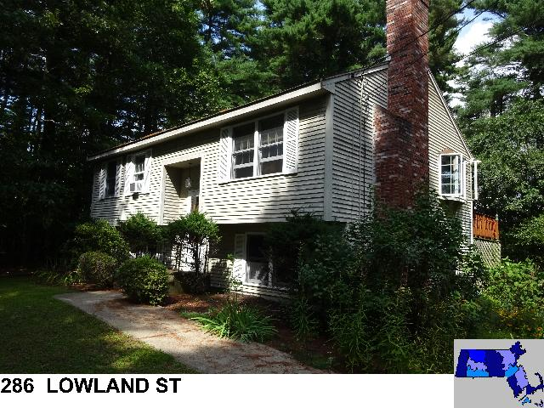
Sale Price = $510,000 Sale Date = 5/26/2021

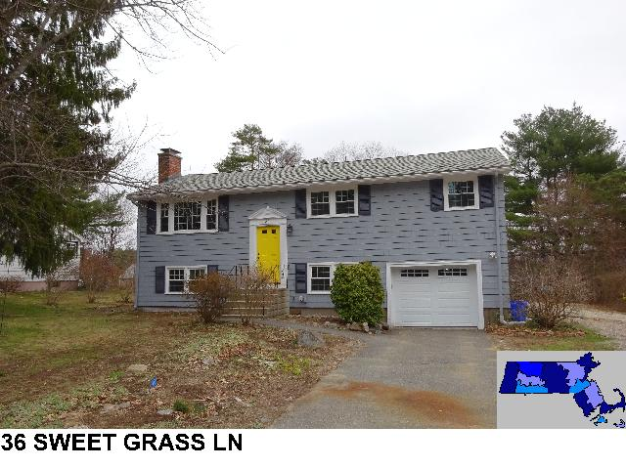
Sale Price = $650,000 Sale Date = 6/21/2021
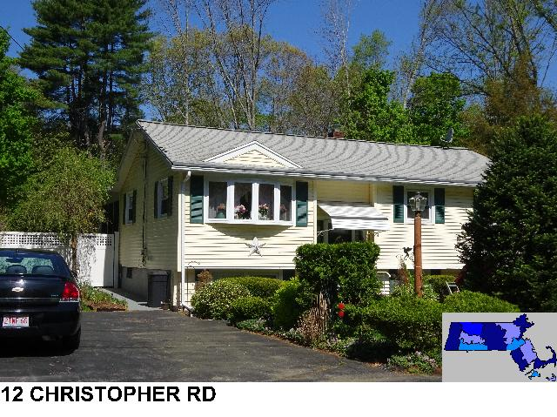
Sale Price = $500,000 Sale Date = 6/22/2021

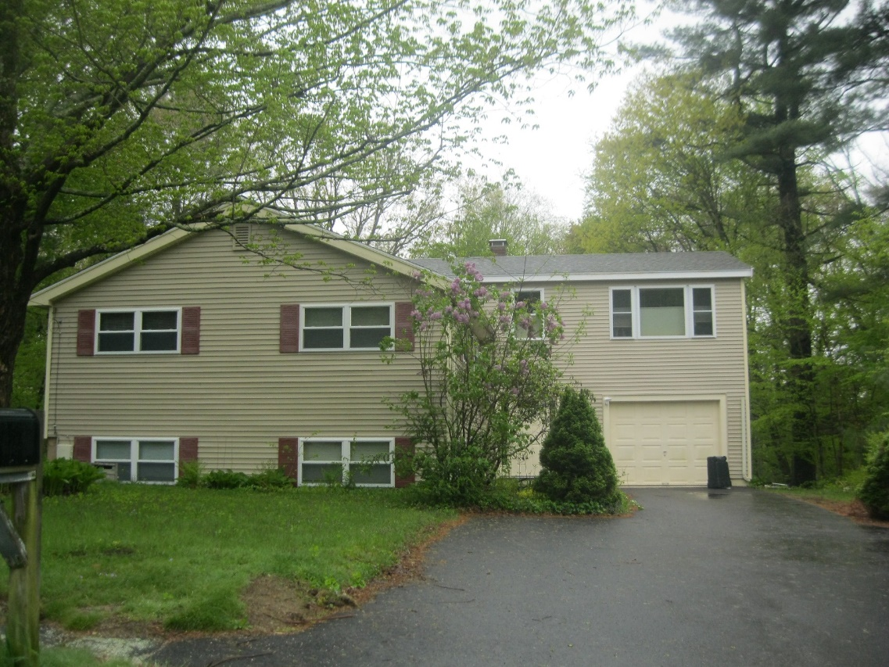
68 Andrew Ln.
Sale Price = $600,000 Sale Date = 7/8/2021

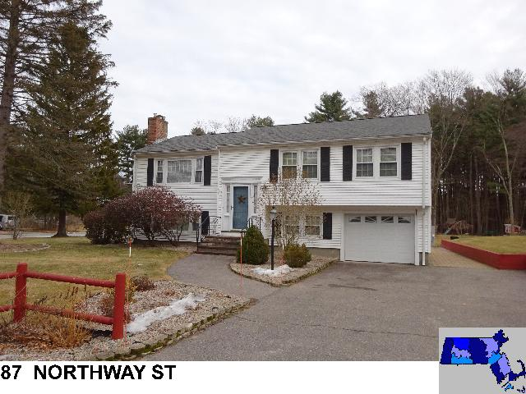
Sale Price = $650,000 Sale Date = 7/12/2021

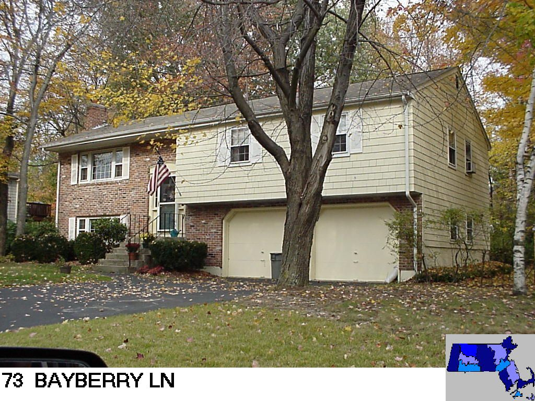
Sale Price = $592,000 Sale Date = 7/27/2021
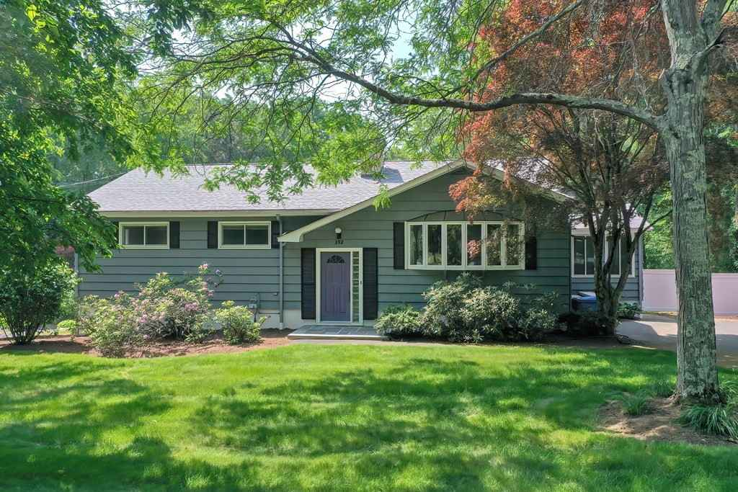
392 Underwood St.
Sale Price = $647,000 Sale Date = 7/27/2021

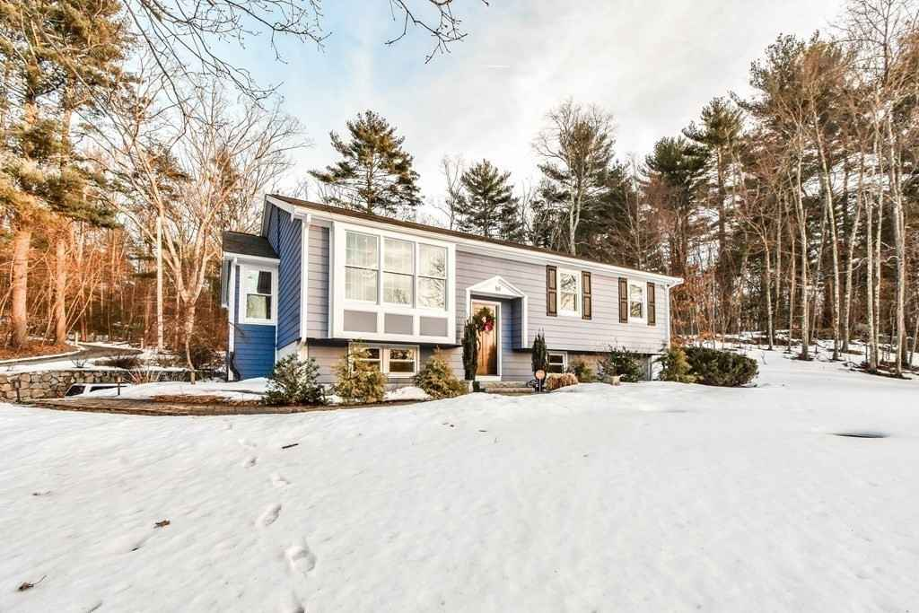
61 Louis St.
Sale Price = $735,000 Sale Date = 7/28/2021

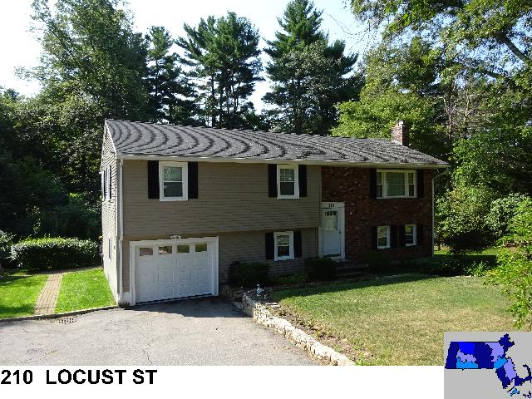
Sale Price = $610,000 Sale Date = 8/19/2021

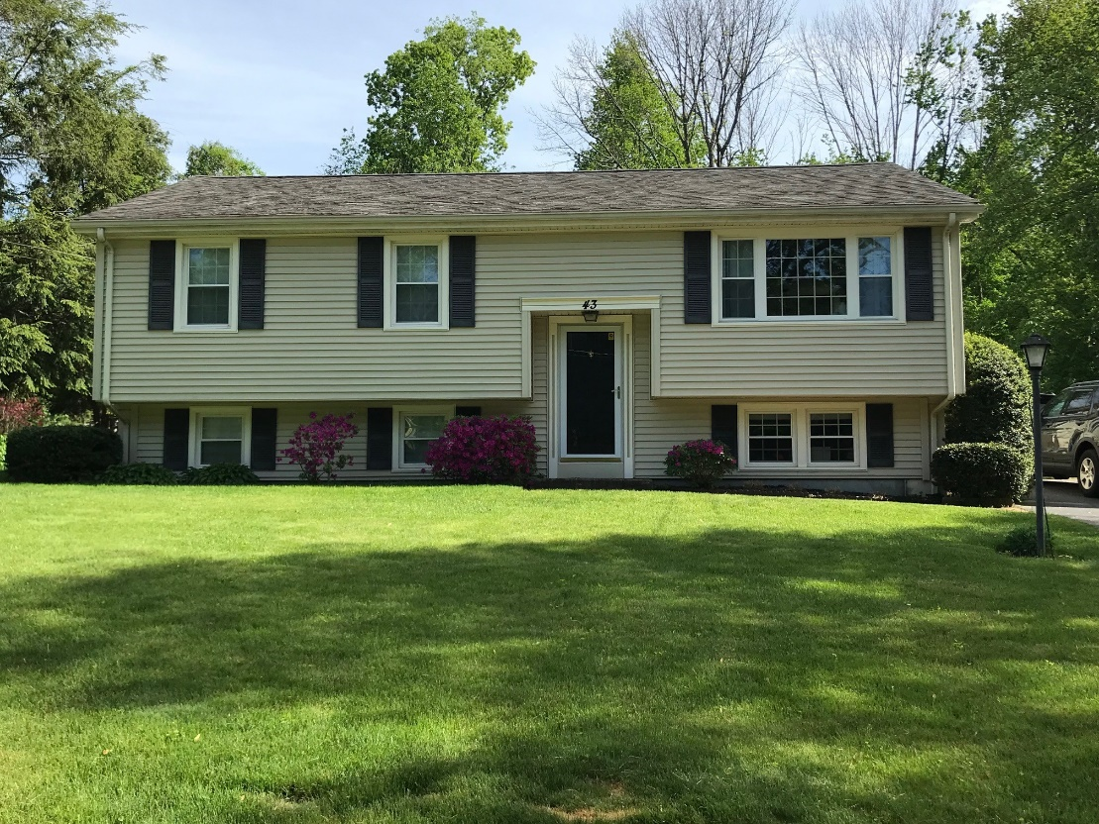
43 Ridge Rd.
Sale Price = $550,000 Sale Date = 8/24/2021
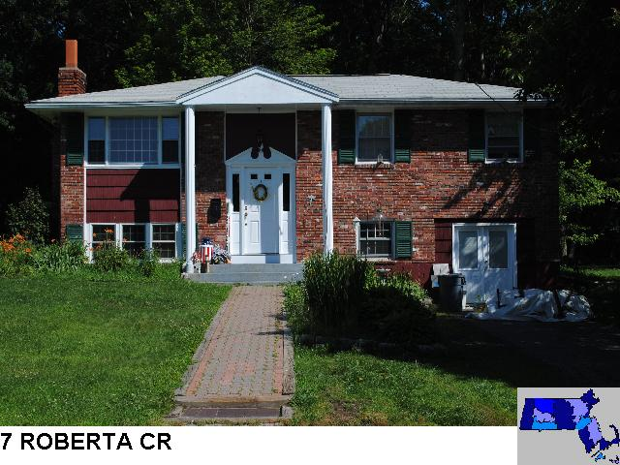
Sale Price = $505,000 Sale Date = 8/31/2021

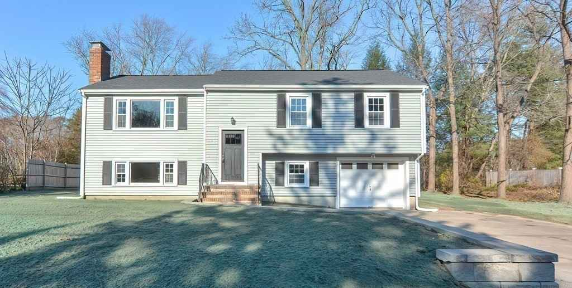
116 Marilyn St.
Sale Price = $350,000 Sale Date = 9/9/2021

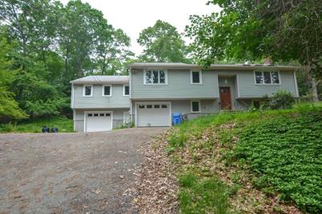
273 Hollis St.
Sale Price = $620,000 Sale Date = 9/14/2021

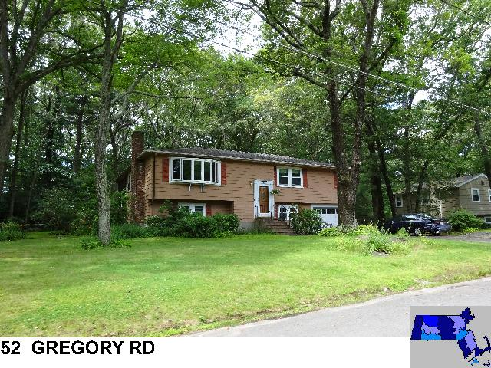
Sale Price = $560,000 Sale Date = 9/22/2021
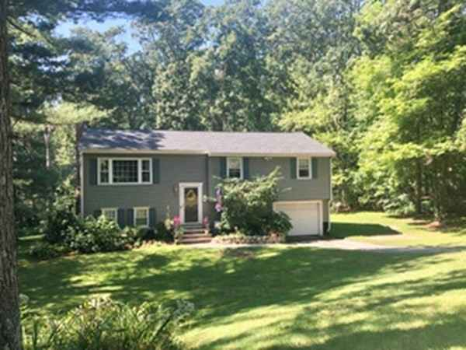
138 Cheryl Ln.
Sale Price = $530,000 Sale Date = 11/23/2021

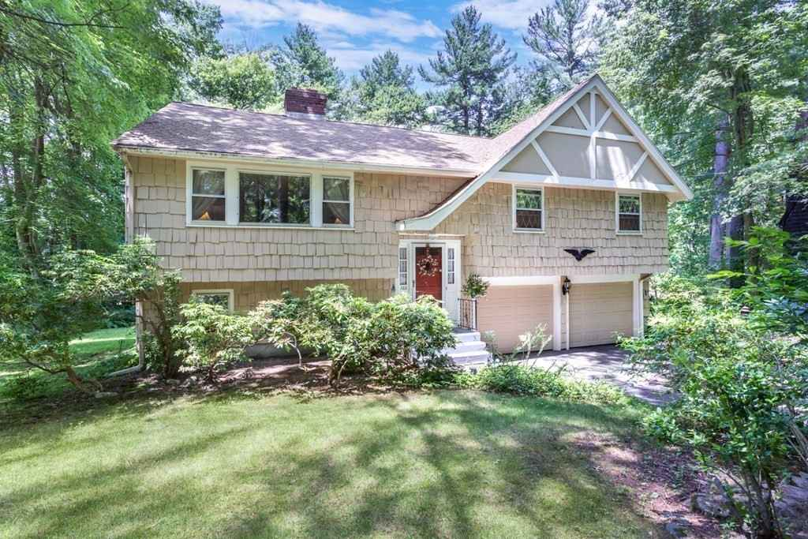
122 Jennings Rd.
Sale Price = 535,000 Sale Date = 11/24/2021

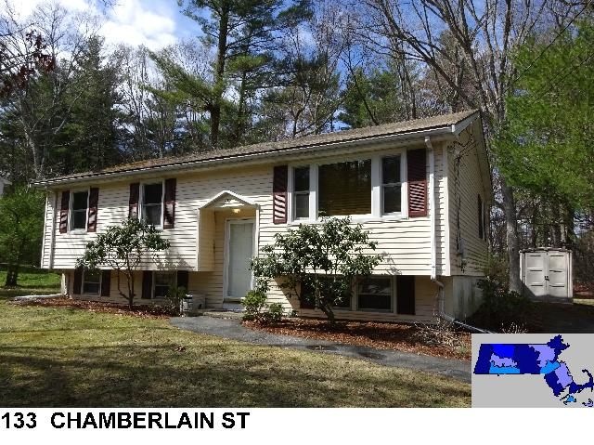
Sale Price = 450,000 Sale Date = 11/30/2021

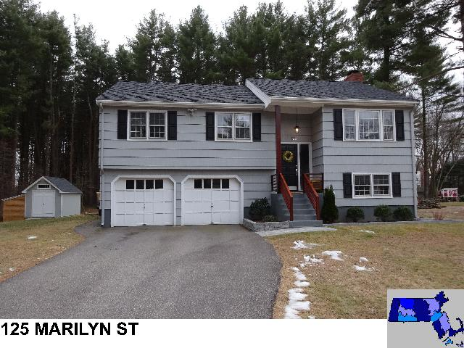
Sale Price = $630,000 Sale Date = 12/9/2021
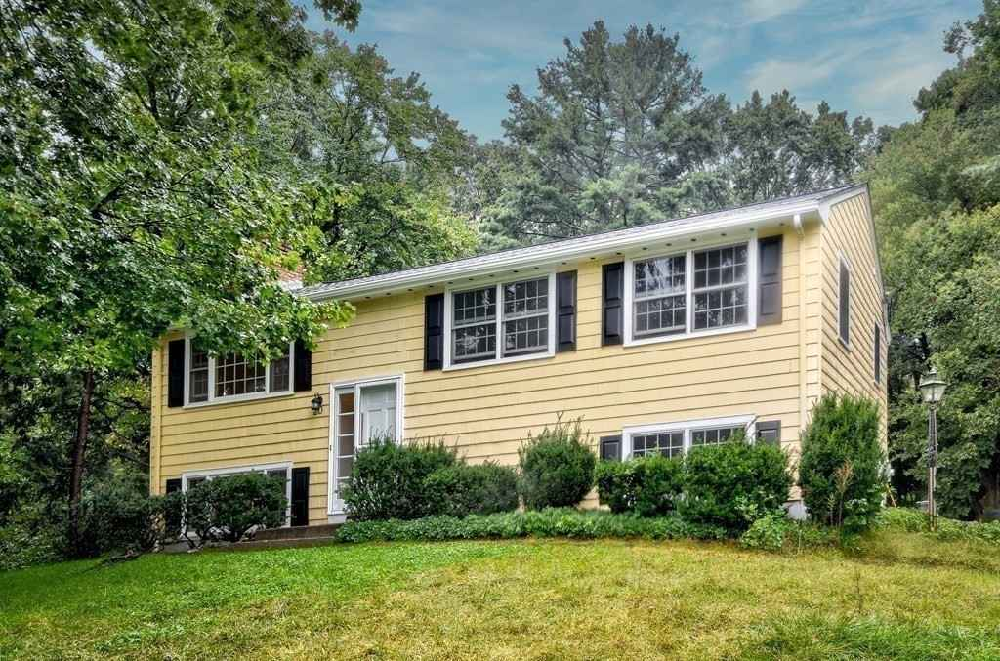
20 Appleyard Ln.
Sale Price = $557,000 Sale Date = 12/13/2021

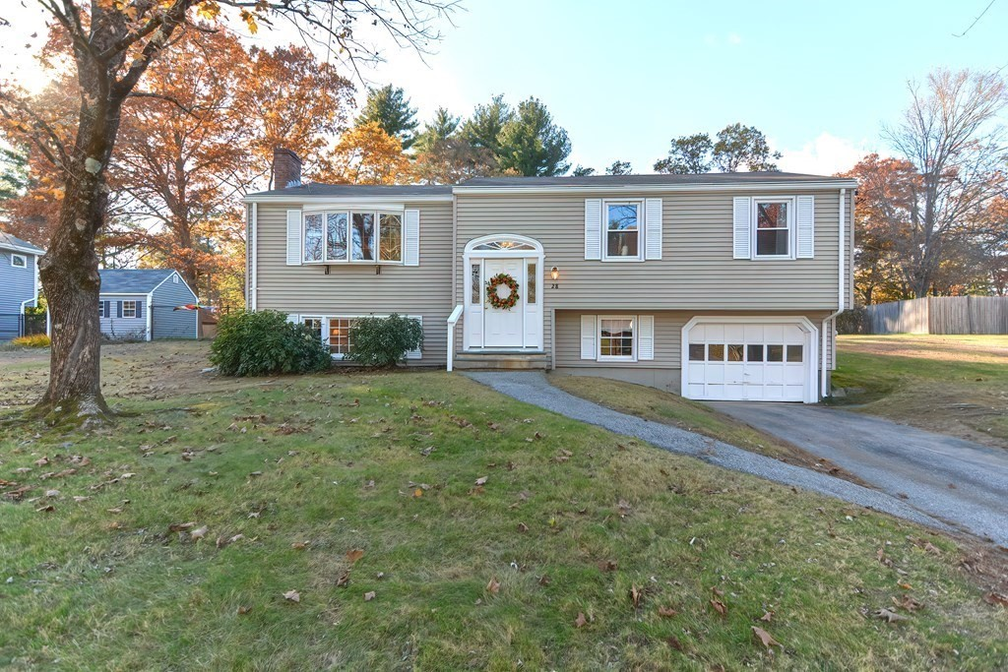
28 Marilyn St.
Sale Price = $499,000 Sale Date = 12/21/2021

Ranch

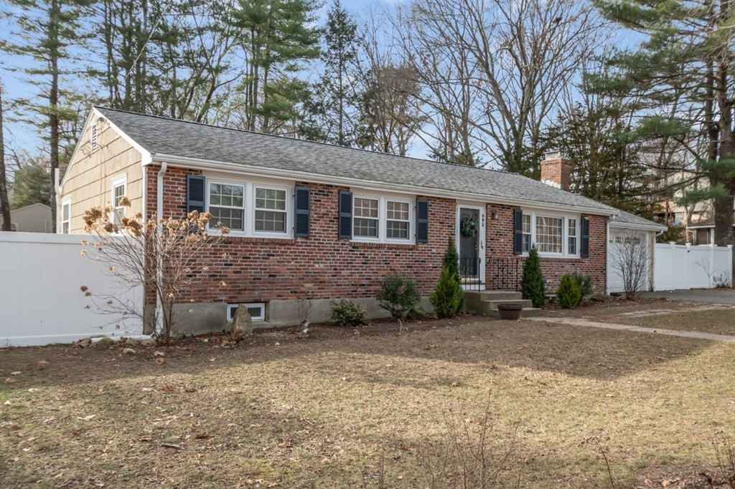
495 Central St.
Sale Price = 500,000 Sale Date = 2/26/2021

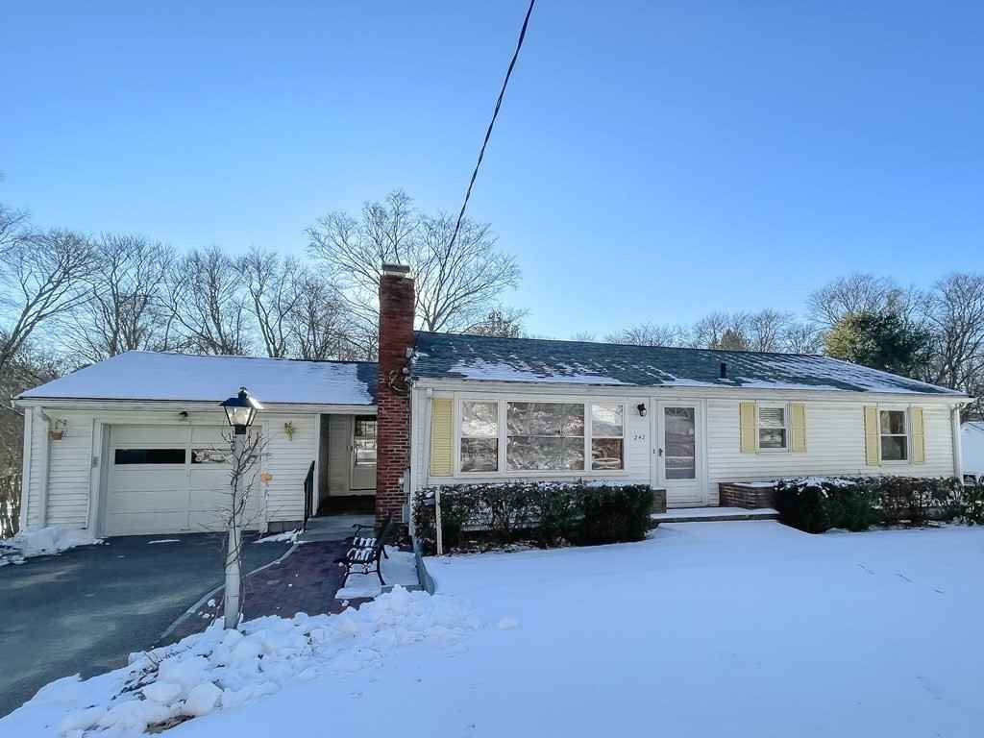
242 High St.
Sale Price = $427,600 Sale Date = 3/10/2021
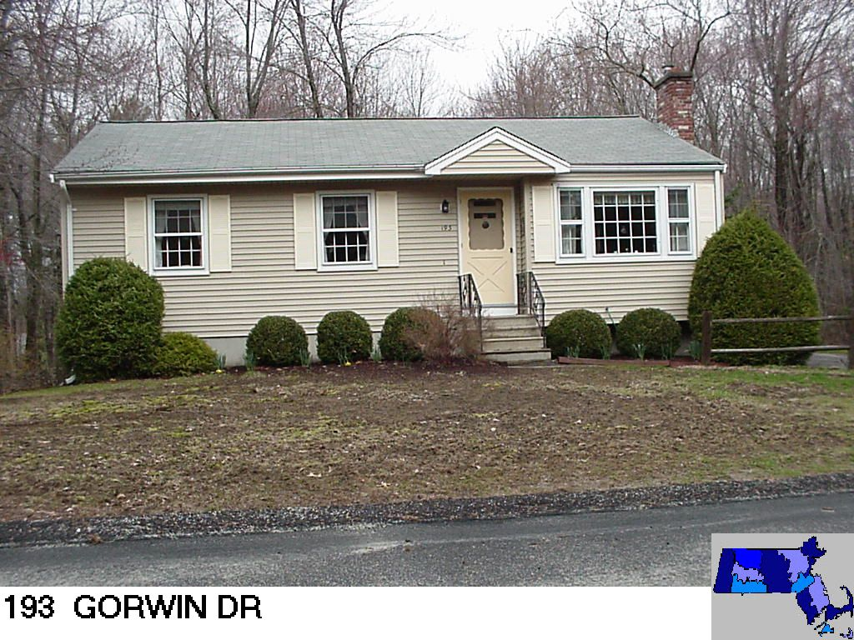
Sale Price = $535,000 Sale Date = 3/31/2021

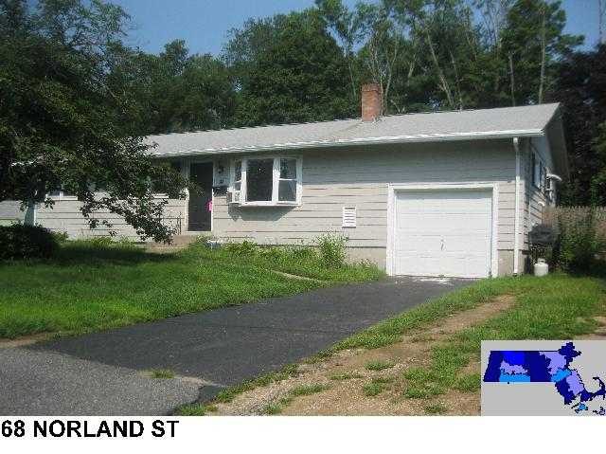
Sale Price = $497,500 Sale Date = 4/9/2021
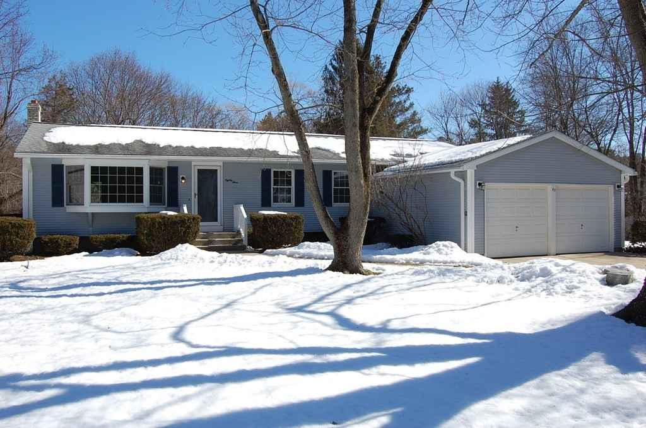
83 Westfield Dr.
Sale Price = $585,000 Sale Date = 4/29/2021

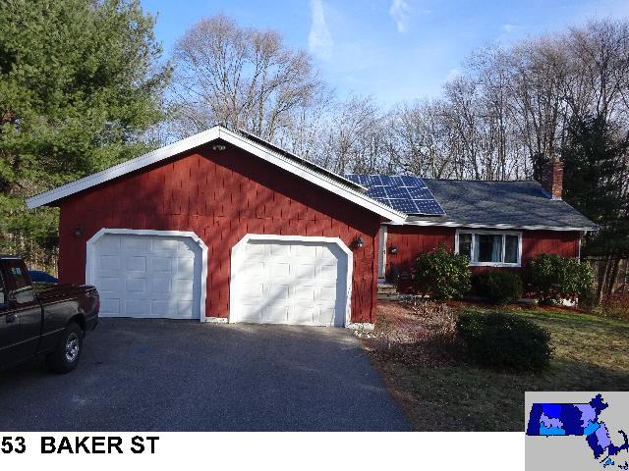
Sale Price = $537,000 Sale Date = 5/3/2021

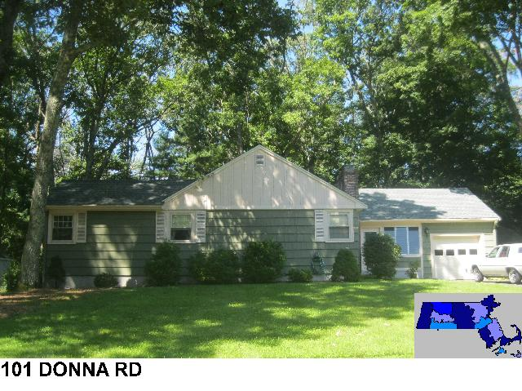
Sale Price = $471,000 Sale Date = 5/11/2021

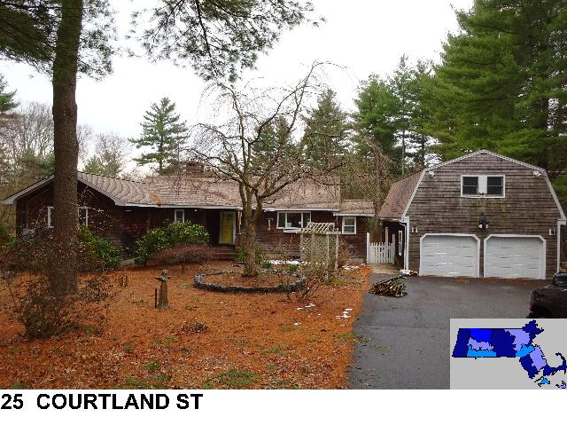
Sale Price = $630,000 Sale Date = 5/28/2021
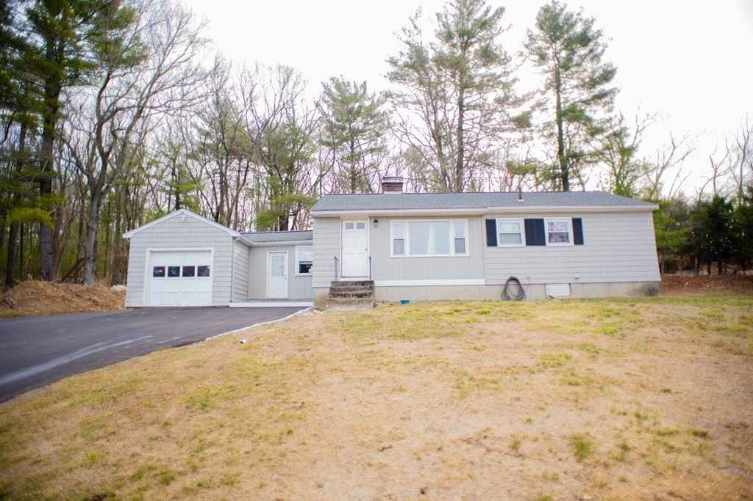
485 Concord St.
Sale Price = $410,000 Sale Date = 6/8/2021

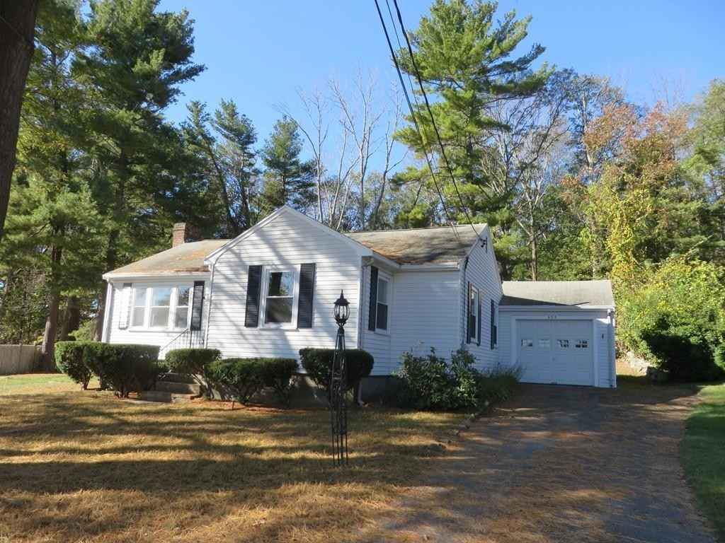
429 Norfolk St.
Sale Price = $495,000 Sale Date = 6/17/2021
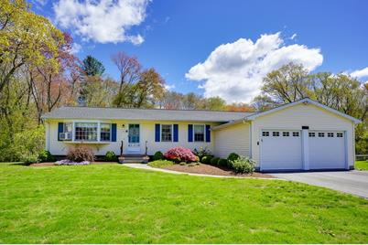
133 Westfield Dr.
Sale Price = $550,000 Sale Date = 7/1/2021

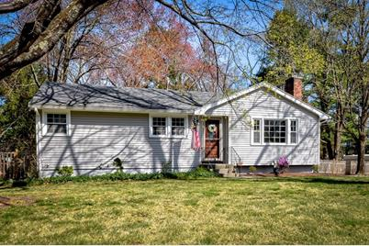
16 Sweet Grass Ln.
Sale Price = $515,000 Sale Date = 7/8/2021

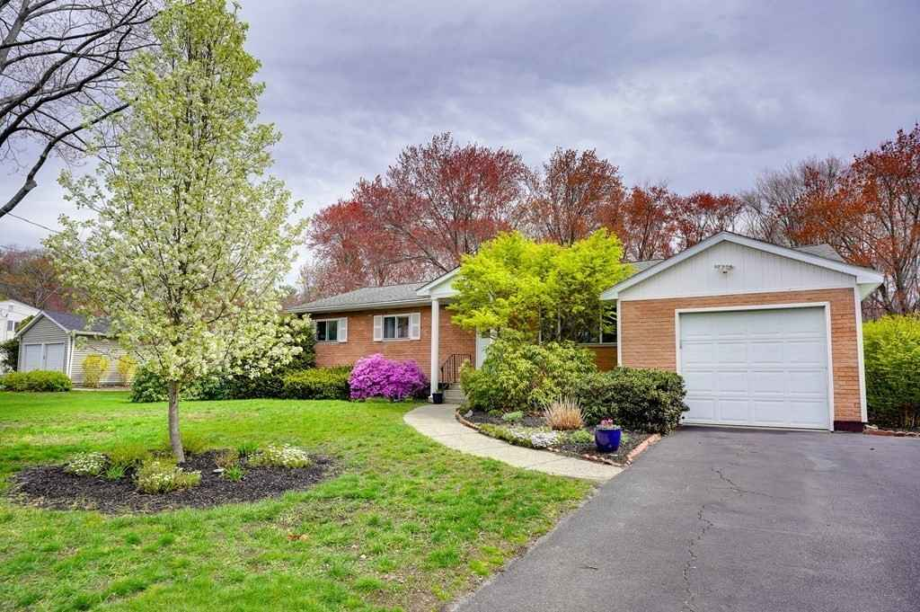
141 Westfield Dr.
Sale Price = $600,000 Sale Date = 7/8/2021

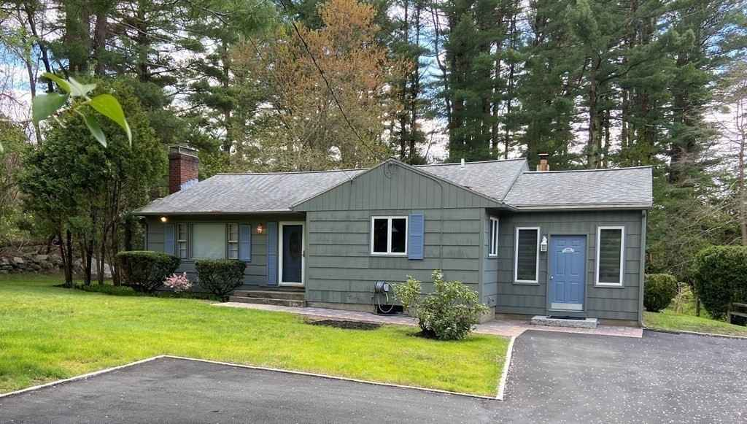
448 Prentice St.
Sale Price = $445,000 Sale Date = 7/9/2021

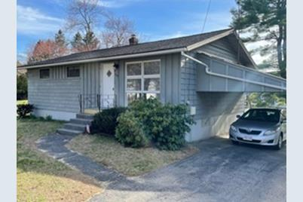
332 Concord St.
Sale Price = $320,000 Sale Date = 7/12/2021

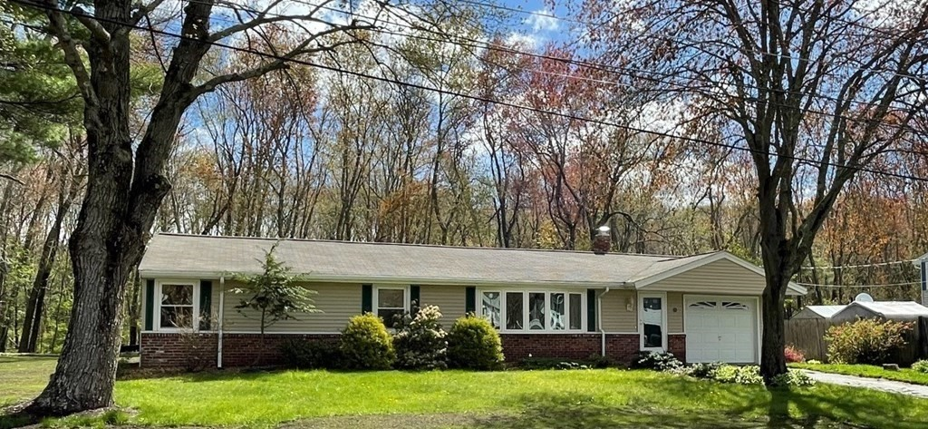
56 Adam Wheeler Ln.
Sale Price = $458,000 Sale Date = 7/13/2021

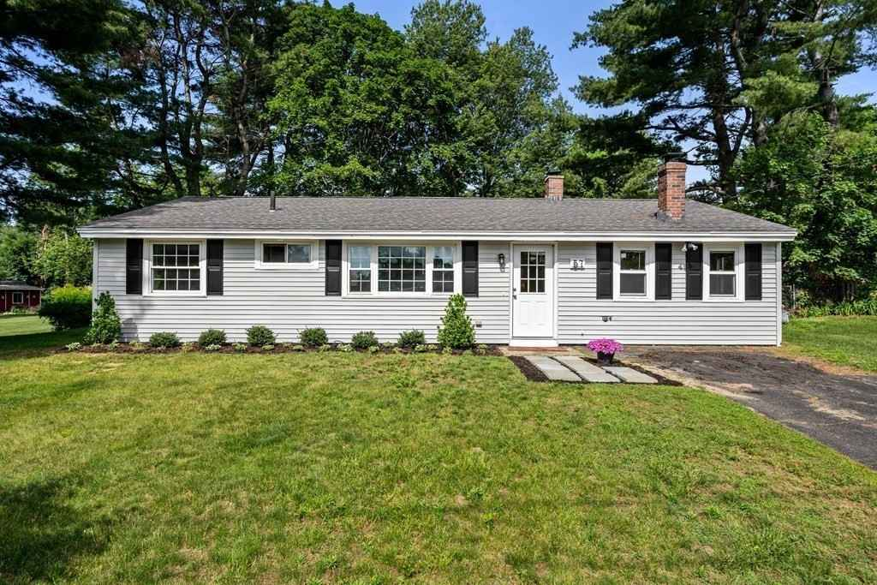
57 Bradford Jay Rd.
Sale Price = $451,000 Sale Date = 7/23/2021

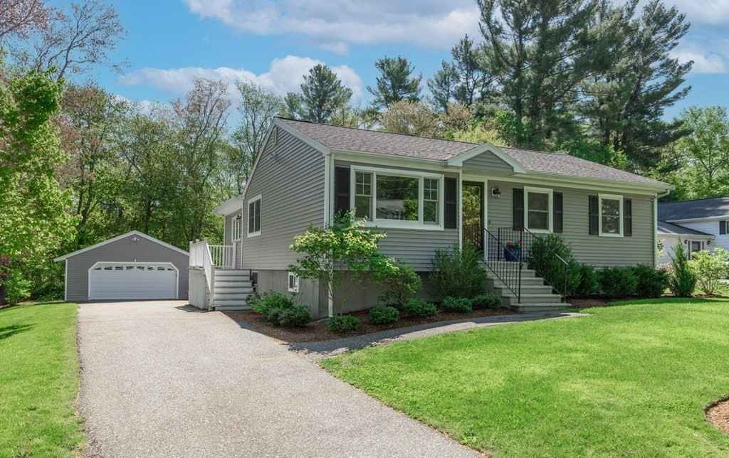
146 Chamberlain St.
Sale Price = $505,000 Sale Date = 7/30/2021

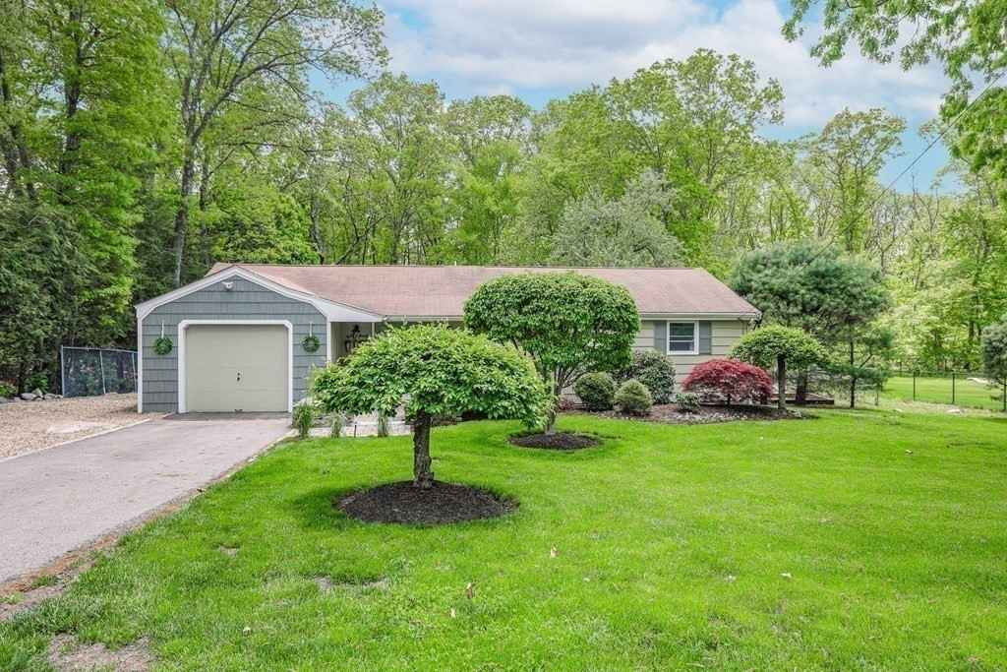
18 Cheryl Ln.
Sale Price = $600,000 Sale Date = 8/2/2021

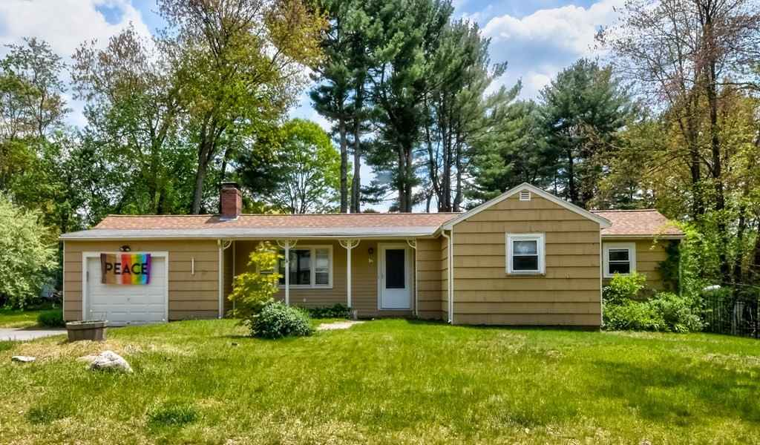
16 Dean Rd.
Sale Price = $360,000 Sale Date = 9/8/2021

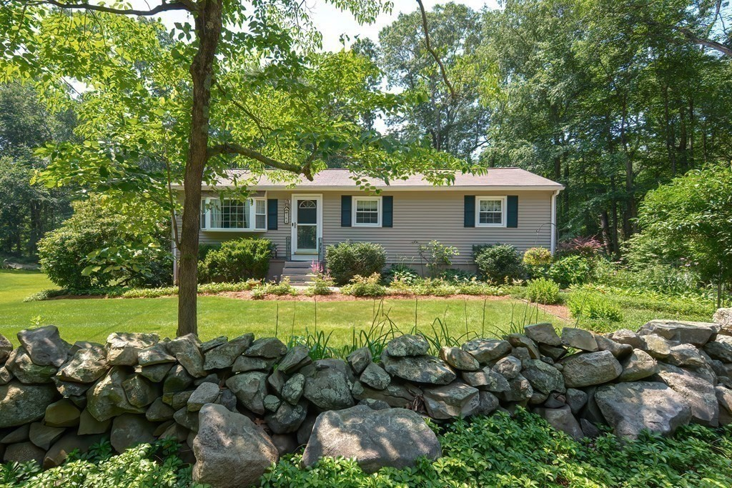
364 Underwood St.
Sale Price = $460,000 Sale Date = 9/8/2021

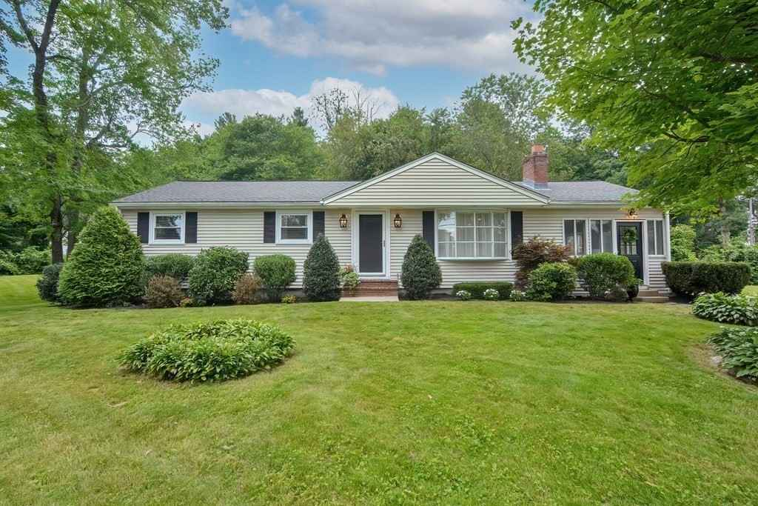
173 Prospect St.
Sale Price = $545,000 Sale Date = 9/27/2021
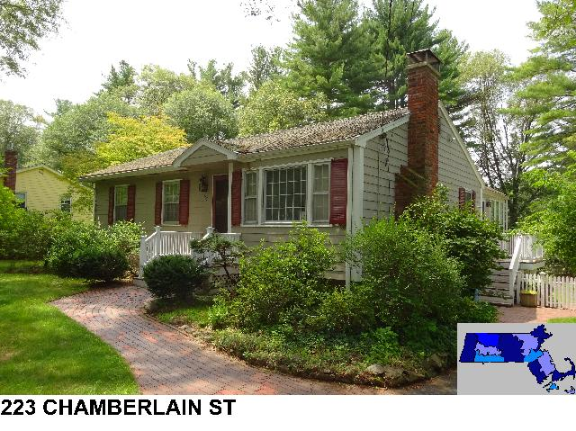
Sale Price = $600,000 Sale Date = 9/29/2021

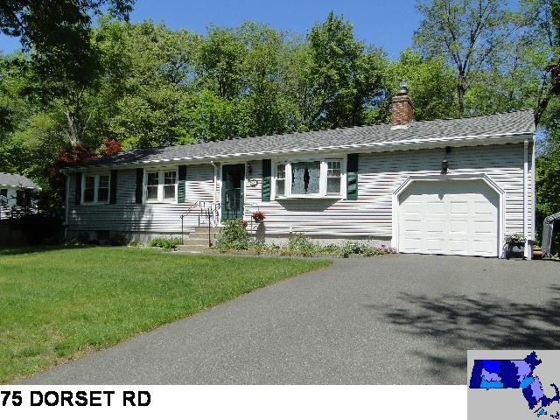
Sale Price = $515,000 Sale Date – 10/5/2021

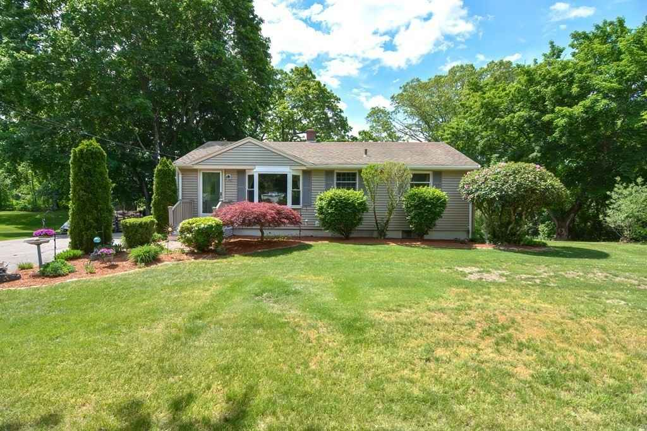
65 Wedgewood Dr.
Sale Price = $560,000 Sale Date = 10/6/2021

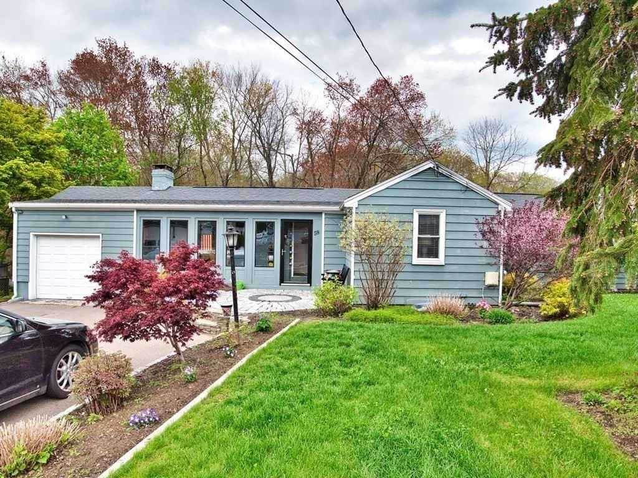
58 Maple Dell Ln.
Sale Price = $350,000 Sale Date = 10/12/2021
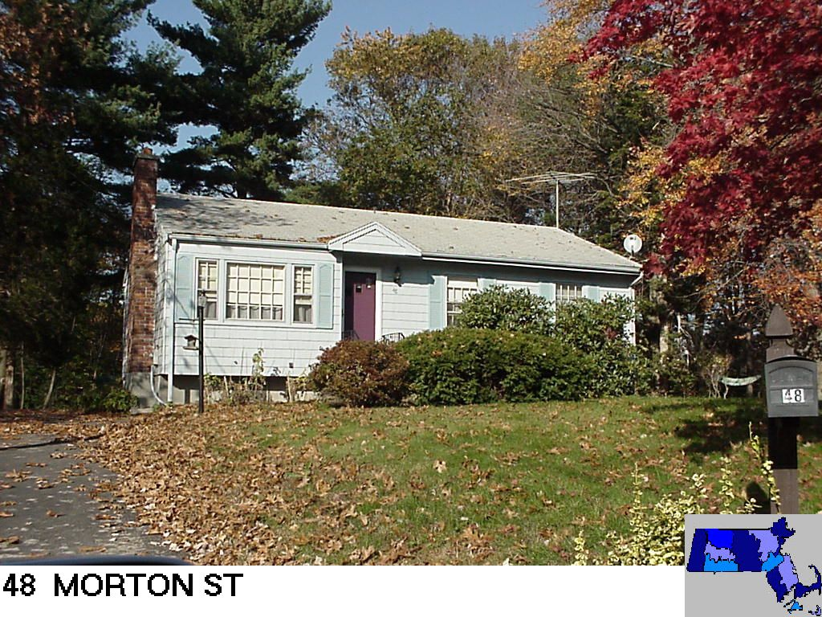
Sale Price = $475,000 Sale Date = 11/5/2021

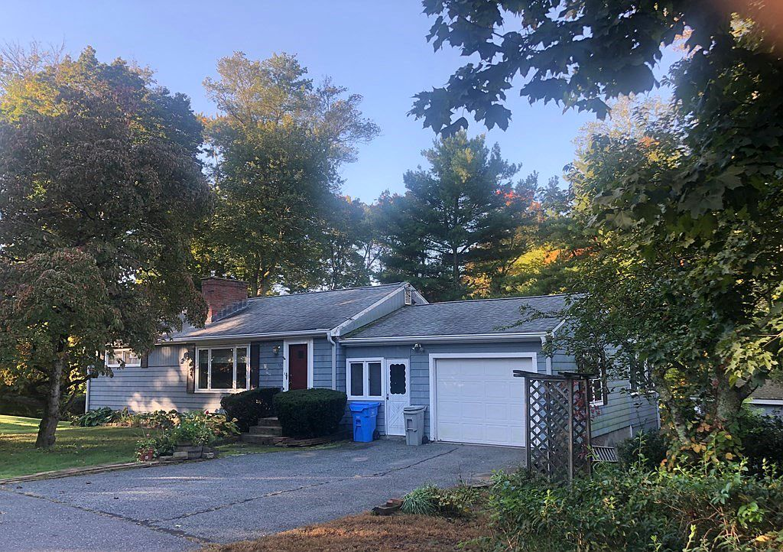
95 Woodland St.
Sale Price = $417,500 Sale Date = 11/23/2021
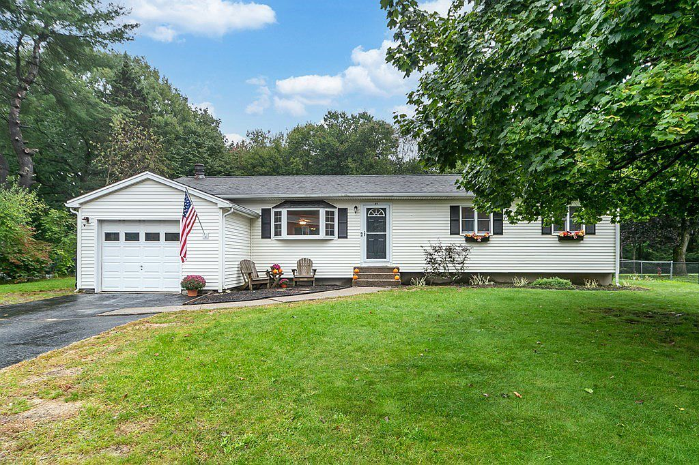
45 Wingate Rd.
Sale Price = $540,000 Sale Date = 12/3/2021

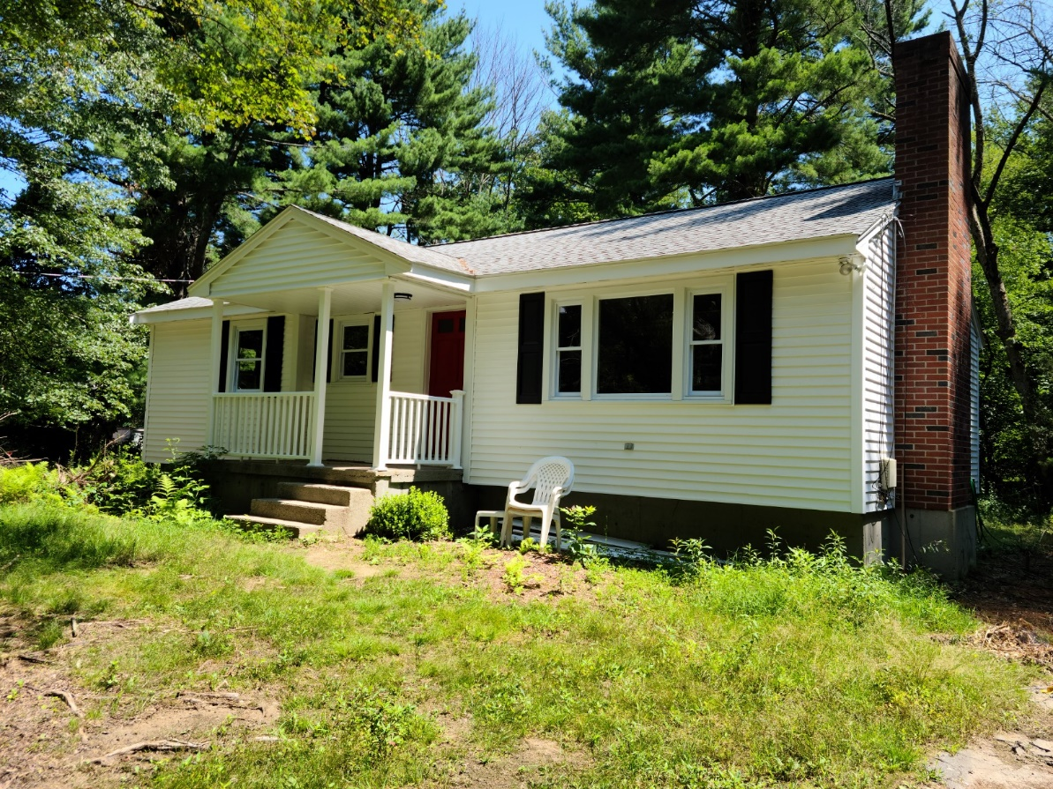
48 Chamberlain St
Sale Price = $420,000 Sale Date = 12/10/2021
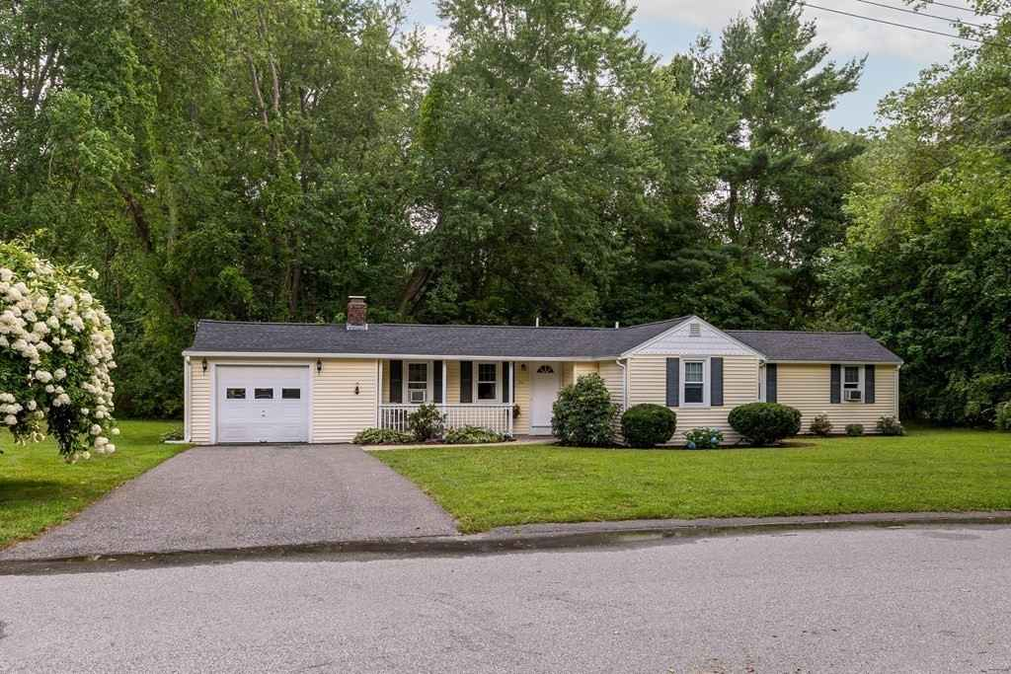
24 Travis Rd
Sale Price = $375,000 Sale Date = 12/13/2021

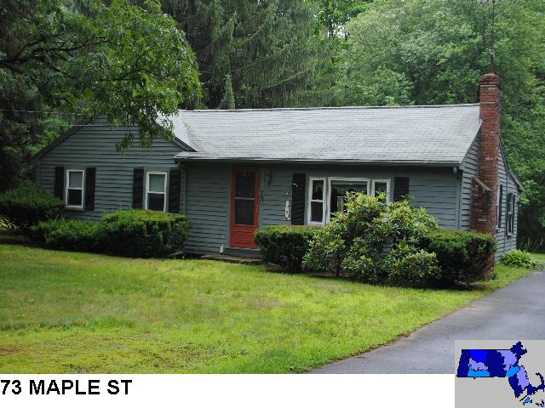
Sale Price = $415,000 Sale Date = 12/13/2021

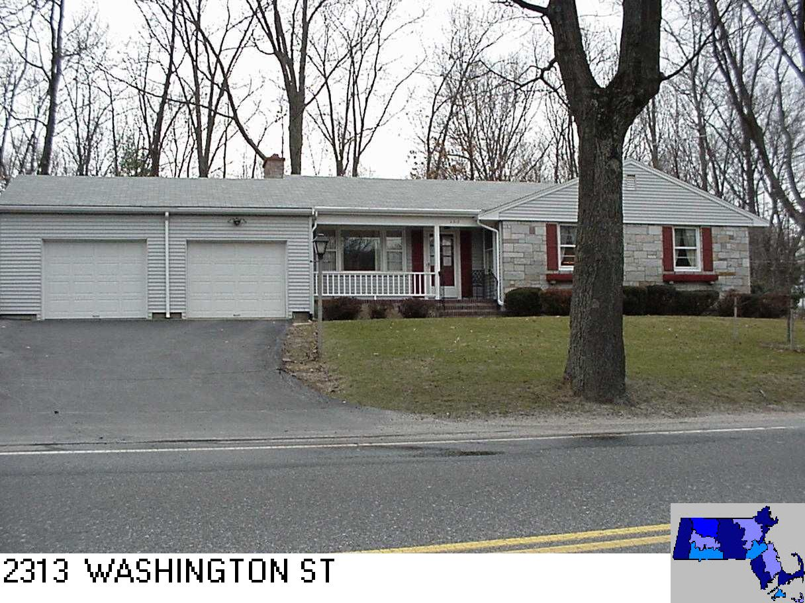
Sale Price = $469,000 Sale Date = 12/15/2021

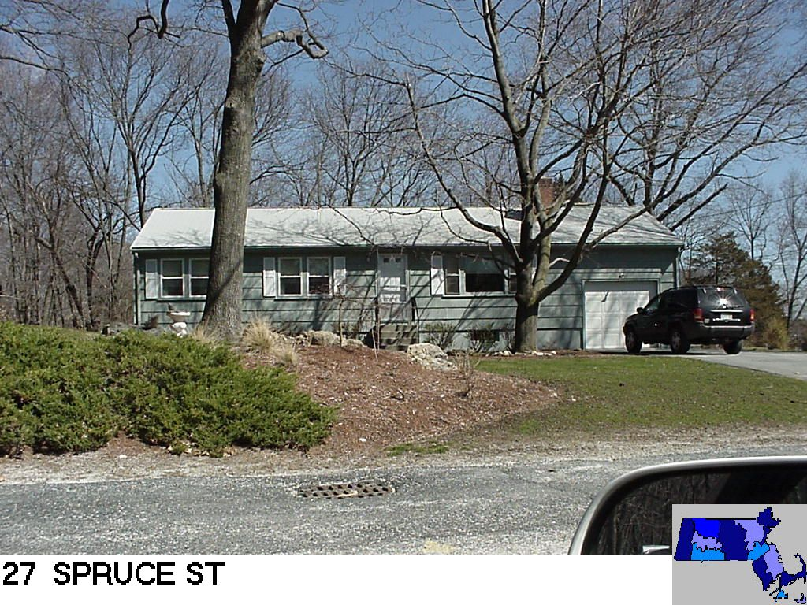
Sale Price = $385,000 Sale Date = 12/15/2021

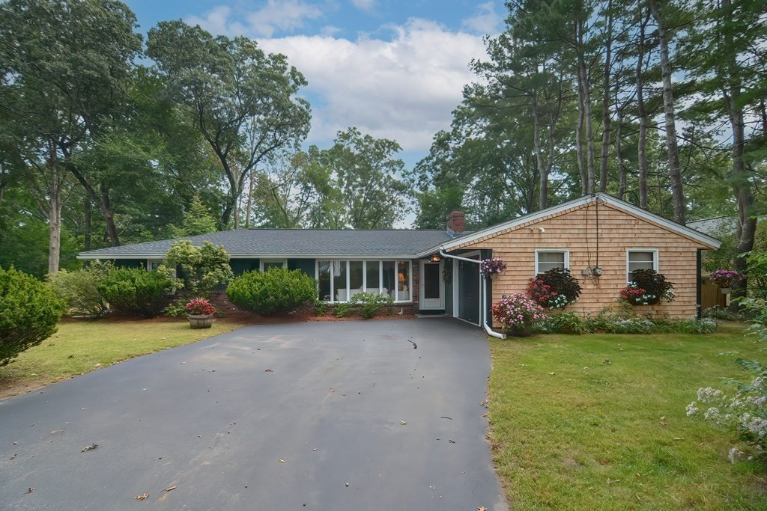
738 Norfolk St
Sale Price = $485,000 Sale Date = 12/20/2021

Split-Level

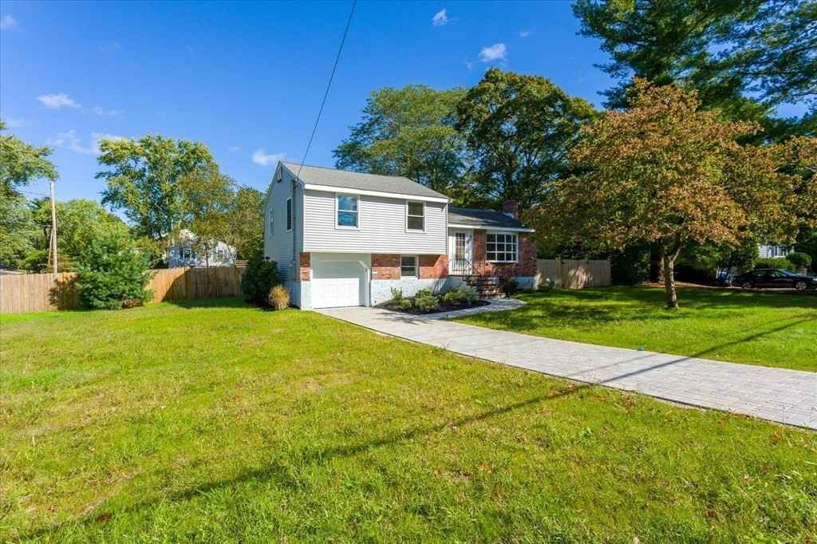
246 Fiske St
Sale Price = $330,750 Sale Date = 2/16/2021

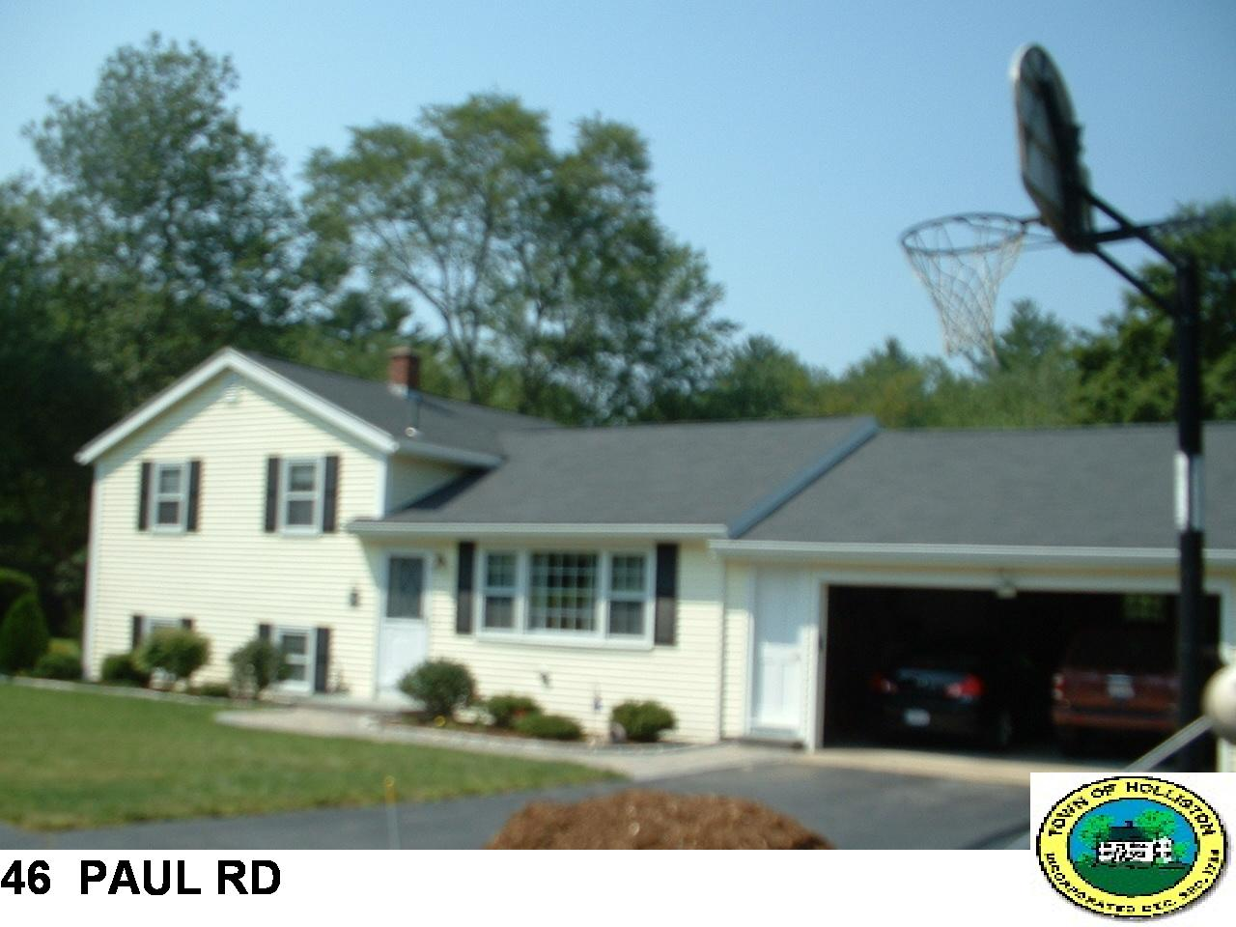
Sale Price = $536,200 Sale Date = 4/21/2021
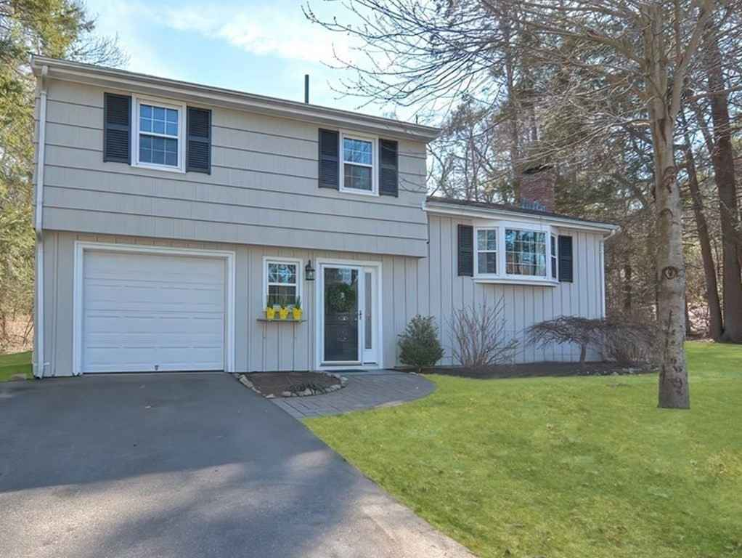
96 Dorset Rd
Sale Price = $497,000 Sale Date = 5/27/2021

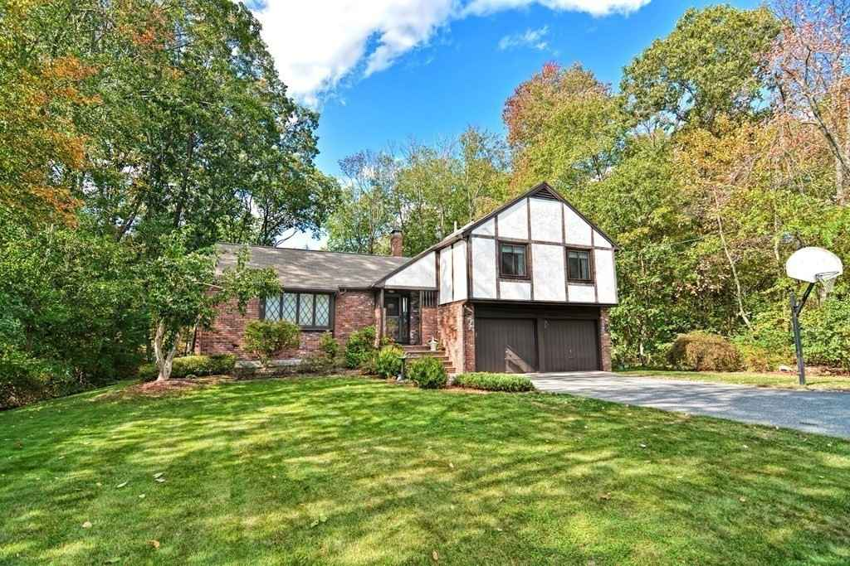
37 Orchard Ln
Sale Price = $650,000 Sale Date = 6/10/2021
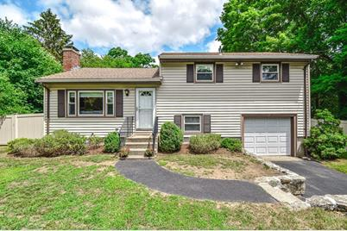
22 Summer St
Sale Price = $487,000 Sale Date = 8/12/2021

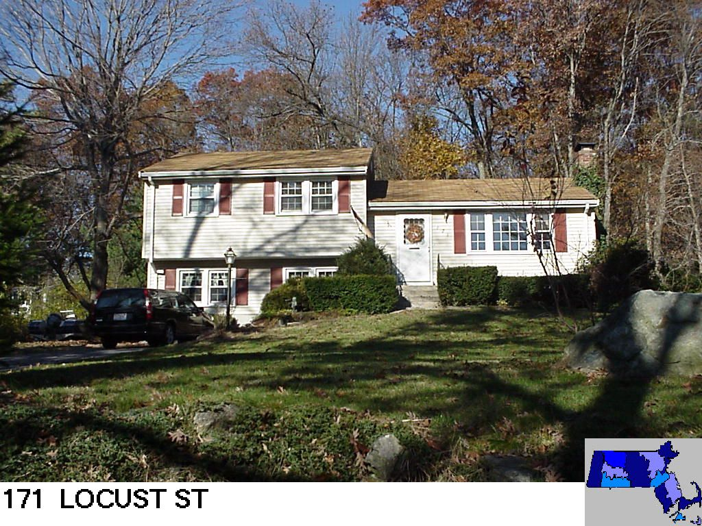
Sale Price = $510,000 Sale Date = 10/25/2021
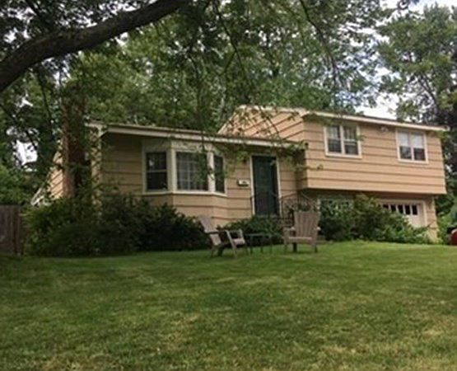
227 Shaw Farm Rd
Sale Price = $450,000 Sale Date = 11/3/2021

Tri-Level

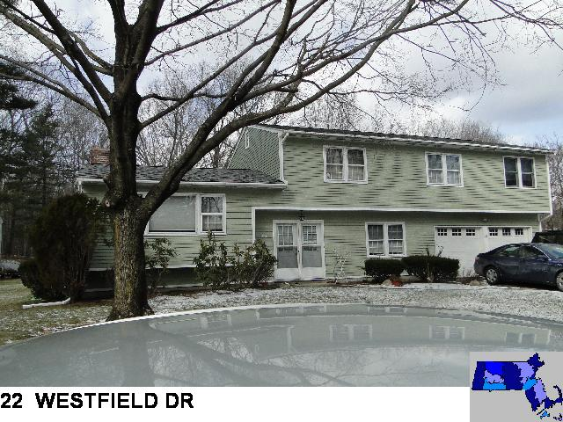
Sale Price = $625,000 Sale Date = 1/6/2021

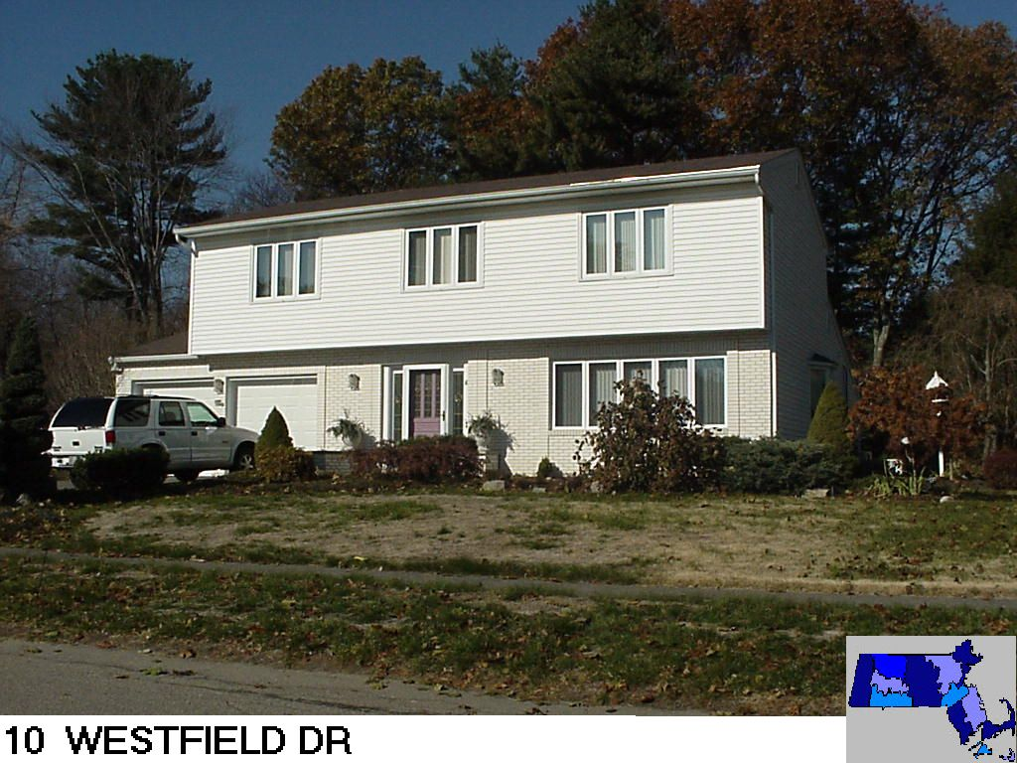
Sale Price = $590,000 Sale Date = 1/8/2021
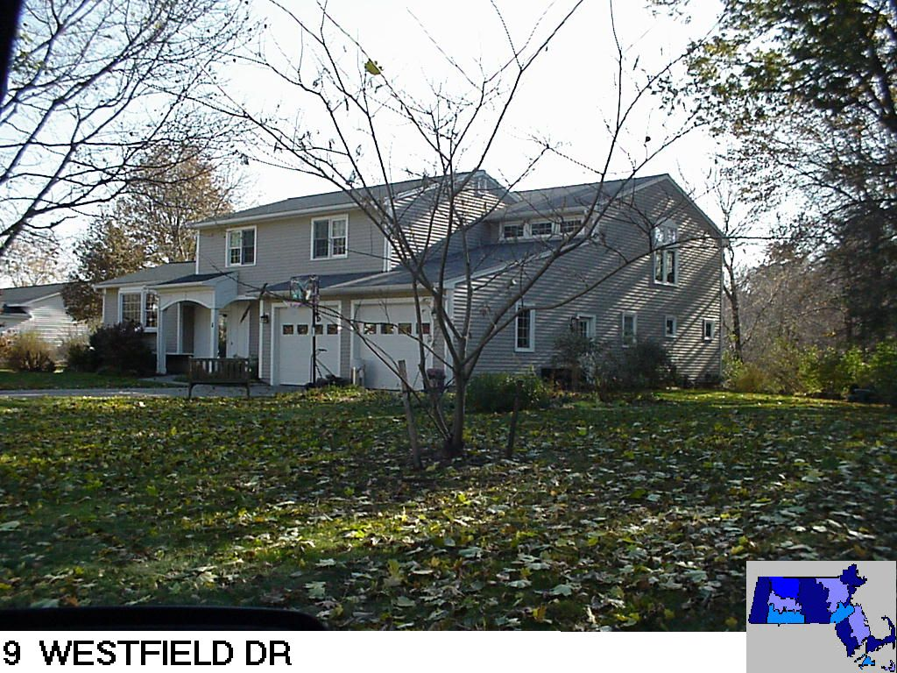
Sale Price = $715,000 Sale Date = 6/3/2021

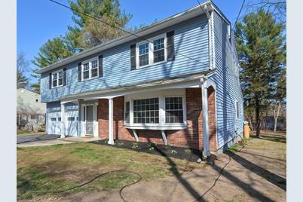
667 Winter St
Sale Price = $630,000 Sale Date 6/11/2021
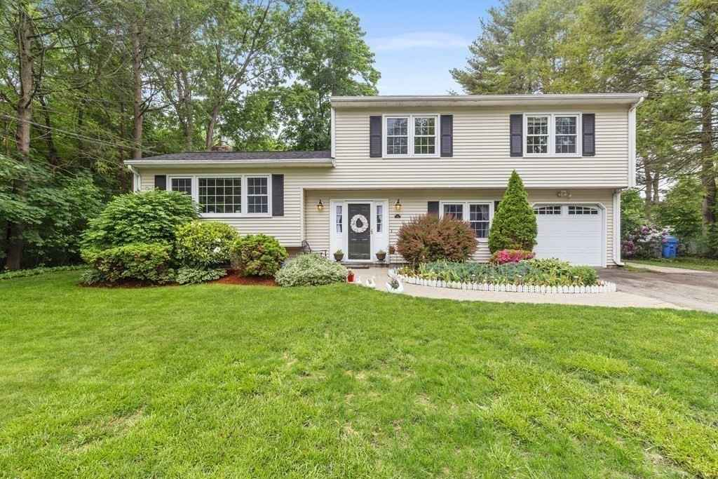
82 Westfield Dr
Sale Price = $610,500 Sale Date = 6/15/2021

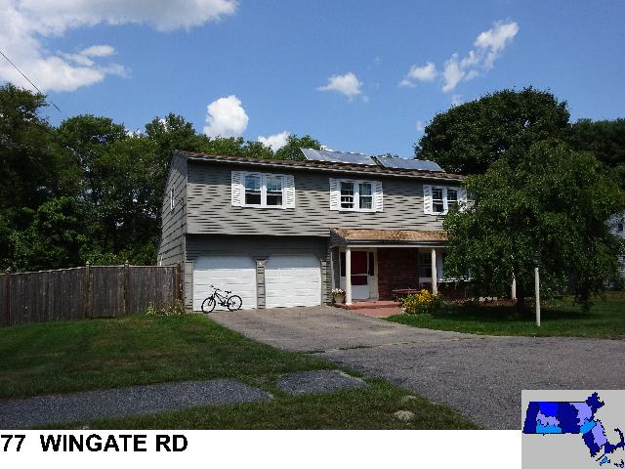
Sale Price = $660,000 Sale Date = 6/29/2021
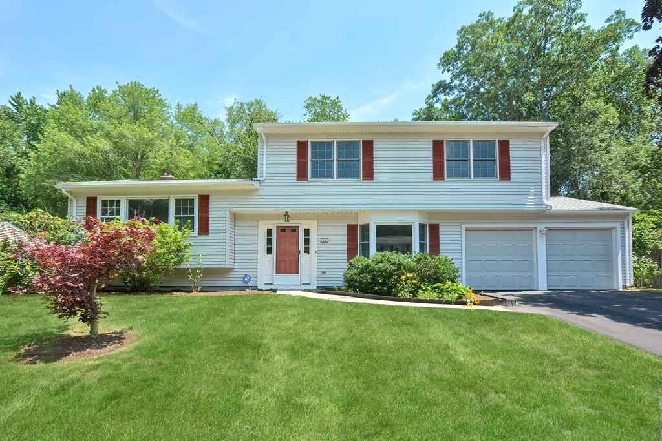
19 Wingate Rd
Sale Price = $600,000 Sale Date = 8/27/2021

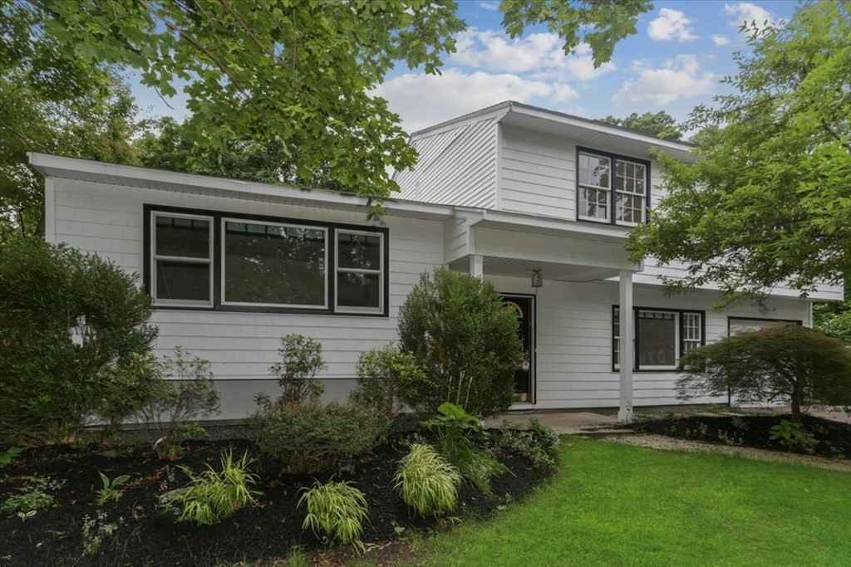
78 Richard Rd
Sale Price = $537,000 Sale Date = 10/8/2021
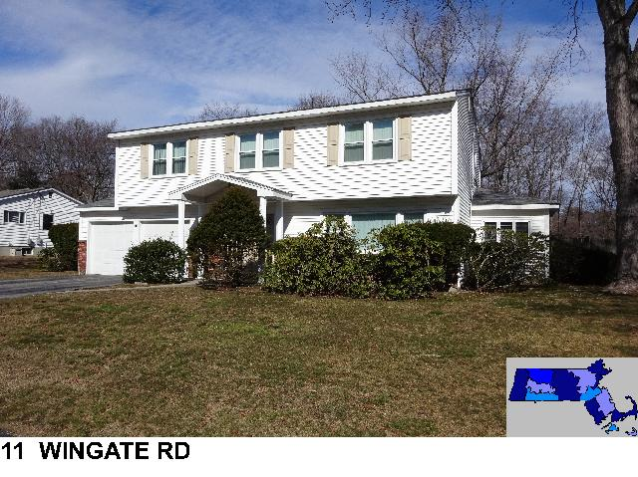
Sale Price = $679,000 Sale Date = 11/5/2021

Tudor

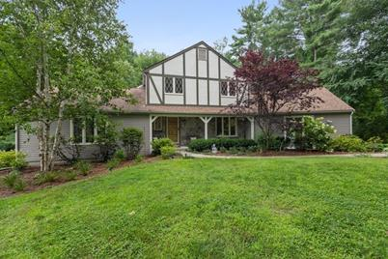
60 Willow Gate Rise
Sale Price = $775,000 Sale Date = 9/28/2021

Condominiums

Garden style

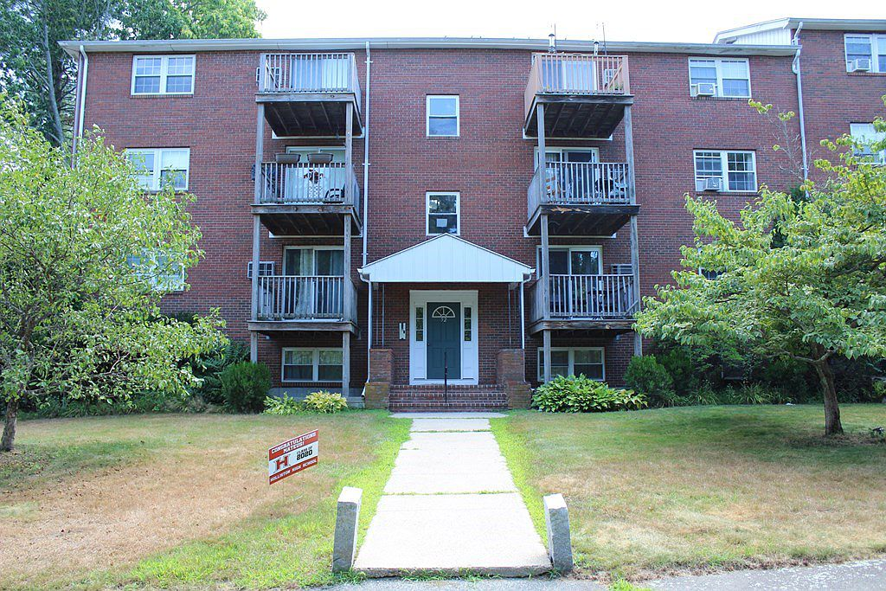

52 Burnap Rd. U52-4 Sale Price = $183,000 Sale Date = 1/28/2021
52 Burnap Rd U52-2 Sale Price = $190,000 Sale Date = 5/3/2021

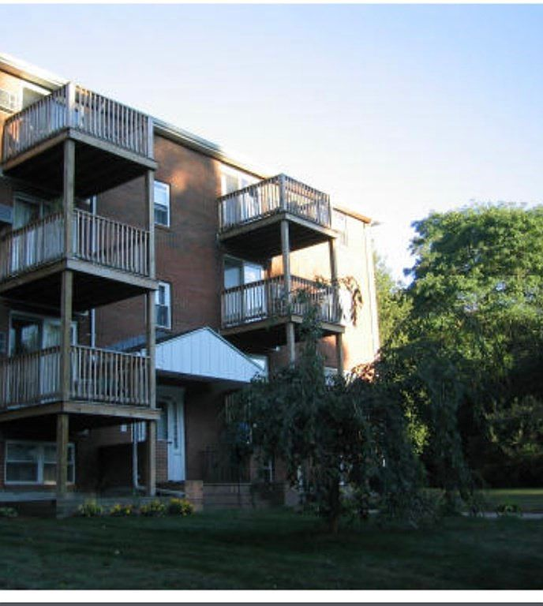
54 Burnap Rd U54-6 Sale Price = $200,000 Sale Date = 4/28/2021
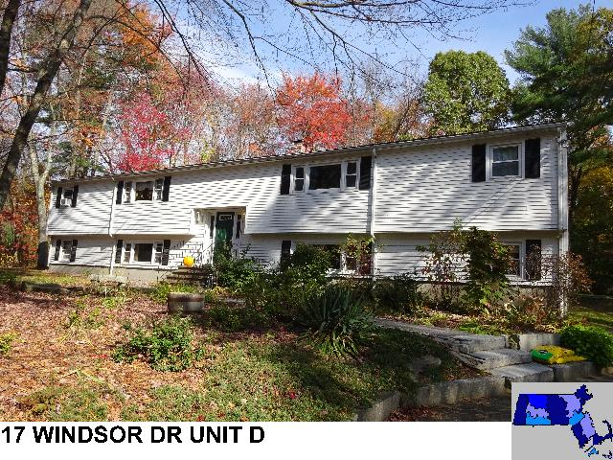
Sale Price = $235,000 Sale Date = 3/5/2021
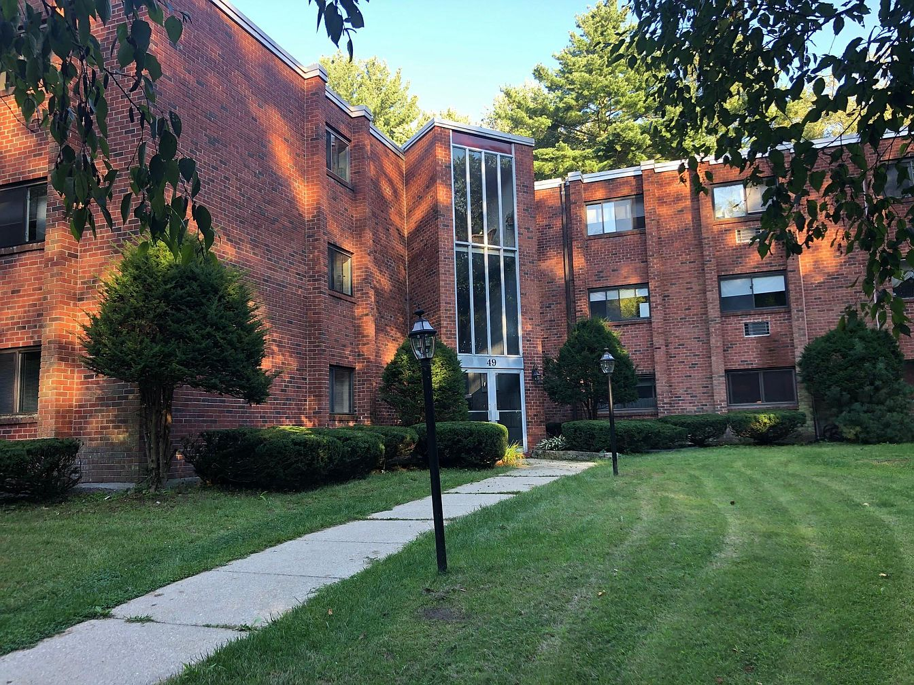
49 Windsor Dr U-308 Sale Price = $239,900 Sale Date = 4/29/2021
49 Windsor Dr U-310 Sale Price = $215,000 Sale Date = 6/1/2021
49 Windsor Dr U-204 Sale Price = $200,000 Sale Date = 6/30/2021
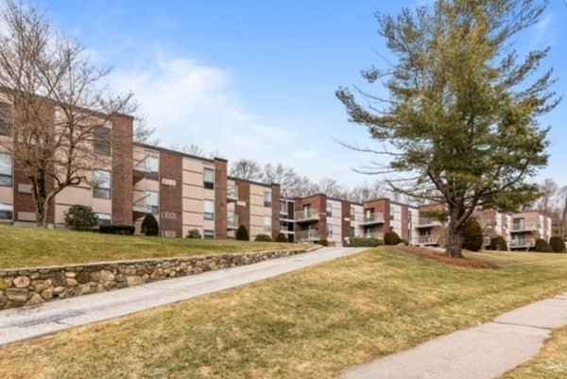
152 Turner Rd U-20 Sale Price = $165,000 Sale Date = 2/25/2021
152 Turner Rd U-9 Sale Price = $180,000 Sale Date = 5/27/2021
152 Turner Rd U-40 Sale Price = $189,900 Sale Date = 9/24/2021

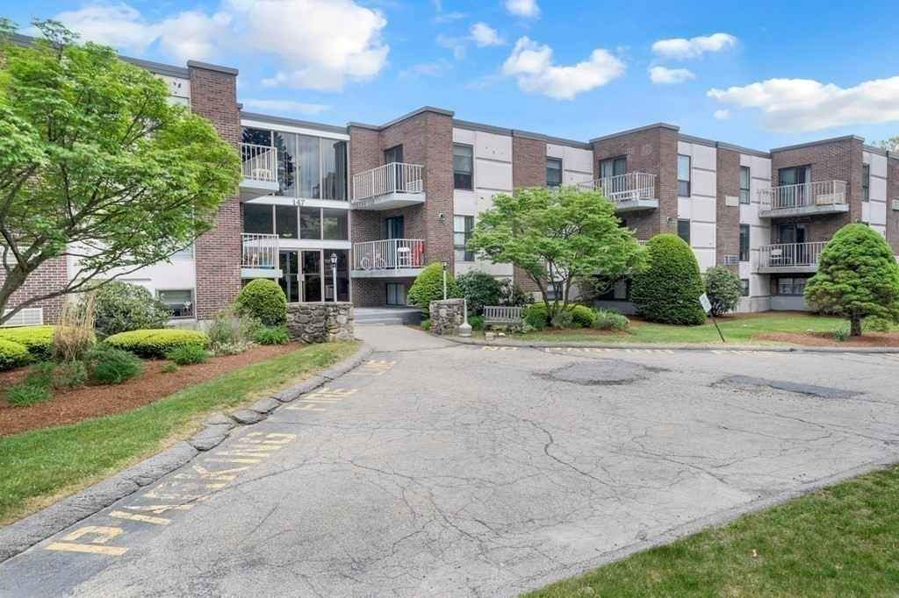
147 Turner U-103 Sale Price = $180,000 Sale Date = 7/20/2021
147 Turner U-73 Sale Price = $170,000 Sale Date = 7/30/2021
147 Turner U-62 Sale Price = $177,000 Sale Date = 8/16/2021
147 Turner U-119 Sale Price = $185,000 Sale Date = 9/24/2021
147 Turner U-112 Sale Price = $187,500 Sale Date = 11/1/2021
147 Turner U-102 Sale Price = $185,000 Sale Date = 12/21/2021
147 Turner U-91 Sale Price = $185,000 Sale Date = 12/29/2021

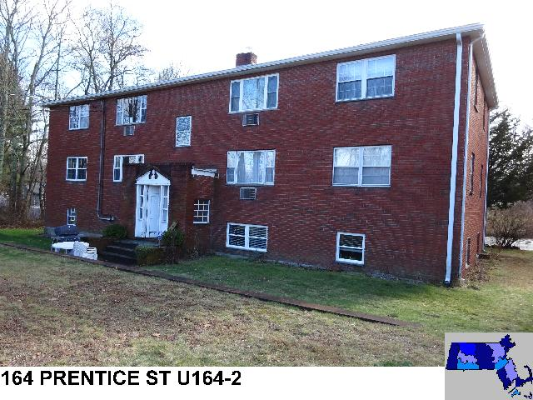
Sale Price = $200,000 Sale Date = 11/19/2021

Townhouse

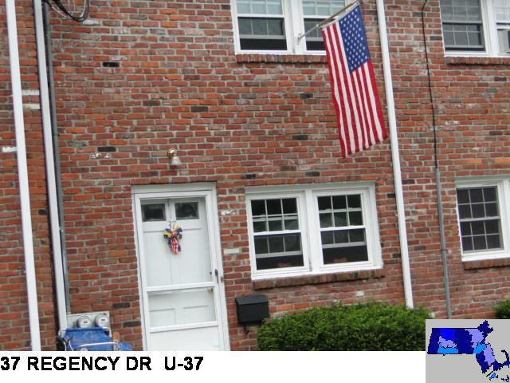
Sale Price = $255,000 Sale Date = 3/23/2021

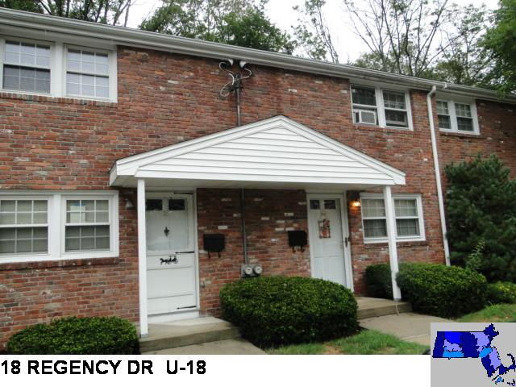
Sale Price = $237,000 Sale Date = 5/25/2021

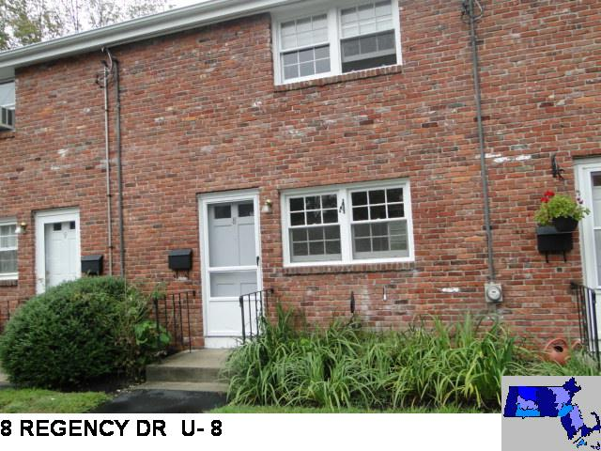
Sale Price = $238,000 Sale Date = 9/29/2021

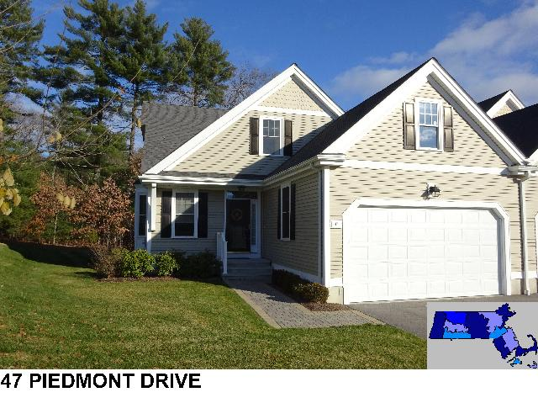
Sale Price = $575,000 Sale Date = 6/28/2021

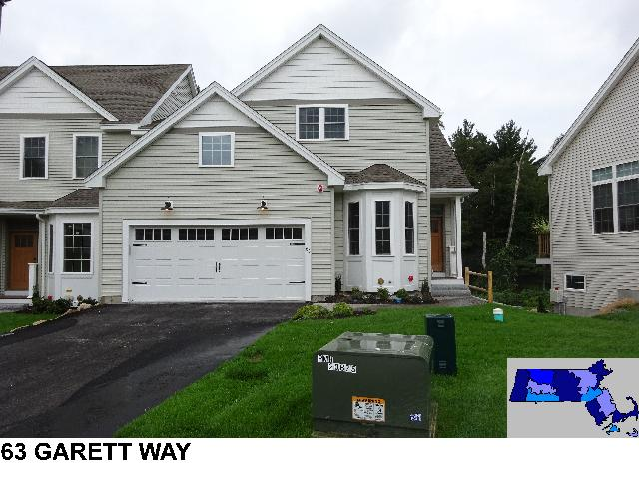
Sale Price = $560,000 Sale Date = 4/13/2021

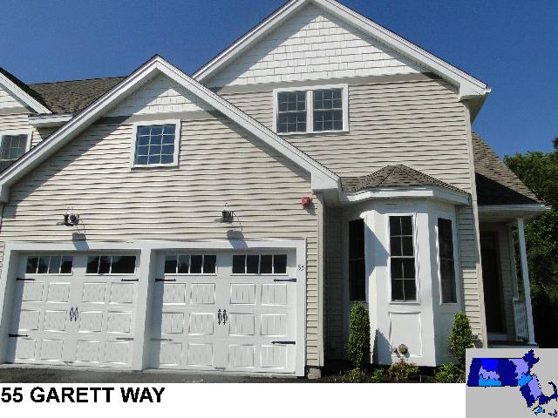
Sale Price = $567,500 Sale Date = 7/29/2021
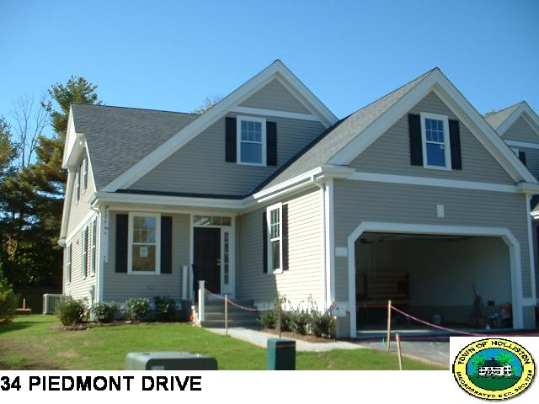
Sale Price = $610,000 Sale Date = 12/15/2021

Hollis Hills,
Brooksmont, &
Hollis Woods
Condominiums

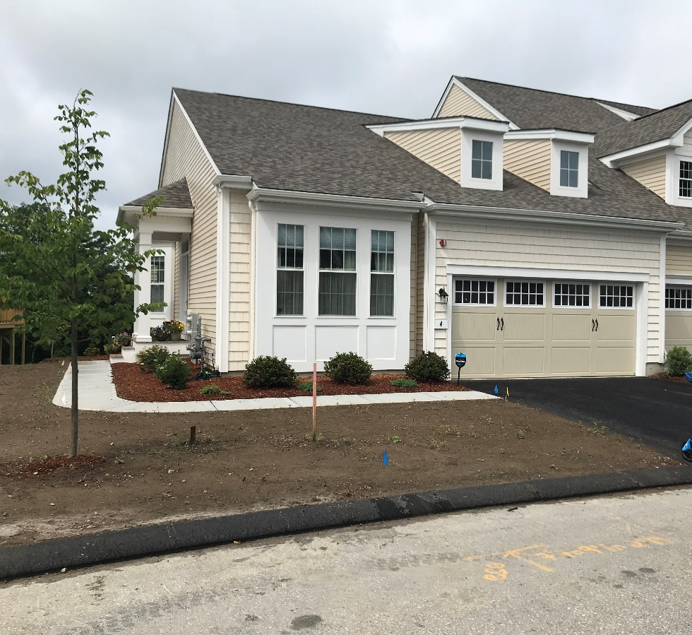
4 Cherry Lane #34 Sale Price = $495,680 Sale Date = 2/11/2021
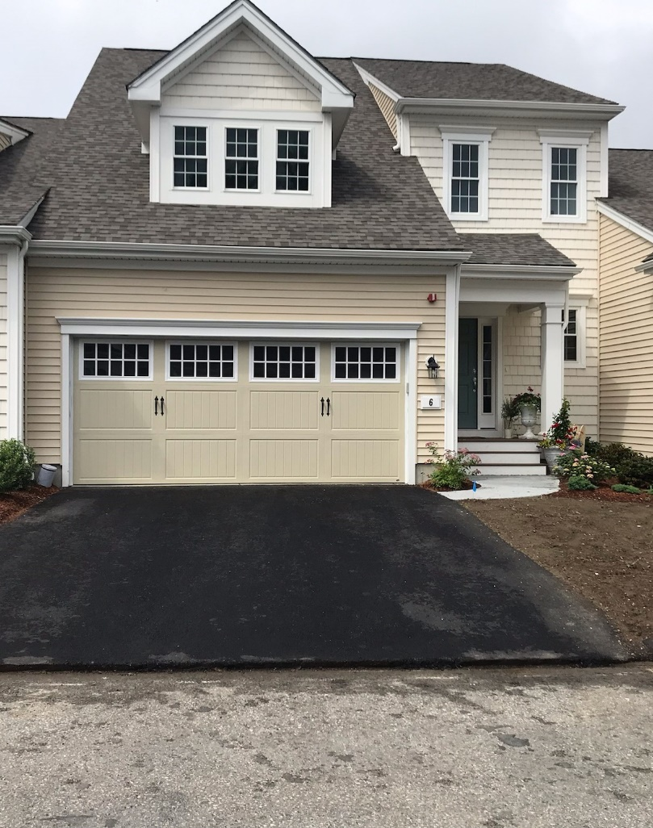
6 Cherry Lane #33 Sale Price = $560,520 Sale Date = 2/26/2021
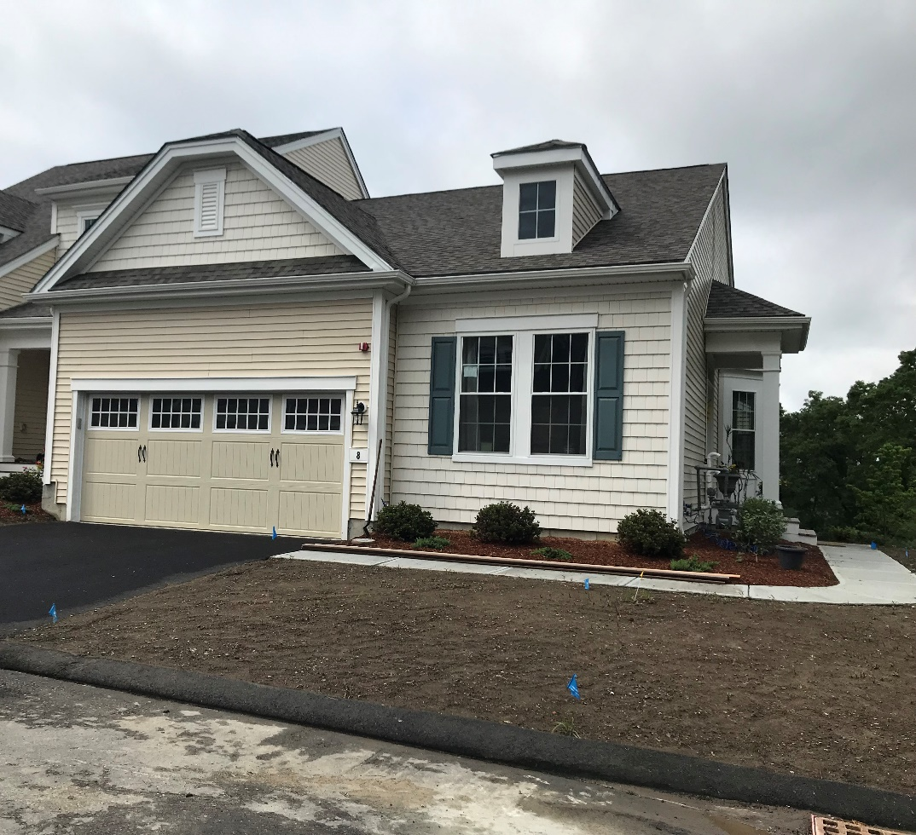
8 Cherry Lane #32 Sale Price = $532,440 Sale Date = 3/16/2021

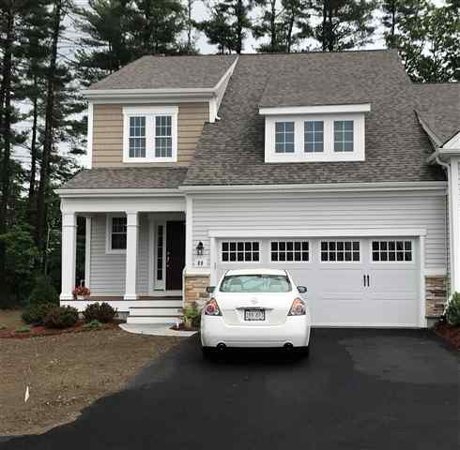
89 Brooksmont Dr #24 Sale Price = $554,010 Sale Date = 3/31/2021
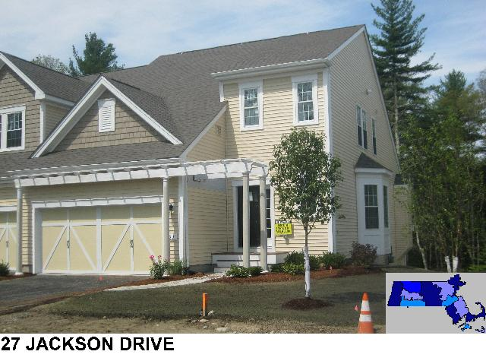
Sale Price = $562,000 Sale Date = 4/8/2021

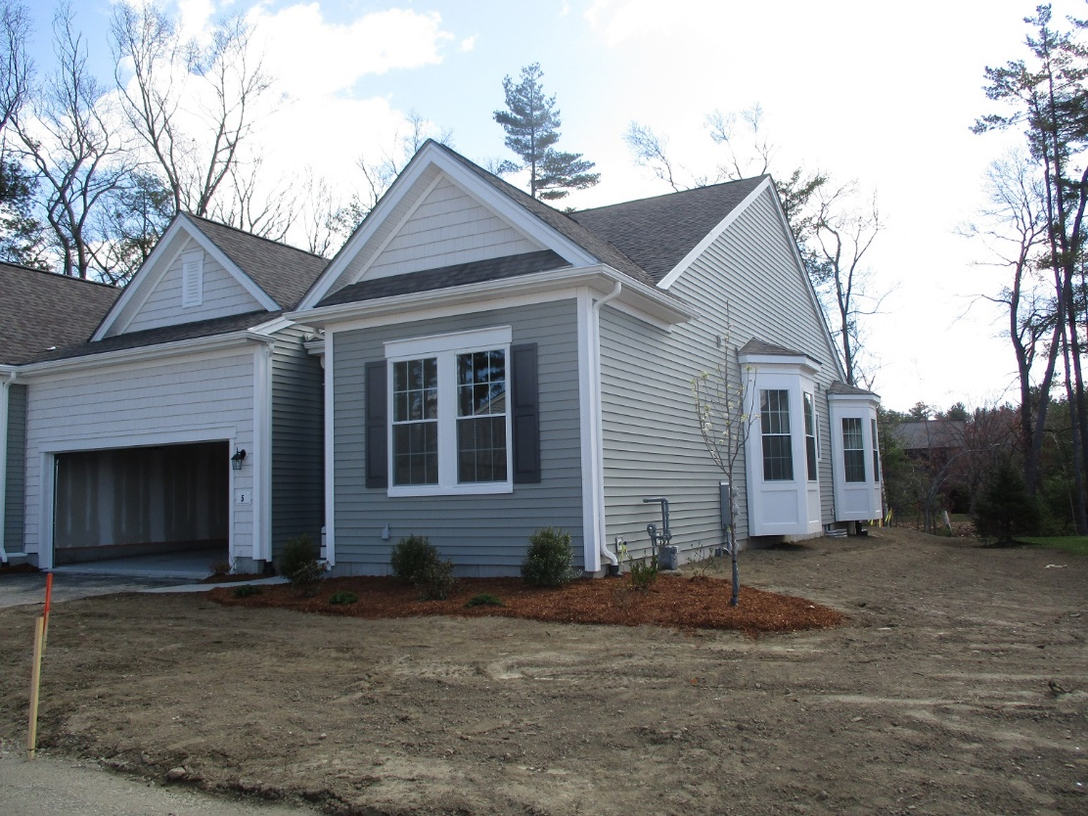
5 Peach Drive #21 Sale Price = $548,135 Sale Date = 4/15/2021

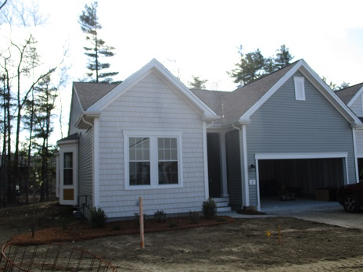
7 Peach Drive #22 Sale Price = $549,745 Sale Date = 4/23/2021

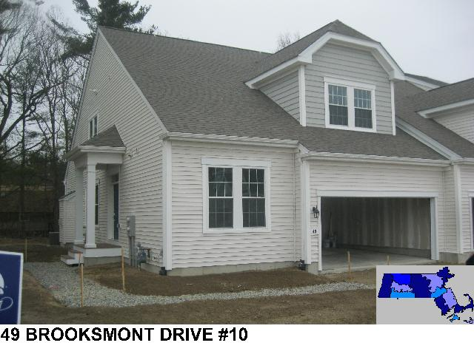
Sale Price = $607,000 Sale Date = 6/17/2021
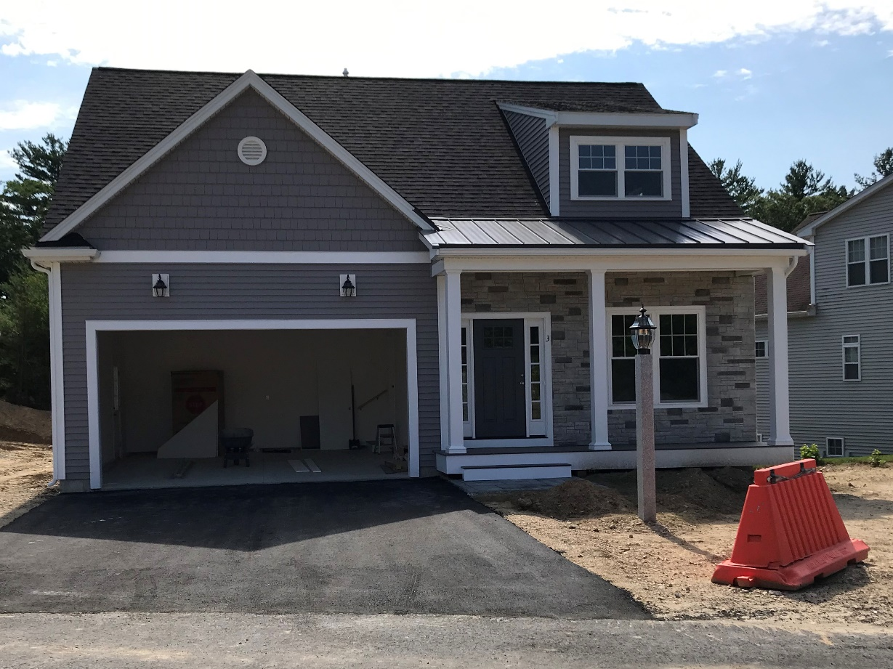
3 Bittersweet Circle Sale Price = $745,000 Sale Date = 7/7/2021

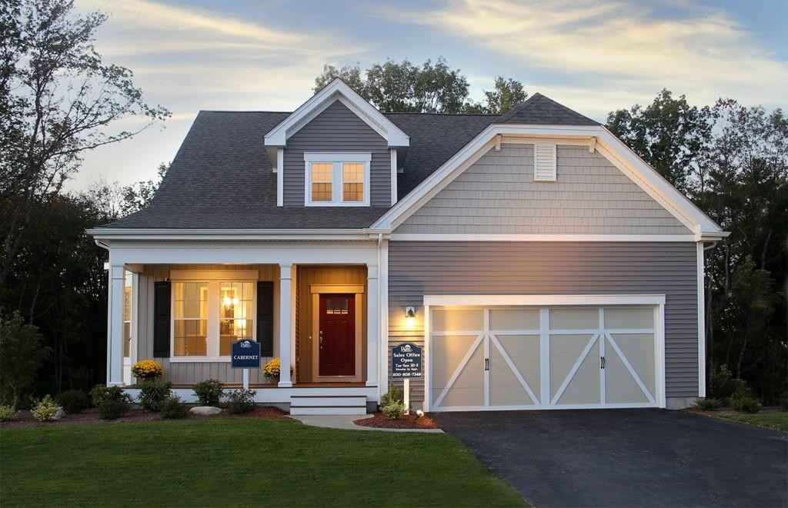
59 Jackson Drive Sale Price = $729,000 Sale Date = 7/9/2021

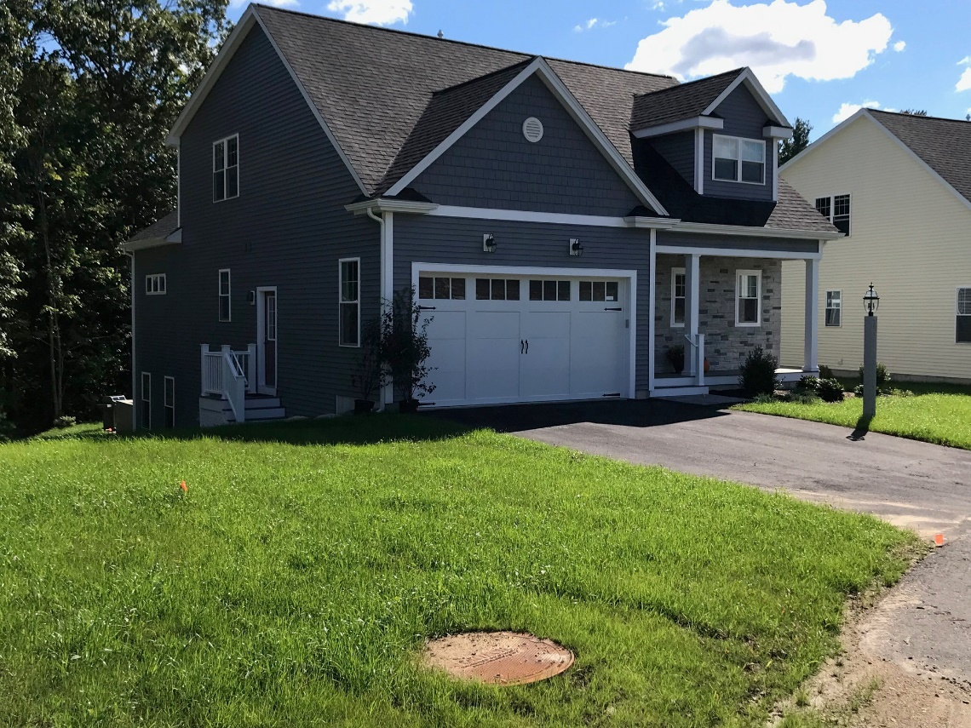
15 Bittersweet Circle Sale Price = $735,000 Sale Date = 7/27/2021

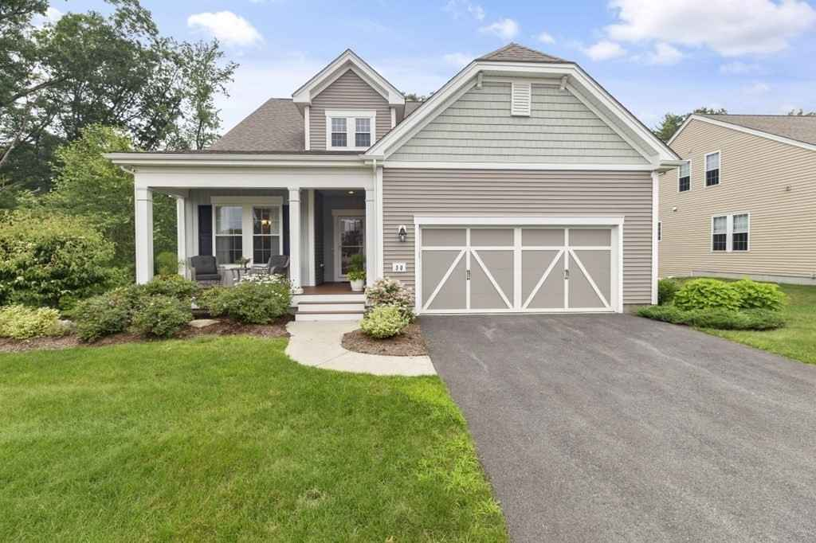
50 Monroe Drive Sale Price = $780,000 Sale Date = 8/10/2021

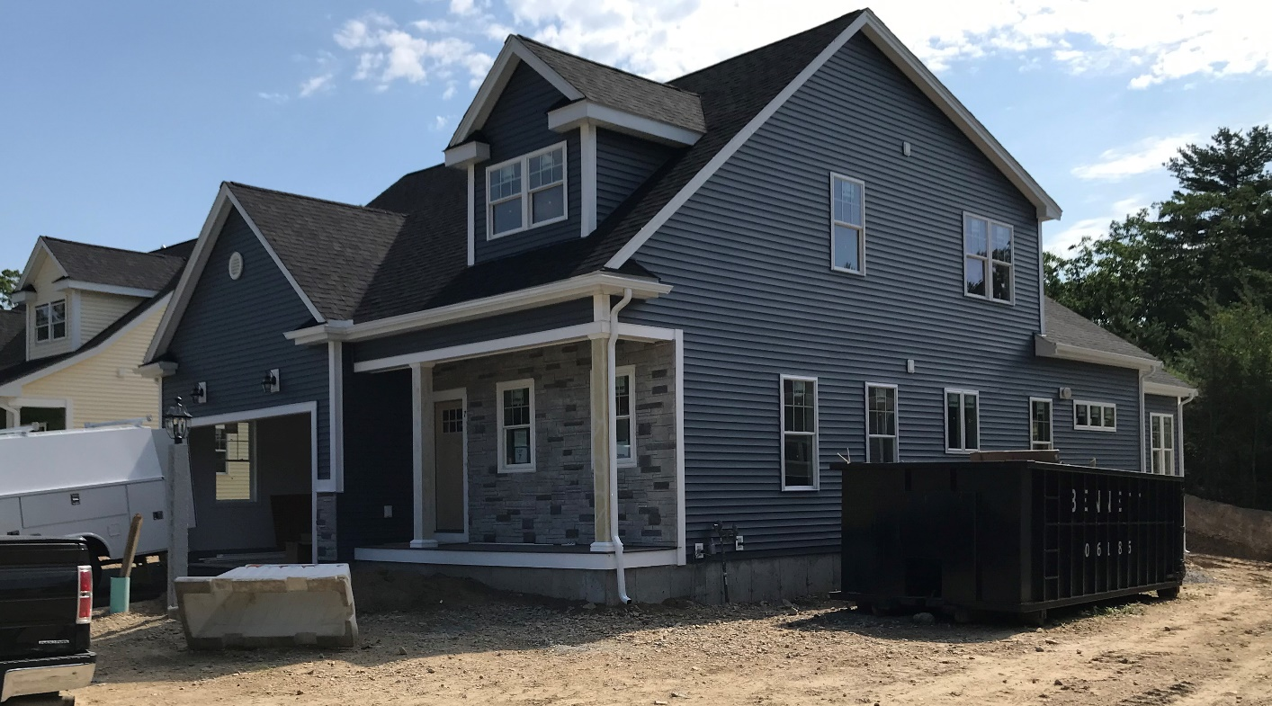
7 Bittersweet Circle Sale Price = $760,000 Sale Date = 8/16/2021

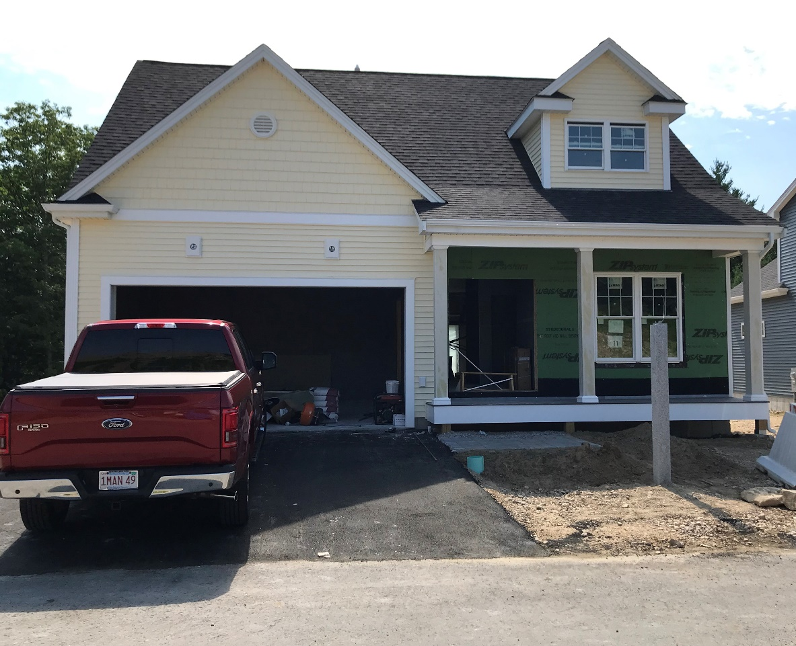
11 Bittersweet Circle Sale Price = $730,000 Sale Date = 8/26/2021

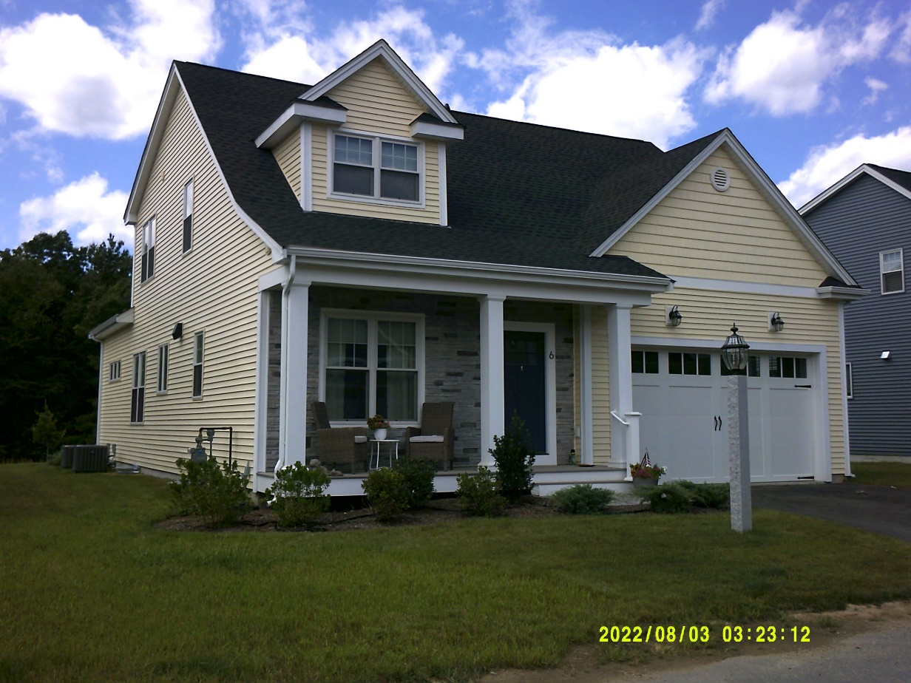
6 Trailside Court Sale Price = $735,000 Sale Date = 10/8/2021

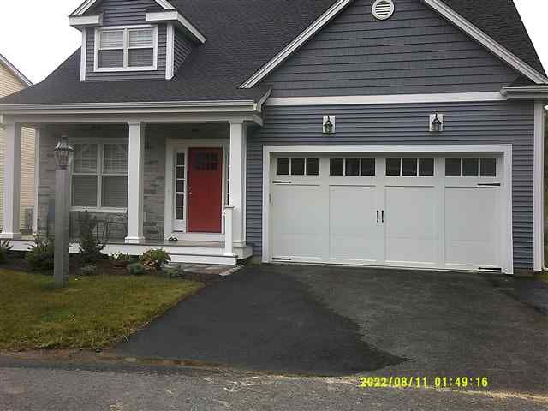
10 Trailside Court Sale Price = $750,000 Sale Date = 11/24/2021

